STANDARD OPERATING PROCEEDURE
(SOP)
FUOPS SECTION
TF SPARTAN
Effective Date: 19 April 2022
THIS SOP SUPERSEDES ALL PREVIOUS EDITIONS

Contents
STANDARD OPERATING PROCEEDURE 0
1 Overview 0
1.1 Function 0
1.2 Roles 0
1.2.1 FUOPS Mission Specialist 0
1.2.2 FUOPS NCOIC 0
1.2.3 FUOPS OIC 0
1.3 FUOPS Products 0
1.3.1 RFATO 0
1.4 Resources 0
1.4.1 CVP 0
1.4.2 SVQ 0
1.4.3 Site Survey 0
1.4.4 Weekly Utilization 0
1.4.5 Email 0
1.4.6 Microsoft Teams 0
1.4.7 MDHHS 0
1.4.8 CDC 0
2 FUOPS Tasking’s 0
2.1 RFATO Creation 0
2.1.1 Vaccine RFATO 0
2.1.2 Testing RFATO 0

Section 1

Overview

Function
The FUOPS Section works to ensure correct preparation for a mission is accomplished prior to that mission. This is accomplished by frequent and regular communication with the call center and the CUOPS team as well as the platoon C2 cells. Each Role within the FUOPS team, while having specific duties, work together in synergy to ensure a smooth preparation.

Roles

FUOPS Mission Specialist
The Mission Specialist produces RFATO’s by consolidating information from Site Visit Questionnaire’s (SVQ), Site Surveys, the Consolidated Vaccination Plan (CVP), and Sync Matrix. The Mission Specialist must continuously review and update RFATO’s with any new and relevant information, while ensuring to remove any out-of-date or obsolete information. The Mission Specialist is the primary recipient of Site Surveys and must ensure the quality of information obtained from those reports. This includes comparing the events scheduled on the Sync Matrix with the events listed on the CVP and resolving any discrepancies found therein by clarifying with the Call Center.

Duties
Mission Specialists assist the FUOPS NCOIC in their duties (outlined in full under FUOPS NCOIC heading). Additionally, the mission specialist is responsible for verifying all the events listed on the Sync Matrix and ensuring RFATOs have been created for each event. Mission specialists should review each site survey they receive from C2 cells to ensure quality information is being gathered.

Information Flow
Mission specialists send and receive the majority of their information from the FUOPS NCOIC/OIC, but there are many circumstances in which information is sent to/received from all components in the TOC.

FUOPS NCOIC
NCOIC ensures the Sync Matrix is up to date and correct. Coordinates with Call Center on any ambiguities regarding requests on CVP, maintains utilization report throughout TF Spartan. The NCOIC also maintains frequent and regular communication with the State Air Guard, MDOC, DHHS and other state organizations. The NCOIC devises multiple COA’s and projects the best option in order to facilitate the intended goal.

Duties
Schedule vaccination events, testing events, and site surveys; pass information to the 3 subordinate Platoons FUOPS from MDHHS on testing and vaccination events; send morning and evening reports to the Platoons; compile data on events; report scheduling information to the J-staff; manage and give tasks to the other LNO’s; schedule and run sync meetings with MED-DET, and Platoon leadership; manage and disseminate event alterations by MING and brief the alterations to the J-staff; provide input in internal meetings for process improvement; send event information to the PAO.

Information Flow
I receive my information from the Consolidated Vaccination Plan (CVP), which is located in the O: drive. Follow the file path of folders in the O: drive starting with COVID 19, then TF Spartan Reports, TF Spartan HQ, and CVP. As a request is loaded into the CVP, schedulers annotate how many teams from each platoon can support the mission. The event information is then uploaded to the Sync Matrix (over all schedule for teams/platoons). After I fill in the Sync Matrix I then disseminate the information to the respective platoons through phone call and email, and confirm the platoons are tracking the Events.

FUOPS OIC
The OIC works closely with the Mission Command Team to ensure that the FUOPS section is following commander’s intent as well as other entities. The FUOPS OIC creates a broad scoped plan and advises the NCOIC on the overall goal for the future path of the mission.

FUOPS Products

RFATO
Request for Assistance / Tasking Order (RFATO) – Mission Specialist creates this product by consolidating information from SVQ’s, Site Surveys, the Consolidated Vaccination Plan (CVP), and Sync Matrix. An RFATO should consist of all mission essential information, emphasizing the five w’s (who, what, when, where, and how). The Mission Specialist should rely on their innate knowledge of the mission to ensure all these questions are answered within the RFATO and the teams are set up for success when conducting an event. For more information on how to create an RFATO please see RFATO Creation

Resources

CVP
The Consolidated Vaccination Plan is an excel or spreadsheet-based scheduling utility used by the call center and holds pertinent information gathered from the Health Department and the Site / Client. This is the sole location in which the info for the Sync Matrix and parts of the RFATO are pulled. Specifically, it contains the EVENT ID which is generated by the health department, or a designated individual for the health department. Other important information pulled is the site name, the contact individuals, the MCIR contact, special instructions. Once the Event is identified, the sync matrix is updated and the RFATO is created, the FUOPS designates how many teams to attach to it and specifies in the blue are with that information.

SVQ
Created by the Call Center. This is a Word Doc used to set up for the teams to make initial contact. It lists in very brief layout who the client is and their contact number, where they are located, what is needed (shots type, dosage). This is enough information for the Team to conduct their site survey. For a better understanding, see SVQ

Site Survey
This is the C2 element’s primary tool for gathering as much information about a new event location as possible prior to the event itself. Much like any reconnaissance, mission parameters should be established during this process providing teams with enough detail to have a comprehensive outline of what is expected of them. See Site Survey
- Call Center consults with FUOPS to schedule a Site Survey and provides an SVQ for designated date.
  - SVQs are only needed for new site locations.
- Once an SVQ has been constructed by the Call Center, FUOPS will move the SVQ to the designated platoon folder in the O: drive or email it directly to the C2 element conducting the Site Survey.
- During the Site Survey, the C2 cell should confirm all details listed on the SVQ.
  - Notify TOC (FUOPS NCOIC) of any changes/discrepancies with SVQ.
  - C2 cells are NOT authorized to make changes to the mission. If the site POC would like to change the date, time, or location, they must coordinate with the Call Center to update their event request.
- C2 cells should be filling out the Site Survey template found in their folders in the O: drive with all the SVQ information and any additional information obtained during the Site Survey.
  - For the “Description of Facility” section there is no specific format, details are left to the discretion of the C2 cell.
  - Recommended prompt questions:
    - What kind of facility is this?
    - Which entrance should the teams use? (If applicable)
    - Who will be the on-site POC? (i.e., who will be at the event in person, who will the team make contact with)
    - Should the team arrive early to assist with set-up?
    - What kind of duties are the teams expected to perform?
    - Will there be civilian/3rd party assistance at the event?
    - Does the facility have vaccination cards and consent forms prepared? (If applicable)
    - Are there any special considerations? (i.e., immobile patients)
- C2 cells should gather as much information as possible to set their teams up for success.
- Site surveys are used as sources for all future events at that location.
  - Site surveys are NOT internal to a platoon.

Weekly Utilization
This is a product created to help forecast and assess where teams are being utilized and for what mission. It shows the projected view of the upcoming week, the venue and type of mission used at that mission.

Email
A primary means of communication with outside entities and governmental agencies. It allows for not only clear concise communication but for knowledge information retention for later retrieval. (**See note below)

Microsoft Teams
A real time, communication tool that can provide both video conference and written communication. (See ** note below).

MDHHS
The Michigan Department of Health and Human Services is a principal department of state of Michigan, headquartered in Lansing that provides public assistance, child and family welfare services, and oversees health policy and management.

CDC
The Center for Disease Control and Prevention is the national agency that provides the peak level of guidance and resources at the national level. In Future Operations spectrum of data gathering, this can provide a long view for seeing trends and possibilities in order to develop possible courses of action further out.

**Note – For DHHS communication, a .gov account needs to be created for Microsoft teams meetings. Instructions will be given.

FUOPS Tasking’s

RFATO Creation
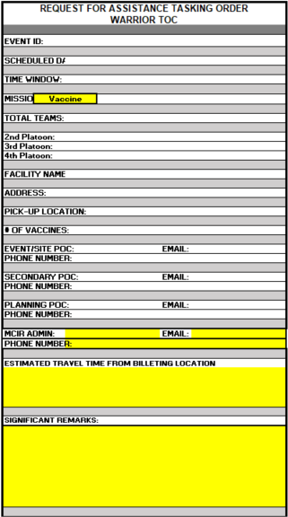
Request For Assistance Tasking Orders are a visually formatted directive broken down by type. Information to fill out the RFATO is pooled from the CVP and Site Survey, and if applicable, any Emails. The missions that are organic (originating from military rather than civilian entities) and do not require the health department involvement will not be found on the CVP such as any National Guard, Medical Detachment, or Air National Guard missions. RFATOs for those missions will be built from direct contact with those entities.

Vaccine RFATO
- Event ID is DHHS generated number found on the CVP.
- Scheduled Date refers to the Clinic Date set up by the call center. This will be found in the area in blue in the CVP.
- Total Teams how many teams total.
- 2nd, 3rd and 4th platoon section is how many teams per platoon.
Total teams could be 3 but you could have 2 teams from 2nd and 1 team from third platoon.
- Facility name is the Site name on the CVP
- Address is the Facility Address
- Pick Up Location is the address of the Health Department where the vaccines are picked up, confirm with Call Center if needed. Not on CVP.
- Number of Vaccines
- Event Site POC The name of the person that will be on site. Best practices for this are to leave it undetermined until a 24 hour ahead confirmation is conducted due to the time of scheduling and the time of clinic can be days and sometimes weeks ahead.
- Secondary POC is often the owner or managing supervisor in charge of the location.
- Planning POC is who was contacted during the site survey
- MCIR is Health Department.
- Estimated Travel Time is easiest occurred by going to google maps, cutting and pasting the map into the provided box.
- Significant Remarks: Any pertinent information gathered during the site visit, the Call center remarks, emails, calls. It can include information specific to site, patients, roads, or health department.

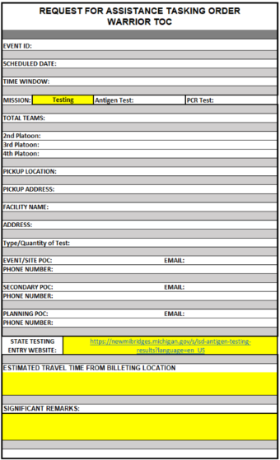
Testing RFATO
- Antigen or PCR test: information requested by the site at the time of scheduling. This information will be listed in Call Center remarks box
- State Testing Entry Website: (Used for Testing or Dual Mission RFATO only) Results of the Testing are entered either by the Team, the Health Dept, or the site dependent upon the agreed instructions. Whoever is entering the information must have valid authority to do so granted by DHHS.

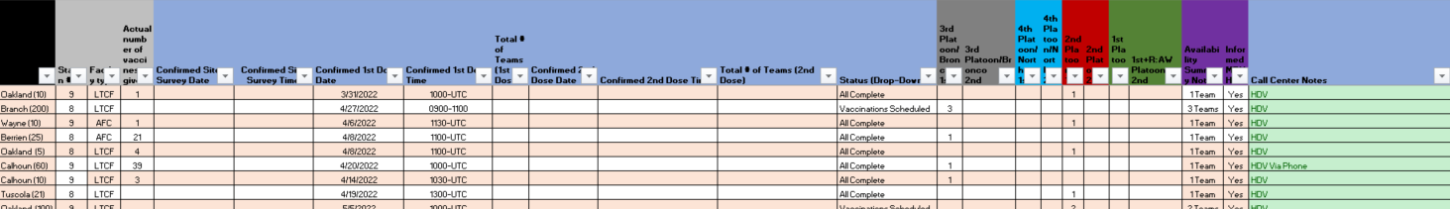
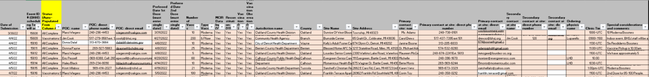
Appendices

SVQ
EVENT ID: | XXXXX |  | SITE:
 |  |  | ADDRESS
DATE OF SITE VISIT |  |  |  |  | TIME
PRIMARY POINT OF CONTACT (PLANNING)
NAME |  |  |  |  | PHONE
EMAIL
EVENT SITE-SPECIFIC CONTACT INFORMATION
NAME |  |  |  |  | PHONE
EMAIL
SECONDARY CONTACT AT SITE
NAME |  |  |  |  | PHONE
EMAIL
TIMING OF SUPPORT REQUESTED—MUST CONFIRM WITH FACILITY
***CALL FUOPs IMMEDIATELY IF ANY DISCPRECANCIES***
FIRST DOSE DATE |  |  |  |  | TIME
SECOND DOSE DATE |  | - |  |  | TIME | -
TEAMS ALLOCATED PER EVENT
 |  | 1ST DOSE | 2nd DOSE
TOTAL TEAMS |  | - | -
 |  | - | -
1PLT |  | - | -
2PLT |  | - | -
3PLT |  | - | -
4PLT |  | - | -
LEVEL OF SUPPORT REQUESTED
NUMBER OF VACCINES |  |  |  |  | TYPE OF VACCINE
TYPE(S) OF SUPPORT REQUESTED
MCIR DATA INPUT |  |  |  |  |  | RECONSTITUTION
VACCINATION |  |  |  |  | POST VACCINATION OBSERVATION
MCIR ADMIN NAME
EMAIL
PHONE NUMBER
VACCINATION INFO
1. Our public affairs office may send a photographer to take pictures and/or video to do a story and will make sure anyone photographed receiving the vaccine is not identifiable. Does the facility consent?
2. Additional comments/concerns from call center for Site Visit team's awareness

Site Survey
The more detail the better. This should be done not more than two weeks away from the event.
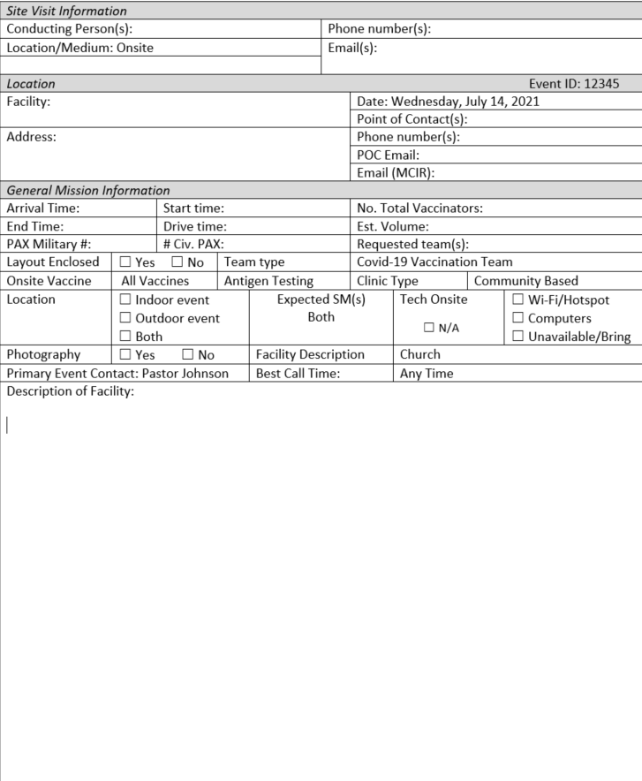
References

