STANDARD OPERATING PROCEEDURE
(SOP)
TOC/ CALL CENTER
TF SPARTAN

Effective Date: 20 April 2022

THIS SOP SUPERSEDES ALL PREVIOUS EDITIONS

Contents
STANDARD OPERATING PROCEEDURE 1
1 Overview: (Header 1) 4
1.1 Section Functions: (Header 2) 4
1.2 Roles and Duties (Header 2) 4
1.2.1 Position title #1 (Header 3) 4
1.2.2 Position title # 2 (Header 3) 4
1.3 Products: (Header 2) 4
1.3.1 Product 1: (Header 3) 4
1.3.2 Product 2: (Header 3) 4
1.4 Resources: (Header 2) 4
1.4.1 Resource 1: 4
1.4.2 Resource 2: 4
2 Taskings Work Flow 5
2.1 Products and taskings 5
3 Appendices: 5
3.1 Appendix A 5
3.2 Appendix B 5

This page left intentionally blank

Section Functions:
The Call center works directly with local health departments, as well as MDHHS to mitigate suffering caused by SARS-COVID-19 within the community. The Call Centers works as a bridge between health care facilities, local health departments, and the Army National Guard. The Call Center also ensures the health and wellness of the RFSC building, by providing COVID-19 testing to all personal within the facility.

Roles and Duties

Call Center NCOIC
The Call center NCOIC ensures all events are coordinated with the local health departments, MDHHS, and potential site. NCOIC meets with FUOPS Team in order to find potential dates and times for any specific section and if necessary, schedules the Site Survey.

Call Center Agent
Personnel will respond to requests and add to the CVP, as well as maintain a steady stream of work. Personnel will also scrub the CVP against the SYNC matrix to make sure dates and times of clinics are correct, as well as fill out the event ID’s and SVQ’s. Lastly, NCO under NCOIC performs regular checks to ensure NCOIC is maintaining clear and open disunion with MDHHS and local health departments.

Products:

Product 1: Reports
Call Center sends reports to MDHHS to show the Army National Guard’s progression. These reports highlight MDOC and Long Term Care Facility (LTCF). These reports are often informal or part of the CVP product which will be gone into later.

CVP:

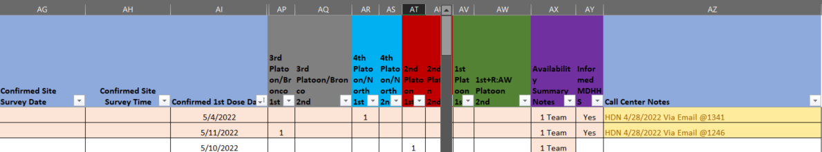

Resources:

SVQ
SVQ (Site Visit Questionnaire) allows our ground teams to have crucial information to properly plan and coordinate events. This is the first step to allow our medics to administer lifesaving vaccines to those who are the most vulnerable. The SVQ is obtained prior to visiting any state regulated facility and all information is obtained by the Call Center in conjunction with local health departments. The SVQ is then used to create FUOPS’s RATFO, as well as a direct link for our ground teams.

Event ID
The event ID is generated via the Call Center, to send local health departments and MDHHS. This is the first step in requesting lifesaving vaccines from local entities. This is then put on the state ran CVP for record keeping. Lastly, event ID’s are a historical record of requested vaccines and vaccines amounts.

Tasking’s Work Flow

Products and Taskings

MDHHS Call list:

