STANDARD OPERATING PROCEEDURE
(SOP)
S1 Section
TF SPARTAN

Effective Date: 20 April 2022

THIS SOP SUPERSEDES ALL PREVIOUS EDITIONS

Contents
1 Overview: 4
1.1 Section Functions: 4
1.2 Roles and Duties 4
1.2.1 S1 OIC 4
1.2.2 S1 Specialist 5
1.3 Products: (Header 2) 6
1.3.1 Product 1: (Header 3) 6
1.3.2 Product 2: (Header 3) 6
1.4 Resources: (Header 2) 6
1.4.1 Resource 1: 6
1.4.2 Resource 2: 6
2 Tasking’s Work Flow 7
2.1 Products and taskings 7
3 Appendices: 7
3.1 Appendix A 7
3.2 Appendix B 7

This page left intentionally blank

Section Functions:
The S1 Section manages all administrative functions within the task force as it relates to personnel. The S1 section coordinates, manages and reports to the JSTAFF and MSC. The sections screens, interviews and onboards all personnel through Joint, Reception, Staging, Onward, and Integration (JRSOI) processes. The S1 section also coordinates all aspects of personnel services, finance services, chaplaincy activities, command information services, and legal services support as needed within the task force.
As a section S1 will perform the following duties:
Maintain a daily/Weekly Battle Rhythm:
- Manage JPERSTAT due to the J1 staff mailbox by 1000: ng.mi.miarng.mbx.j1-jointstaff@mail.mil and POC as specified.
- Weekly leaders call in on M, W, F at 1100: 571-481-7100, 1107#, 321987#
- Leave Tracker manager for all soldiers on mission after approval by TF OIC to include tracking leave, correcting leave, signing leave in/out, approving new profiles and archiving all DA Form 31’s
- Due: 1100 Monday’s 63rdTC folder > COVID-19 > TF Spartan> CUOPS folder> Weekly Stats)

- DTS Approving Official for Task Force Spartan
- DTS NDEA for Task Force Spartan
- Approve all DTS vouchers submitted on Task Force Spartan
- Create and manage CEW’s to submit to the J3 and all MSC’s
- Manage all personnel rosters, to include filling vacancies
- Manage and coordinate all JRSOI’s/R-JRSOI’s. To include the sponsors, time, date and location of event ahead of each event.
- Calculate leave balances for every soldier ahead of each R-JRSOI event
- Coordinate remote PDHA reviews with a provider ahead of each R-JRSOI event
- Coordinate electronic COVID Questionnaires for provider review ahead of each R-JRSOI event
- Coordinate electronic DD 214 requests with J1 personnel for processing as a part of the R-JRSOI packet
- Submit all electronic R-JRSOI items to J1 staff mailbox or designated location: ng.mi.miarng.mbx.j1-jointstaff@mail.mil
- Create and manage awards for all soldiers on Task Force Spartan on a DA Form 638
- Create and manage Certificate of Achievements/Appreciations for soldiers, airmen civilian personnel
- Create and manage award memos for all soldiers on Task Force Spartan
- Assist with soldier promotion items, such as 4100 & ERB/SRB reviews
- Aid in resolving soldier pay problems with all MSC’s
- Coordinate soldiers pay problems with USPFO personnel
- Manage all soldier hardships/counseling statements via a DA Form 4187
- Coordinate soldier interventions with the Chaplain
- Manage all personnel actions via a DA Form 4187 and submit accordingly
- Manage and oversee two S1 assistants
- Report directly to CSM with any changes to Admin functions or needs.
- Provide available personnel information to FUOPS/COUPS
- Task teams with required items due to the S1 for personnel management, such as TF wide MWR event roll-ups
- Assist teams with all personnel problems with no limitations
- Coordinate LOD’s and medical issues that arise for soldiers on the mission with MSC’s
- Coordinate and assist with REDCROSS messages as needed and report information to JOC
- Manage MEDPROS for Medical Readiness
- Organize MRE events with OSS to ensure all soldiers are in the green
- Maintain applicable state permissions for IPPS-A, iPERMS, MEDPROS, DTMS, MOBCOP/DAMPS via “New SAAR Application Program @: https://midpcwebapps.ng.ds.army.mil/SAARWEB/Pages/Home.aspx
- Conduct weekly/as needed Platoon/63rd Troop Command/site visits to resolve S1 issues for soldiers on ground, including award and certificate coordination updates
Create federal/state award memos with complete soldier rosters submitted to all MSC’s for applicable ribbons such as COVID Response Ribbon, Armed Forces Service Ribbon, State Active-Duty ribbon

Roles and Duties

S1 OIC
The OIC manages all administrative functions for the task force by overseeing, delegating functions to two S1 Clerks as well as developing practices and processes to predict, facilitate and react to all personnel needs for the task force. The following are some of the many functions conducted by the S1 OIC. Supervise duties at the preceding skill levels with broad ranging responsibilities, regardless of specific position or assignment. In addition to those mission specific priorities and requirements by the Senior Commander and the J/G-1, there are general requirements must monitor and execute in order to ensure the health of organizations, and development and growth of the future enlisted leaders.
Provide direct mentorship to S1s, provide training, guidance and oversight to platoon’s (within the task force’s area of operation), maintain external relationships outside of the task force.

S1 Specialist
Duties entail using the defense travel system (DTS) to processes soldiers per diem and lodging expenses. Using training and deep understanding of DTS we create authorizations and vouchers. First, we must determine the location where soldiers will be staying at for the duration of the mission. Next, we must submit an entitlement memo that states that soldiers are entitled to having per diem, lodging, and travel paid out to them. We also submit a cost estimate work sheet (CEW), which explains the projected expenses of mission from each soldier. Then, we ensure all soldiers are receiving the allotted per diem amount with in the per diem page of DTS. Next we determine proper Line of Accounting (LOA) for this mission. The step following the previous includes, adding justification for any flagged items for the trip. Lastly, we ensure the routing list is TF SPARTAN and submit the authorization.

Once the Authorization is approved, the task is to create a voucher for a soldier to sign. The first step is to edit the soldier’s itinerary if they traveled between multiple hotels, such as from Lansing to Okemos. We then enter the lodging expenses using the receipts that are supplied by the soldier, which includes hotel cost and taxes. In some situations a soldier needs a signed a locally produced AEA worksheet (Actual Expense Allowance) if the hotel expenses exceed the allotted lodging amount. Then we must edit the per diem page to ensure each soldier is receiving their entitled per diem amount. The next step is to verify the proper distribution of reimbursement between the GTCC and the soldier’s personal bank account. Then, justify all flagged items for the trip. Lastly, the soldier will sign and submit the voucher using their CAC.

Products:

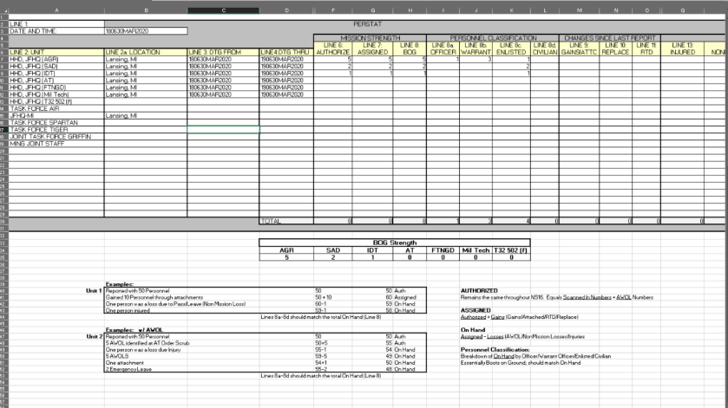
Product 1: PERSTAT
LINE 1 — DATE AND TIME (DTG)
LINE 2 — UNIT (Unit Making Report)
LINE 3 — FROM (DTG for the Beginning of Period Applying to Personnel Information)
LINE 4 — TO (DTG for the End of Report Period)
LINE 5 — UNIT (Designation of the Unit for Which the Personnel Status Information is Being Submitted)
Figure 1: PERSTAT
LINE 6 — AUTHORIZED (Number of Personnel Authorized by Personnel Classification)
LINE 7 — ASSIGNED (Number of Personnel Assigned by Personnel Classification)
LINE 8 — ON HAND (Number of Personnel Authorized by Personnel Classification)
LINE 9 — GAINS(Number of Personnel Gains by Personnel Classification)
LINE 10 — REPLACEMENTS (Number of Personnel Gained That Are Replacements by Personnel Classification)
LINE 11 — RETURNED TO DUTY (Number of Personnel Gained That Have Been Returned to Duty Through Medical Channels by Personnel Classification)
LINE 13 — WOUNDED (Number of WIA by Personnel Classification)
LINE 14 — NONMISSION LOSS___________________________(Number of NON MISSION RELATED Injury Loss by Personnel Classification)

LINE 17 — AWOL______________________________________(Number Absent Without Leave by Personnel
Classification)

Product 2: Cost Estimate Worksheet
(only when there is an extension or an additional to the CEW)
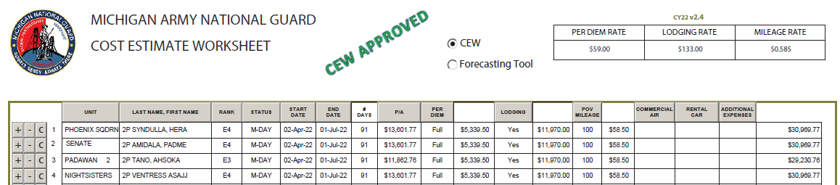
Figure 2 CEW

Product 3: JRSOI Packet
(GOVCC, valid ID card, DTS authorization, leave tracker profile, PCR testing)

Product 4: R-JRSOI Packet
(DA31, DD 214 Request FORM, Covid Risk Evaluation Questionnaire, DD 4187, DA1561, PDHA #2795)

Product 5: Downgrade Plan
(When downgrade is approaching)

Tasking’s Work Flow

Products and taskings
This is where you go step by step for each product you create and each tasking you fulfill. Here you can add illustrations etc and break down to the details and functions.

Appendices:

Appendix A
If you need to break down into more explanations this is where you do so
- Leave process Each SM on the TF should have a leave profile initiated in the leave tracker by the platoon leader. No SM is to submit their own leave into the leave tracker. Each leave is to be submitted on a DA31 FORM to be approved/disapproved by the platoon leader. Sent to the TF OIC and CC’d the S1 section once approved by the TF OIC the SM’s leave is then entered into the leave tracker by the S1 personnel.
- Volunteer Roster Process
  - Obtain the monthly volunteer roster from J1
  - Scrub list for potential volunteers
  - Contact volunteers to find out what their capabilities are for the mission (interview solider).
- JRSOI Process (Checklist included)
  - Obtain location, date and time of event
  - Construct roster from volunteer roster sent from J1 or other known sources
  - Coordinate sponsors to participant in event
  - Hold event with available sponsors of required in-briefings and required needed onboarding documents/requirements, etc
- R-JRSOI Process (Checklist Included)
  - Obtain location, date and time of event
  - Construct roster of those redeploying
  - Coordinate sponsors to participant in event
  - Hold event with available sponsors of briefings, etc
  - Provide a guide/checklist of documents and instructions and a location to put all required documentations
  - PATH FOR R-JRSOI DOCUMENTS during the Downgrade phase (PLZ CREATE {1} INDIVIDUAL FOLDER PER SM PER PLT)
O:\COVID-19\TF Spartan Reports\S1\DO-OUTS (PLT's ~ S1 business)

- CEW Process (Include current CEW document) once you get the go ahead to create, change or proceed with a CEW you verify and place all the names that will be included on the CEW and send to G3, JOC, for approval and CC’ J1 and TF command for situational awareness. 2. Wait for approval. Once you receive approval on the CEW 3. Send out the CEW, the JRSOI roster with the location, time and date that the JRSOI will take place. POCs for the CEW after it has been approved will then be forwarded to/without limits: All MSC’s, *NOTE: the JRSOI/RJRSOI are a J/G1 function and may be conducted as such. If so, this process will be obsolete.
- Extension process:
  - Find out who is willing to extend if an extension is deemed
  - Received the presidential memo
  - Construct the CEW based on the final roster of those extending
  - Send CEW for approval
  - Send CEW to brigades and MSCs to produce orders of the SMs that are a part of their Brigade
- DTS process/guidance
- Safety Award process
- COA certificate process (Include Example Template)
- Manage Weekly Sync Matrix by 1100 via O:Drive to the following path, due: 1100 Mondays at the following path within the O:Drive : 63rdTC folder > COVID-19 > TF Spartan> CUOPS folder> Weekly Stats) tallying the following numbers from Monday to Monday:
  - How many awards processed in numbers
  - How many leave forms processed in numbers
  - DTS-Authorizations/Vouchers in numbers
  - Pay problems resolved in numbers

Appendix B
References or websites, or file paths, research, CDC Guidance links, etc can go here.

Additional topics:

