STANDARD OPERATING PROCEEDURE
(SOP)
3rd PLT
TF SPARTAN

Effective Date: 20 April 2022

THIS SOP SUPERSEDES ALL PREVIOUS EDITIONS

Contents
STANDARD OPERATING PROCEEDURE 1
1 Overview: 5
1.1 Platoon Functions: 5
1.2 Roles and Duties 5
1.2.1 PLT OIC 5
1.2.2 PLT NCOIC 5
1.2.3 PLT S1 5
1.3 PLT S4 5
1.4 CVTT (COVID Vaccine/Testing Team) 6
1.4.1 GP – General Purpose Soldier, a Solider on a CVTT who a medical MOS is not, rank is typically E-5 and below but could be higher. 6
1.4.2 Administrator – a qualified medical professional, civilian or military (65D, 68W, 4N) who is putting needles in arms at a site 6
1.5 PLT Products: 6
1.5.1 Daily Mission Tracker (excel spreadsheet) 6
1.5.2 Daily Mission Tracker (white board) 6
1.5.3 Fuel Log (Excel Spreadsheet) 6
1.5.4 Personnel Accounting and Strength Reporting (PERSTAT) 6
1.5.5 MCIR (Michigan Care Improvement Registry) 7
is the state-wide database for tracking vaccinations. 7
1.5.6 Michigan Antigen Testing Results (website) 7
1.5.7 PPE Report (Excel Spreadsheet) 7
1.5.8 LOGSTAT and SUR ((Supply usage report) Excel Spreadsheets) 7
1.5.9 SUR (Supply Usage Report) 7
1.5.10 Vehicle Mileage (Excel Spreadsheet) 7
1.5.11 DTS Reconciliation 7
1.5.12 Leave Tracker 7
1.6 Resources: (Header 2) 7
1.6.1 Resource 1: 7
1.6.2 Resource 2: 7
2 Taskings Work Flow 8
2.1 Products and taskings 8
2.2 MICR 8
2.3 Michigan Antigen Test Results 8
2.4 Appendix A 15
2.5 Appendix B 15

This page left intentionally blank

Overview:

Platoon Functions:
Platoon Functions: To implement guidance from higher command structure on Covid 19 mitigation policies to include Field Hospital Support, Covid 19 antigen and PCR testing, and vaccinations of Michiganders in support of local Health Departments under the direction of the Michigan Department of Health.

Roles and Duties

PLT OIC
To ensure Command and Control of personnel assigned and coordinate with Command Staff any issues of upcoming as well as ongoing missions, ensure medical guidance and updates are relayed in a timely manner to support teams. Ensure all CCIR’s are reported and updated as needed in accordance with Commander’s Directives. Monitor all future missions and ongoing missions to ensure fluid operations. Oversee and take responsibility of C2 cell working under his/her directions. Maintain and evaluate the morale and welfare of all personnel assigned to platoon.

PLT NCOIC
Responsibilities include the managing and supervision of CVTT teams and C2 staff. Ensuring good work flow in the TOC. Oversee the S1 section to ensure proper PERSTAT and other administrative functions are followed. Oversee the S4 section ensuring vehicle accountability and proper reports submission. Input data as necessary to Dashboard. Maintain and monitor lodging facility activities and movement. Leave Slips

PLT S1
ensure proper PERSTAT and other administrative functions are followed. Monthly DTS vouchers and authorizations for Platoon. R-JRSOI Documents for soldiers coming off mission. Managing Synch Matrix with SM Leave, drill, and appointment dates. Ensuring Perstat is complete and accurate each day. Address any pay issues and making sure they're resolved in a timely manner. Making sure soldiers are up to date with certificates and training for missions. Monthly DTS vouchers and authorizations for Platoon.
R-JRSOI Documents for soldiers coming off mission. Managing Synch Matrix with SM Leave, drill, and appointment dates. Ensuring Perstat is complete and accurate each day.

PLT S4
Ensuring vehicle accountability and proper reports submission Hand receipt holder for every piece of equipment issued to the platoon. Maintain contact with teams leads to be sure that have proper PPE and equipment for missions i.e., tent, table, laptop, cellphone and cooler/freezer if needed etc. Manage and maintain LOGTAGS for the coolers/freezers. Maintain contact with Spartan S4 if more supplies need to be drawn or a vehicle issue arises i.e., contract issues, accidents, etc. Maintain contact with team leads and Belle Tire to check and see when vehicles can get serviced i.e., oil change, new tires etc. Keeping track of the expiration date of all testing equipment and returning expired tests to Spartan S4 so that in can be properly discarded. Daily reporting of PPE on hand and Vehicle mileage that goes to Spartan S4 and then to the J4. Weekly reporting of the LOGSTAT and SUR (Supply usage report) that goes to Spartan S4 then to the J4. Building and completing the teams and C2's fuel logs at the beginning of the month which goes to Spartan S4 then to the J4.

CVTT (COVID Vaccine/Testing Team)
General purpose workers and trained and medically supervised vaccine administrators

GP
General Purpose Soldier, a Solider on a CVTT who a medical MOS is not, rank is typically E-5 and below but could be higher.

Administrator
a qualified medical professional, civilian or military (65D, 68W, 4N) who is putting needles in arms at a site

PLT Products:

Daily Mission Tracker (excel spreadsheet)
Is a shared excel spreadsheet document created to track the number of COVID test (pos or neg) (antigen or PCR), and number of vaccines and type.

Daily Mission Tracker (white board)
Is a handmade weekly Calendar made and updated daily to give real information foresight for CVTTs and C2 staff with current and future missions.

Fuel Log (Excel Spreadsheet)
Fuel Log is a document in which all rental vehicle receipts are compiled together per vehicle and audited against the State Activity Report. Missing/incomplete receipts are accompanied by a memorandum signed by the card holder. The order of the document goes fuel log, all fuel receipts in order by date, state activity report, memorandum if required, credit card agreement signed by supervisor and SM, and lastly the User agreement signed by supervisor and SM. The Fuel Log is compiled once the State Activity Report is released by the J4 and the completed document is due back to Spartan S4 by the 5th of the month, every month.

Personnel Accounting and Strength Reporting (PERSTAT)
Monitoring platoon personnel on leave, Inactive Duty Training and Appointments to accurately convey platoon strength and capabilities.

MCIR (Michigan Care Improvement Registry)

is the state-wide database for tracking vaccinations.

Michigan Antigen Testing Results (website)
Is a website the Michigan National Guard ustilize to input all data from antigen testing

PPE Report (Excel Spreadsheet)
PPE Report is a master list of all PPE on hand in supply. It is updated as supplies are pulled and issued to the teams Monday through Friday and is sent to Spartan S4 before 0800 Monday through Friday who then compiles it with their Master PPE Report and sends it to the J4.

LOGSTAT and SUR ((Supply usage report) Excel Spreadsheets)
LOGSTAT is used for tracking test kit information, what is on hand and what is used weekly. The LOGSTAT is updated and saved weekly. Numbers in Line-5 are on hand in supply. Numbers in Line-15 are reported through Spartan S4 at the end of the week. Report is sent before 0800 every Monday morning to the Spartan S4 who then complies it with theirs and sends it to the J4 mailbox.

SUR (Supply Usage Report)
is a report which tracks all inventory received from the USPFO directly. It logs the expenditure of PPE as it is handed out to the teams from supply. The SUR is sent up every Monday morning before 0800 to Spartan S4 who then complies it with theirs and sends it up to the J4.

Vehicle Mileage (Excel Spreadsheet)
Vehicle Mileage is a master report of the platoon’s vehicles that is sorted by Emergency Fuel Card Number. It tracks who is signed for the fuel card, the vehicles plate number, Enterprise Unit numbers, Contract Location, VIN, Model, Make, Drivetrain as well as mileage and when the mileage was last reported. The mileage report is updated Monday through Friday and the report is sent to Spartan S4 before 0800 Monday through Friday who then compiles it with theirs and sends it up to the J4. On Monday mornings in addition to the report the total mileage across all vehicles is reported to Spartan S4.

DTS Reconciliation
Reviewing service member DTS vouchers to include, expenses, expense dates, and per diem rates. Uploading supporting documents and proper authorizations so that service members had a quick DTS authorization and pay out.

Leave Tracker
Monitoring DA-31's sent up the chain of command on behalf of third platoon service members once signed off, adding the leave dates to the task force Sync Matrix.

Resources: (Header 2)

Resource 1:
What information are you pulling from? Who pulls this information? Like products, this is a generality listed as a section resource. If specific authorizations or positions are necessary to gain access to the resource please go over that here.

Resource 2:
Add as many resources as possible

Taskings Work Flow

Products and Taskings
This is where you go step by step for each product you create and each tasking you fulfill. Here you can add illustrations etc and break down to the details and functions.

MICR
The most efficient way to do MICR entry is to have a person sitting next to the patient while they injection site is prepped, and final screening questions asked. This eliminates handwriting errors, time to hand fill forms, and moving forms around a site. MICR entry off of an already filled out paper or verbally from the patient takes an almost identical amount of time to administering a shot. When there is a good alance of shots to MICR entry personnel, MICR entry in a different room than shots are administered can work. A significant number of Michigan residents do not have any MICR records on file, so creating a MICR profile for them takes a couple extra minutes. Appendices:

Michigan Antigen Test Results
https://newmibridges.michigan.gov/

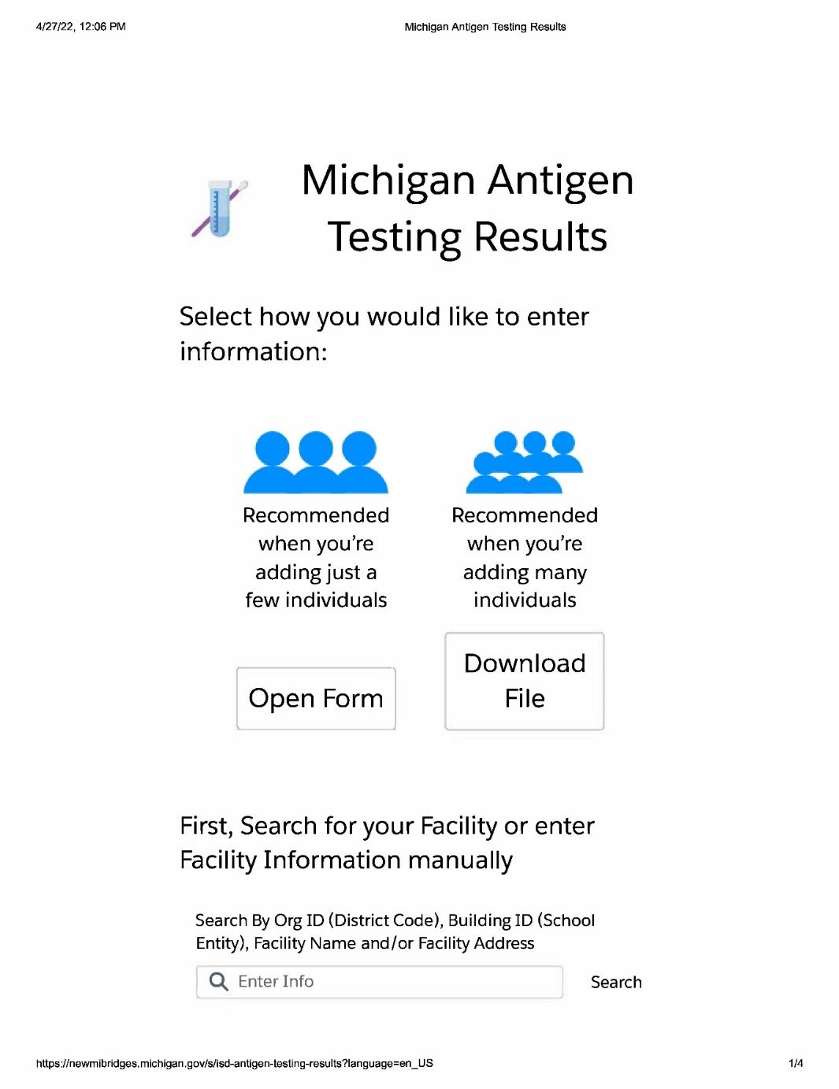

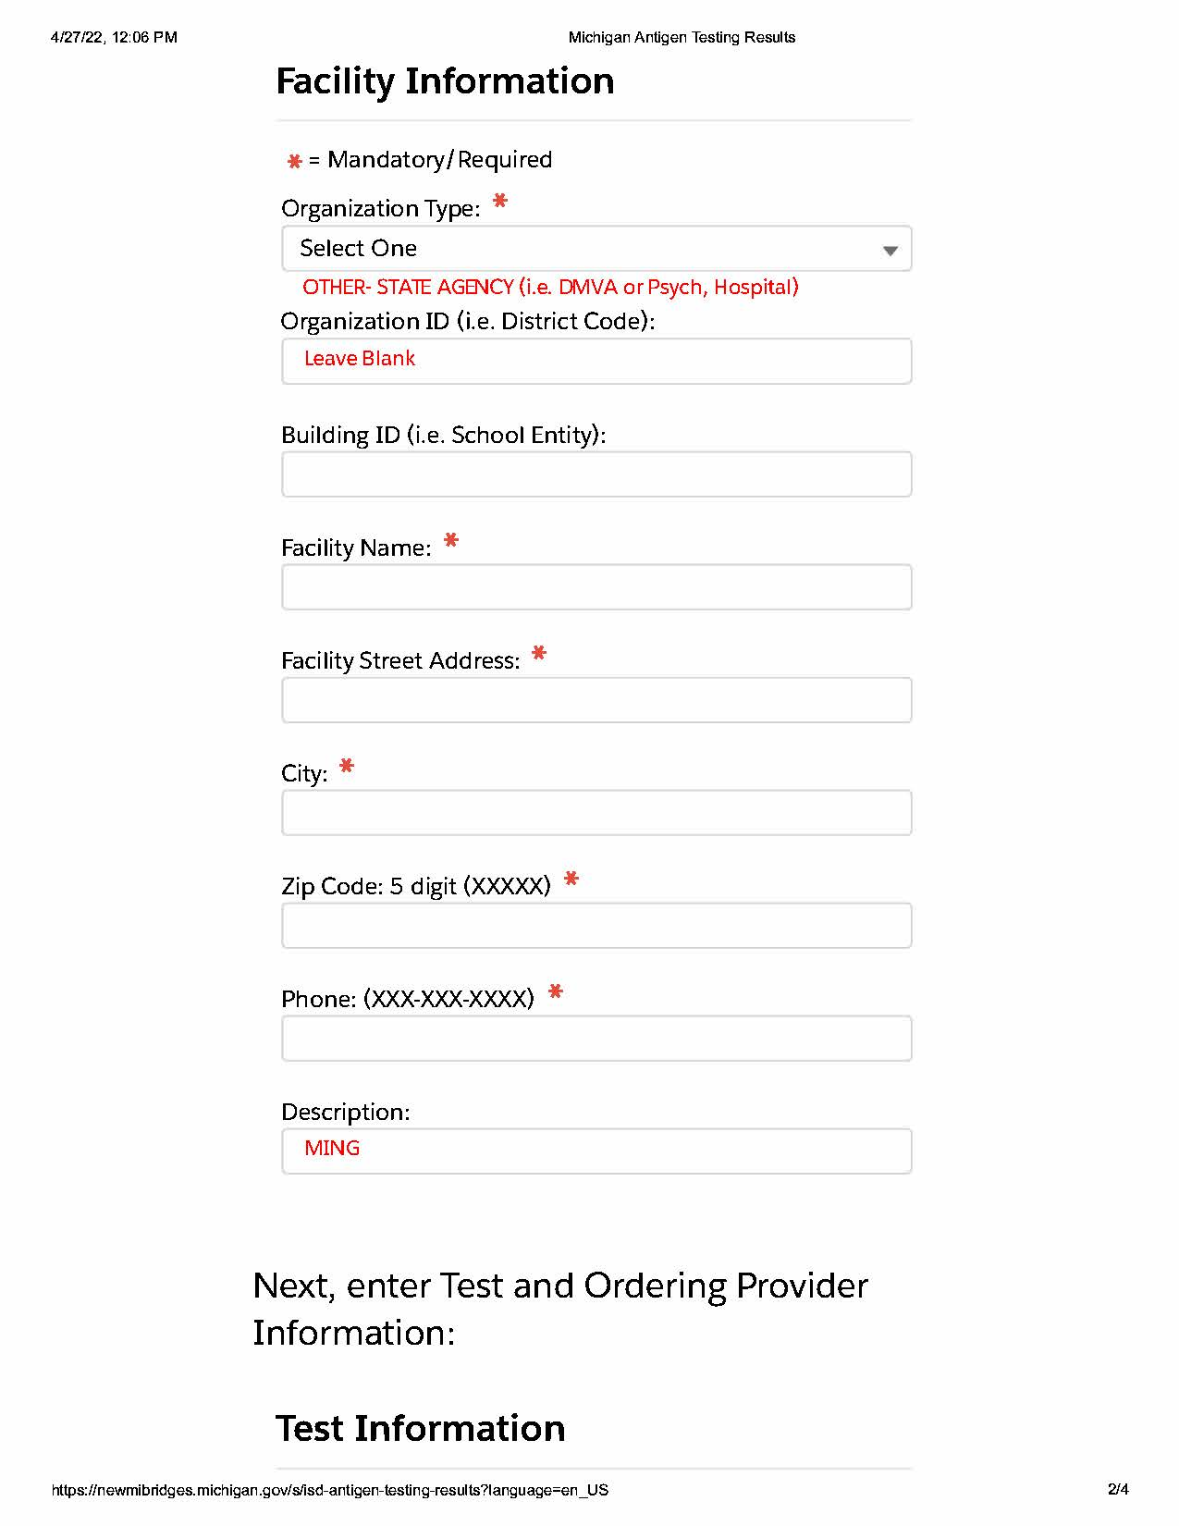

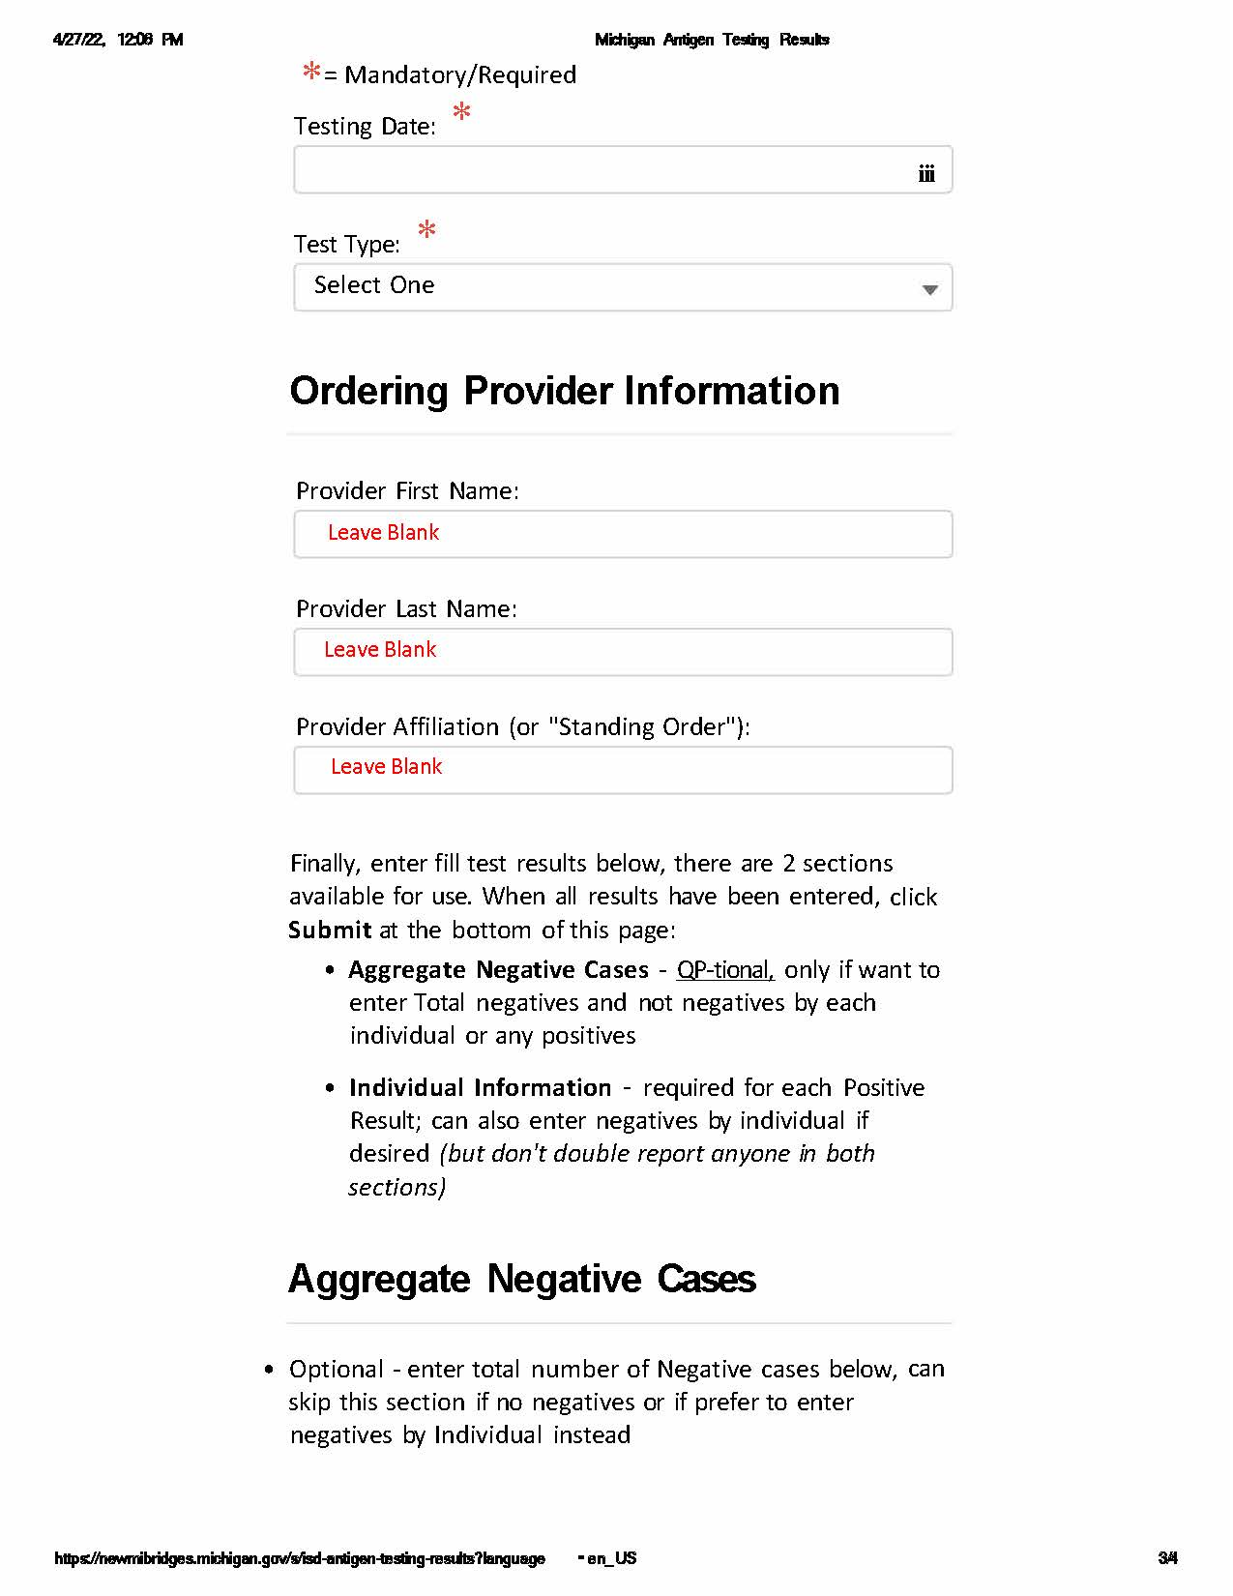
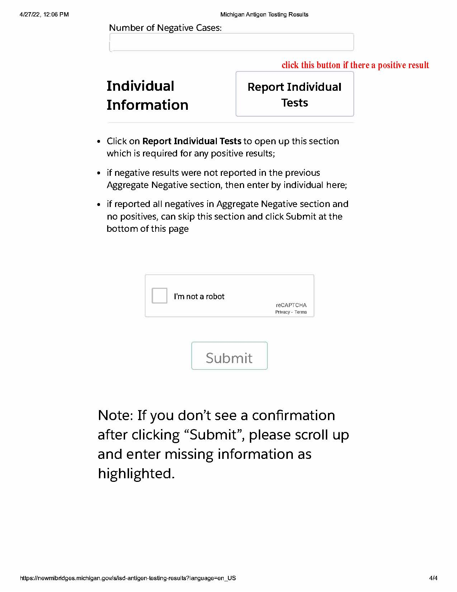

Appendix A

Appendix B
References or websites, or file paths, research, CDC Guidance links, etc can go here.

