STANDARD OPERATING PROCEEDURE
(SOP)
2nd Platoon
TF SPARTAN

Effective Date: 20 April 2022

THIS SOP SUPERSEDES ALL PREVIOUS EDITIONS

STANDARD OPERATING PROCEEDURE
(SOP)
2nd Platoon
TF SPARTAN

Effective Date: 20 April 2022

THIS SOP SUPERSEDES ALL PREVIOUS EDITIONS

Contents
STANDARD OPERATING PROCEEDURE 1
1 Overview: (Header 1) 5
1.1 Platoon Command and Control (C2 Element) 5
1.2 Platoon Command and Control Roles and Duties 5
1.2.1 Officer-in-Charge (OIC) 5
1.2.2 Non-Commissioned Officer-in-Charge (NCOIC) 5
1.2.3 Operations Non-Commissioned Officer (NCO) 6
1.2.4 Supply and Logistics NCO 6
1.3 Covid-19 Vaccination and Testing Teams 6
1.3.1 Team Leads 6
1.3.2 General-Purpose Personnel 7
1.3.3 Medics 7
1.4 Products 7
1.4.1 Daily Mission Tracker 7
1.4.2 Personnel Status Report (PERSTAT) 7
1.4.3 Personal Protective Equipment (PPE) Report 9
1.4.4 Michigan Care Improvement Registry (MCIR) 9
1.4.5 Michigan Antigen Reporting 9
1.4.6 Logistical Situation Report/LOGSITREP (LOGSTAT) 9
1.4.7 Vehicle Mileage Report 9
1.4.8 Leave Tracker 10
1.5 Resources 10
1.5.1 Centers for Disease Control and Prevention (CDC) 10
1.5.2 Emergency Use Authorization (EUA) 10
1.5.3 Food and Drug Administration (FDA) 10
2 Tasking’s Workflow 10
2.1 Products and taskings 10
3 Appendices: 10
3.1 Appendix A 10
3.2 Appendix B 10

This page left intentionally blank

Overview: (Header 1)

Platoon Command and Control (C2 Element)
The C2 cell element comprises an OIC, a NCOIC, a supply specialist, and a quality control specialist, that conducts site reconnaissance, and field observation. The C2 cell element is also responsible for personnel tracking, soldier health and welfare, accountability of equipment, and regular equipment maintenance. Each role within the C2 cell element is vital for platoon success, such as maintaining individual training requirements and mission essential training.

Platoon Command and Control Roles and Duties

Officer-in-Charge (OIC)
The OIC reports directly to the Task Force command. The daily reporting comprises PERSTAT (personnel status), vehicle mileage, vehicle fuel use, mission readiness, and platoon status. The OIC is also responsible for projecting vaccination, testing, and courier events. In the event of injury, illness or death involving personnel, the OIC completes a CCIR (Commanders Critical Information Requirement) and receiving Red Cross messages. In the event of an accident, or damage to vehicles or equipment, the OIC completes an AGAR (US Army Abbreviated Ground Accident Report, DA Form 285-AB). Besides these reports, the OIC writes awards and accommodations, reporting mission specific concerns, conducting weekly platoon meetings, and taking part in Task Force conference calls. Covering and scheduling various personnel actions, such as leave and appointments.
- Send the PERSTAT report daily to the S1 at the required time. PERSTAT information comprises SMs full name, rank, DODID, SMs position (vaccinator, general purpose, C2), order start date, MOS, and assigned unit. The PERSTAT also comprises mission status: on mission, SRP, AT, IDT, pass, leave, school, other, and non-mission loss. (See Appendix B, Image 1.1).

Non-Commissioned Officer-in-Charge (NCOIC)
The NCOIC reports directly to the OIC. The NCOIC fills in for the OIC when needed to ensure PERSTAT (personnel status), vehicle mileage, vehicle fuel use, mission readiness, and platoon status are complete. The NCOIC uses the sync matrix daily to confirm current and upcoming events, as well as checking for updated RFATOs. The NCOIC also takes part in weekly meetings and participates in Task Force conference calls. The NCOIC is also responsible for confirming the covering of missions under scheduling various personnel actions, such as leave and appointments. The NCOIC communicates with vaccination and testing point of contacts. The NCOIC accomplishes communicating with sites by doing a 24-hour call ahead to confirm mission details. The 24hr call ahead comprises confirming the date, time, type of clinic, facility name, facility address, quantity of tests/vaccinations, on-site point of contact the day of the clinic and confirming if teams will conduct MCIR/entering testing data results. Besides the 24-hour call ahead, communication by the NCOIC via email for event specific details to ensure the clinic runs as smooth as possible. The NCOIC conducts daily mission briefs to teams to ensure mission readiness and success. If there is a discrepancy 24 hours ahead of time, the NCOIC communicates with the call center and FUOPS. If there is an issue on the day of operations, the NCOIC communicates with CUPOS.

Operations Non-Commissioned Officer (NCO)
The Operations NCO reports directly to the NCOIC and the OIC. Operations NCO provides support to teams at the site through training and supplying resources and guidance, particularly to nuances of vaccine products and testing. Supply guidance and material resources to administrative personnel before, during and after events. Complete event binders and update materials as necessary to remain current with the evolution of the events. Liaison between MING personnel and site administrators/coordinators to troubleshoot technical and procedural issues. Including handling quality control at local sites, ensuring personnel follow the policy, procedures, and protocols of the Task Force. Conduct site visits to different event locations to meet with personnel on ground and the site personnel. Operations NCO works in collaboration with site administrators/coordinators to improve processes and procedures at vaccination and testing events. Assist the NCOIC with the 24-hour call ahead to sites and site surveys as necessary.

Supply and Logistics NCO
The Supply and Logistics NCO tracks inventory and handles, supplying personnel with necessary equipment and materials. The Supply and Logistics NCO provides personal protective equipment (PPE) to teams, antigen tests and supplies, polymerase chain reaction (PCR) tests and supplies, track inventory of all supplies and equipment to teams, and tracking and managing duties regarding fleet vehicles. Picks up resupply of equipment and materials form the Task Force.
Fleet vehicle responsibilities include ensuring servicing requirements, exchanging fleet vehicles when applicable, and reporting inventory to the OIC. Reporting changes to fleet vehicles and inventory of supplies to the NCOIC and OIC. Supply and Logistics NCO manages expiration and disposal of unusable inventory.
The Supply and Logistics NCO conducts reporting to the OIC, NCOIC and the Task Force when necessary. Reports include the materials and equipment, personal protective equipment, office supplies and miscellaneous materials, antigen and PCR tests and auxiliary medical supplies. Completion of the daily report of vaccinations and tests conducted by the teams during the day. The report is then sent to the Task Force.

Covid-19 Vaccination and Testing Teams
Covid-19 Vaccination and Testing Teams (CVTT) consist of three personnel, the team lead, one general-purpose service member and one medic. CVTT teams is the component providing direct support to private and public sector testing and vaccination events. Teams work directly with the public providing point of care and building trust within the communities they serve.

Team Leads
Team leads coordinate health and welfare of team members, prepare teams for event requirements, arrive on time, maintaining equipment and materials, gathering personal protective equipment and miscellaneous supplies, and communicating subordinate concerns to the TOC. Leads communicate event departure times, arrival times and other event pertinent information. Team leads work with site coordinators/administrators to liaison between them and the platoon TOC. Team leads should maintain subordinate military professionalism and bearing, leading by example. The team leads to enforce the measures.
Team leads maintain fleet vehicles and complete all required paperwork. Team leads collect, maintain fuel receipts, service receipts and complete fuel logs to turn into the TOC at the end of the month. Team leads handle sensitive credit cards and ensuring they remain secure.
Team leads report daily vaccination and testing numbers to the TOC. Report changes at vaccination and testing events to the TOC and support sites with resolving issues, concerns, or complaints.

General-Purpose Personnel
General-purpose personnel were responsible for data entry input, lookup and assisting with corrections. General-purpose personnel throughout the operation would support traffic and foot traffic, direct patients through the vaccination or testing events, provide medical technician support for medics, run medical and miscellaneous supplies to various stations in the vaccination process. SMs operate Covid-19 mitigation screening to reduce the spread of the virus. Personnel help with the verification and completion of registration forms or other miscellaneous documents. General-purpose personnel in conjunction with medics will courier test and vaccines throughout the state. Service Members also support medical professionals through monitoring patients in the observation area. Working closely with the public and checking on how each patient feels. Personnel may provide additional technical and logistical support and guidance as requested.

Medics
Medics provide antigen, molecular assay testing, and vaccinations to the public. Medics provide support to the medical professionals and nurses at the vaccination events. Medics dilute and draw vaccine, maintain vaccine temperature, transport, and monitor coolers, monitor, and care for cold cubes and other miscellaneous auxiliary vaccine supplies. Medics support medical staff and personnel to implement and follow infection control measures. Medics prescreen patients to ensure they are eligible for a specific vaccine. Medics monitor patients in observation for adverse and/or allergic reactions to the vaccine. Medics may provide support to individuals who are experiencing allergic reactions or anxiety directly or indirectly regarding the vaccine. Medics may provide technical and medical guidance on layout or improving functioning of vaccination events. Medics work both indoor and outdoor events to provide point of care (POC) to the public.

Products

Daily Mission Tracker
Projection of week in advance on whiteboard of scheduling of teams, the site location and times. The schedule also to provide information to teams on changes to team dynamics for various reasons. Side information to contain Annual Trainings, mandatory training, leave, appointments and drill dates when applicable.

Personnel Status Report (PERSTAT)
The PERSTAT is the responsibility of the OIC or NCOIC of the platoon. The personnel status tracker for each platoon is on the consecutive tabs in the Excel workbook as the sync matrix. Purpose is to track and account for team personnel. Command and Control personnel can schedule personnel effectively to meet the needs of the event. The OIC or NCOIC should send the Perstat report to S1 every morning prior to 0900 hours. The information from the PERSTAT is additionally to help complete the report in during the 1100 leadership meeting.
The PERSTAT has three main parts, the PERSTAT, losses and the personnel roll-up each on separate spreadsheets in the Excel workbook. The first workbook in the PERSTAT includes summary information regarding the platoon. The PERSTAT separates grouping of information. The first group covers the unit identifier (platoon number or name), location of the platoon and the date range the PERSTAT. The second grouping covers mission strength exhibiting the number assigned personnel and the number of personnel total (BOG-Boots on Ground). The third grouping breaks down number of assigned personnel by personnel classification to include how many officers, warrant officers, enlisted and civilian personnel. Fourth grouping outlines changes since the last PERSTAT date range to include gaining personnel, replacement of personnel and number of personnel of personnel who have returned to duty (RTD). The last set of cells in the row includes losses from the platoon including personnel suffering injuries, personnel who reverse process off mission and those who are absent without leave (AWOL).
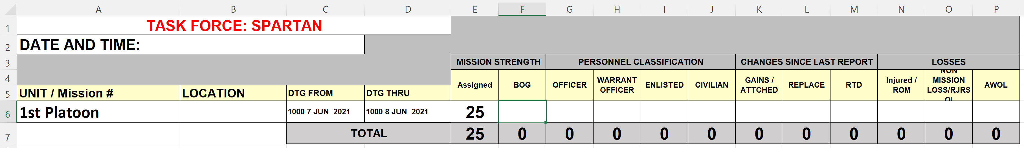
The second spreadsheet elaborates on losses from the mission. The injury, sickness and quarantine section lists the personnel and the exact reasoning for illness, injury or whether personnel is in quarantine. Non-mission loss which is loss due to new job positions or leaving mission for miscellaneous reasons. Enter personnel who are absent without leave and lastly the leave tracker segment. The segment covers specific personnel leave reasons, location, departure and return date.
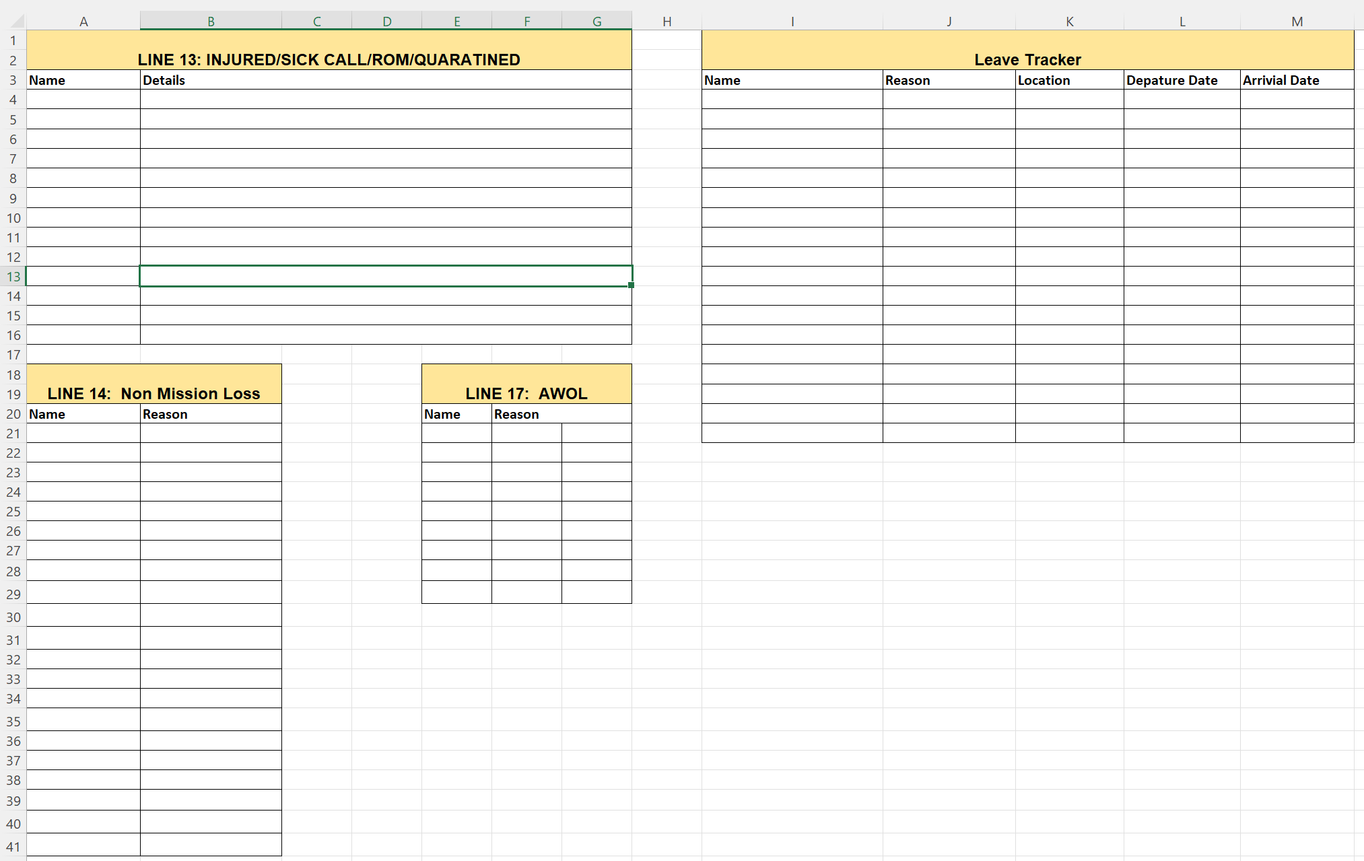
The final spreadsheet in the PERSTAT is the personnel roll-up. The roll-up comprises of service members full name, rank, Department of Defense identification number (DODID), service member’s position (vaccinator, general purpose, C2), order start date, Military Occupational Specialty (MOS), and assigned unit. The PERSTAT also comprises mission status: on mission, Soldier Readiness Program (SRP), Annual Training (AT), Inactive Duty Training (IDT), pass, leave, school, other, and non-mission loss.

Personal Protective Equipment (PPE) Report
The report tracks inventory of personal protective equipment, antigen and molecular assay tests the platoon has available. The report is due every morning prior to 0800 hours to the Task Force S4,
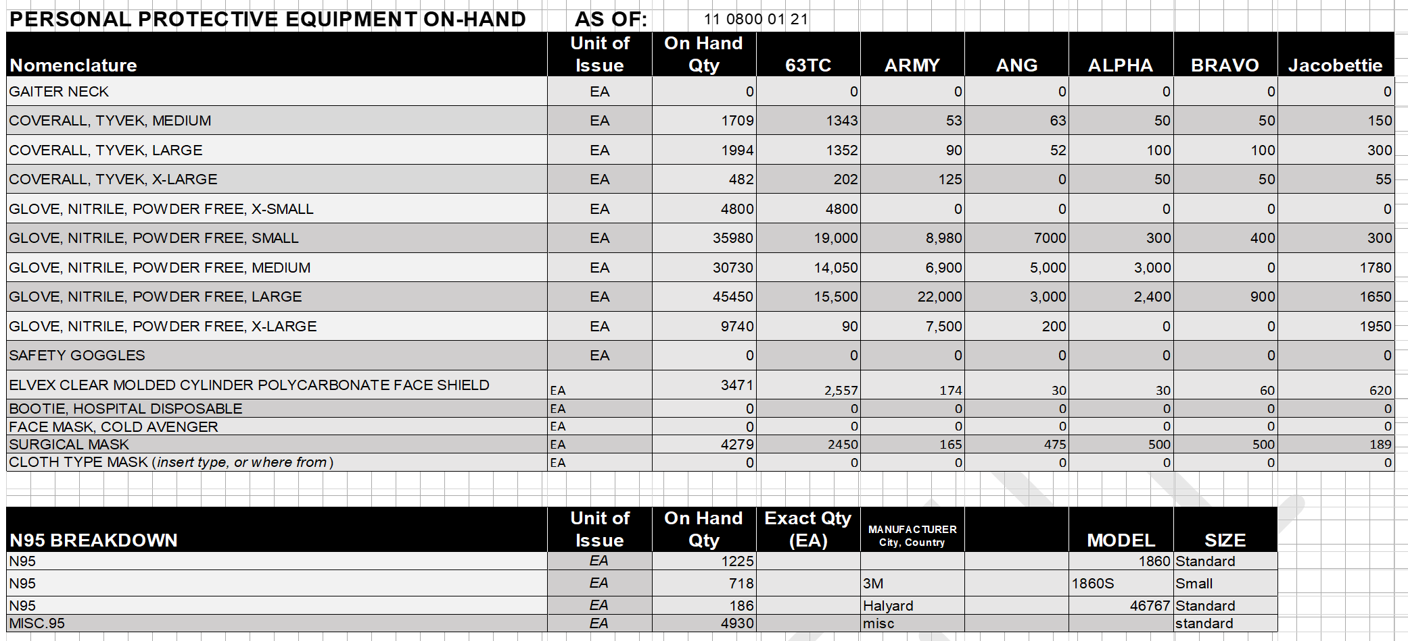

Michigan Care Improvement Registry (MCIR)
The Michigan Care Improvement Registry (MCIR) is an online state electronic medical record (EMR) system for tracking immunizations in the state of Michigan. General-purpose and authorized personnel request permission from site administrators to be able to enter dose and immunization record of patients. The website for MCIR is at the following link: https://mcir.org/.

Michigan Antigen Reporting
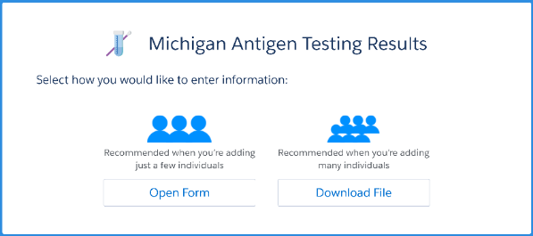
The online reporting tool design to conduct surveillance of the Covid-19 disease in Michigan. Reporting through manual case entry, through electronic laboratory reporting system or another system designed for reporting. When conducting Antigen testing, positive results must be reported to the MDHHS within four (4) hours to the Michigan Antigen Testing Results Portal (https://newmibridges.michigan.gov/s/isd-antigen-testing-results?language=en_US). Twenty-four (24) hours after conducting Antigen testing negative results should be reported through the Michigan Antigen Testing Results Portal. As it applies to MING personnel, they should report results during Antigen testing when plausible. General-purpose personnel can enter information into the system while MING medical professionals conduct testing.

Logistical Situation Report/LOGSITREP (LOGSTAT)
The test kit tracker tool is available on the O-drive. The person responsible for updating and tracking test kits for the platoon will be the individual who oversees test kits for the platoon. Previously in First platoon, and currently in second platoon a Specialist is responsible for supplies in the TOC.

Vehicle Mileage Report
The vehicle mileage is a shared report of all the vehicles in each of the platoons. The report tracks mileage, fuel card assignments, vehicle assignments, vehicle information (plates, VIN numbers, ownership, make, model, and year) and current and prior mileage. The report is due daily prior to 0800 hours to the Task Force S4.

Leave Tracker
Leave tracker monitors all Request for Leave DA-31 Forms sent by the platoons for personnel on mission.

Resources

Centers for Disease Control and Prevention (CDC)
The Centers for Disease Control and Prevention provides updates on guidance throughout the pandemic. Information during a pandemic can be found at their website at www.cdc.gov.

Emergency Use Authorization (EUA)
Due to federal law all vaccine brand producers must provide patients with Emergency Use Authorization (EUA) document for patients. The EUA includes information regarding the vaccine brand, ingredients, and reporting in the case of an adverse event potentially due to the vaccine.

Food and Drug Administration (FDA)
The Food and Drug Administration (FDA) website provides information and guidance regarding vaccines. The website will also provide updates and approval of other treatments for diseases. The website is at www.fda.gov.

Tasking’s Workflow

Michigan Care Improvement Registry (MCIR)

Appendices:

Appendix A
If you need to break down into more explanations this is where you do so

Appendix B
References or websites, or file paths, research, CDC Guidance links, etc can go here.
(PERSTAT) image 1.1

