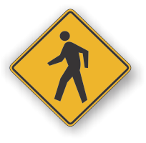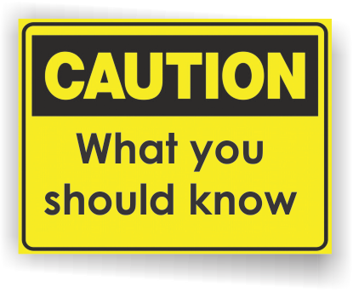[](http://www.countyhealthrankings.org)

**Be Prepared: Protect Your Family and Community Month**

**Do You Have a Family Disaster Plan?**

Families can best cope with disaster by preparing before disaster strikes and working together as a team. A family disaster plan includes a communication plan, a disaster supplies kit, and an evacuation plan. Knowing what to do is your best protection *and* your responsibility.

**Know what disasters could happen to you.**

Contact your American Red Cross chapter or local emergency management office — be prepared, take notes!

Know the answers to these questions:

* What types of disasters are most likely to happen? How do you prepare for each?
* What is your community’s warning signals? What do they sound like? What do you do when you hear them?
* What is the process for care of animals after disaster? Remember, animals other than service animals may not be allowed inside emergency shelters.
* What are the disaster plans at your workplace?
* What are the plans at your children’s school or daycare center?
* What are the plans for other places where your family spends time?

**INSERT LOCAL HEALTH DEPARTMENT CONTACT INFORMATION**

**Disaster Preparedness in Michigan**

<http://www.michigan.gov/michiganprepares>

**Ready America**

<http://www.ready.gov/america/index.html>

**American Red Cross**

<http://www.redcross.org/preparedness/cdc_english/home.asp>

**Federal Emergency Management Agency**

<http://www.fema.gov/pdf/library/f&web.pdf#search=%22food%20water%20in%20an%20emergency%22>

**Centers for Disease Control and Prevention**

**Emergency Preparedness and Response**

<http://www.bt.cdc.gov/>

**Be Prepared. Have a Plan.**

**Information Resources:**

**Create a Disaster Plan**

Talk to your family and discuss why you need to prepare for disaster. Talk about the dangers of fire, severe weather, and earthquakes to children. Plan to share responsibilities and work together as a team. Talk about the types of disasters that are most likely to happen. Talk about what everyone should do in each case.

Start making your plan today!

Pick two places to meet:

1. Right outside your home in case of a sudden emergency, like a fire.
2. Outside your neighborhood in case you can’t return home. Everyone must know the address and phone number.

Ask an out-of-state friend to be your “family contact”. After a disaster, it’s often easier to call long distance. Other family members should call this person and tell them where they are. Everyone must know your contact’s phone number.

Discuss what to do in an evacuation. Plan how to take care of your pets.

Families should have more than one way to communicate during emergency situations and share their plans beforehand with all those who would be worried about their safety.

Start planning today. Visit the Centers for Disease Control and Prevention’s Emergency Preparedness website at <http://www.bt.cdc.gov/preparedness/index.asp> .

**Disaster Planning Checklist**

* Post emergency telephone numbers by phones (fire, police, ambulance, etc.).
* Teach children how and when to call 911 or your local Emergency Medical Services number for emergency help.
* Determine the best escape routes from your home. Find two ways out of each room.
* Find the safe spots in your home for each type of disaster.
* Show each family member how and when to turn off the water, gas, and electricity at the main switches.
* Check if you have the right insurance coverage.
* Teach each family member how to use the fire extinguisher, and show them where it’s kept.
* Install smoke detectors on each level of your home, especially near bedrooms.
* Conduct a home hazard hunt.
* Stock emergency supplies and assemble a disaster supplies kit (visit <http://www.bt.cdc.gov/disasters/> for more information).
* Take a Red Cross first aid and CPR class.

**Available Services:**

**{INSERT LOCAL SERVICES AVAILABLE}**

**Do 1 Thing. You and your family can build an emergency kit, and make plans one step at a time.**

<http://do1thing.com/audiences/individuals>

**Michigan Prepares is a new site with loads of information for you.**

<http://www.michigan.gov/michiganprepares>

**The American Red Cross has several programs available to help you and your family with disaster preparedness.**

<http://www.redcross.org/>