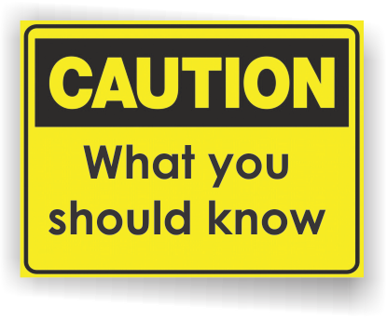[](http://www.countyhealthrankings.org)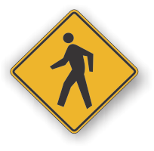

**Deaths in Michigan from Smoking**

* Adults who die each year in Michigan from their own smoking: 16,200.
* 213,000 young people under 18 who live in Michigan will ultimately die prematurely from smoking.

**Tobacco-Related Monetary Costs in Michigan**

* Smoking-attributable healthcare costs: $4.59 billion
* Medicaid portion of smoking attributable health care cost: $1.36 billion
* Michigan residents’ tax burden: $1,026 per household
* Smoking-caused productivity losses in Michigan: $4.78 billion
* Smoking-caused health costs and productivity losses per pack sold in Michigan: $10.44

*(Information from Campaign for Tobacco Free Kids Facts sheets and Toll Sheets* [*https://www.tobaccofreekids.org/*](https://www.tobaccofreekids.org/)*)*

**Exposure In the US.**

* 58 million people or 1 in 4 nonsmokers in the US are still exposed to secondhand smoke (SHS).
* About 2 in every 5 children (including 7 in 10 black children) are exposed to SHS.
* More than 1 in 3 nonsmokers who live in rental housing are exposed to SHS.
* The home is the primary source of SHS exposure for children.
* Many who live in public housing are especially affected by SHS, including children, the elderly, and people with disabilities.

*(Information from Vital Signs by the Centers for Disease Control*

*<http://www.cdc.gov/vitalsigns/tobacco/index.html)>*

**Information Resources:**

**INSERT LOCAL HEALTH DEPARTMENT INFORMATION**

**American Cancer Society** offers quit tobacco resources.

1-248-663-3454 or 1-800-227-2345. <http://www.cancer.org>

**American Heart Association** offers printed material.

1-800-242-8721. www.americanheart.org

**American Legacy Foundation** offers online assistance and

referrals to community programs. <http://www.becomeanex.org/>

**American Lung Association** offers quit smoking classes, printed material, quit tobacco website.

1-800-586-4872. Also offers telephone quit advice. 1-800-548-8252. www.lungusa.org

**Michigan Department of Community Health Tobacco Section website** offers information on secondhand smoke, quitting and much more. www.michigan.gov/tobacco.

**Michigan Tobacco Quitline** offers free information and tobacco treatment referral 24 hours/day at 1-800-QUIT-NOW (1-800-784-8669) or 1-855-DÉJELO-YA (1-855-335-3569). Free counseling and NRT may be available to certain callers. <https://michigan.quitlogix.org>/

# Facts:

**Secondhand Smoke**

**Kick “Butts” Month**

* When nonsmokers are exposed to secondhand smoke, it is called involuntary smoking or passive smoking. Nonsmokers exposed to secondhand smoke absorb nicotine and other compounds just as smokers do. The greater the exposure to secondhand smoke, the greater the level of these harmful compounds in your body.
* The 2006 U.S. Surgeon General's Report, "*The Health Consequences of Involuntary Exposure to Secondhand Smoke*," has concluded that **there is no safe level of exposure to secondhand smoke and, on average, children are exposed to more secondhand smoke than adults**. Children are significantly affected by secondhand smoke. Children's bodies are still developing, and exposure to the poisons in secondhand smoke puts them at risk of severe respiratory diseases and can hinder the growth of their lungs. Secondhand smoke is a known cause of low birth weight, Sudden Infant Death Syndrome (SIDS), asthma, bronchitis, pneumonia, middle ear infection, and other diseases.
* Secondhand smoke can be harmful in many ways. In the United States alone, each year it is responsible for:
* An estimated 35,000 to 40,000 deaths from heart disease in people who are not current smokers.
* About 3,000 lung cancer deaths in nonsmoking adults.
* Other respiratory problems in nonsmokers, including coughing, phlegm, chest discomfort, and reduced lung function.
* 150,000 to 300,000 lower respiratory tract infections (such as pneumonia and bronchitis) in children younger than 18 months of age, which result in 7,500 to 15,000 hospitalizations.
* Increase in the number and severity of asthma attacks in about 200,000 to one million asthmatic children.
* Increases in the risk of sudden infant death syndrome (SIDS) and middle ear infections in young children.
* Low birth weight in babies whose mothers are exposed to Environmental Tobacco Smoke (ETS).

*(Information provided by the American Cancer Society.)*

EXAMPLE:

|  |  |
| --- | --- |
| Contact your local Health Department  Call the Michigan Tobacco Section at  ***(517) 335-8376*** |  |

**www.michigan.gov/tobacco**

Call the Michigan Tobacco Quitline at 1-800-QUIT-NOW (1-800-784-8669)

Call your local hospital (insert information)

**Available Services:**