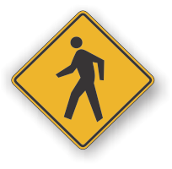[](http://www.countyhealthrankings.org)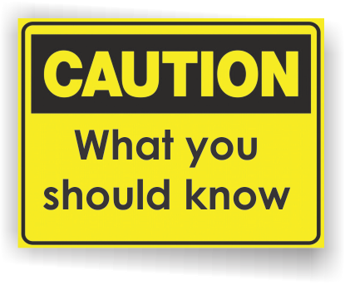

**INSERT LOCAL HEALTH DEPARTMENT CONTACT INFORMATION**

[**Michigan Department of Health and Human Services - Foodborne Illness**](http://www.michigan.gov/emergingdiseases/0,1607,7-186-32755---,00.html)

[**Selected Federal Agencies with a Role in Food Safety**](http://www.foodsafety.gov/)

**Food Safety and Inspection Service (FSIS)**

The Food Safety and Inspection Service (FSIS) is the public health agency in the U.S. Department of Agriculture responsible for ensuring that the nation's commercial supply of meat, poultry, and egg products is safe, wholesome, and correctly labeled and packaged.

**U.S. Food and Drug Administration (FDA)**

The FDA is charged with protecting consumers against impure, unsafe, and fraudulently labeled products. FDA, through its Center for Food Safety and Applied Nutrition (CFSAN), regulates foods other than the meat, poultry, and egg products regulated by FSIS. FDA is also responsible for the safety of drugs, medical devices, biologics, animal feed and drugs, cosmetics, and radiation emitting devices.

**Centers for Disease Control and Prevention (CDC)**

CDC leads federal efforts to gather data on foodborne illnesses, investigate foodborne illnesses and outbreaks, and monitor the effectiveness of prevention and control efforts in reducing foodborne illnesses. CDC also plays a key role in building state and local health department epidemiology, laboratory, and environmental health capacity to support foodborne disease surveillance and outbreak response.

**Information Resources:**

* A foodborne illness is an illness that is passed from food to humans. Bacteria and viruses grow and multiply easily in food that is mishandled, undercooked, or stored at improper temperatures.
* Local public health departments monitor food service in restaurants, at festivals, and local events. The Michigan Department of Agriculture and Rural Development oversee food safety at grocery stores, markets, supermarkets, and delicatessens with limited seating.
* The most commonly recognized and most often identified foodborne illnesses are those caused by the bacteria [*Campylobacter*](http://www.cdc.gov/ncidod/dbmd/diseaseinfo/default.htm#C), [*Salmonella*](http://www.cdc.gov/ncidod/dbmd/diseaseinfo/default.htm#S), and[*E. coli O157:H7*](http://www.cdc.gov/ncidod/dbmd/diseaseinfo/default.htm#E). The most common virus transmitted to humans by food is called calicivirus otherwise known as Norovirus.
* The populations most at risk for severe illness and death from a foodborne illness are young children, pregnant women, and the elderly.
* Food-related illnesses are commonly underreported to local health departments by the public. Common foodborne illness symptoms are vomiting and diarrhea lasting 24 to 48 hours on average.

# Facts:

**Foodborne Illness**

**FOOD SAFETY MONTH**

**Available Services:**

**{INSERT LOCAL SERVICES AVAILABLE}**

The local public health department is an important part of the food safety system. A call from a concerned citizen is how outbreaks of food contamination are first detected. If your local public health department contacts you to find out more about an illness you had, a restaurant you visited, or an event you attended, please try to help.

In public health foodborne illness investigations it is as important to talk to both healthy and ill people that could have been exposed to the contaminated food. Your assistance is important even if you were not sick.

**What foods are most associated with foodborne illness?**

* Raw or undercooked foods such as raw or rare meat and poultry, raw eggs, and raw shellfish.
* Foods that mix the products from many animals such as bulk raw milk, pooled raw eggs, or ground beef.
* Food that is unpasteurized including fresh milk, fresh squeezed fruit juices, and farm fresh eggs. Pasteurization is a process that heats products to a temperature that kills contaminates before use.

**Improper handling of food is the most common cause of foodborne illness. The two most common mistakes are:**

* Food that is not cooked all the way through or is stored at temperature that is not cool or hot enough to prevent contaminate growth.
* Exposing food items such as salad greens or other fresh foods to raw foods through unsafe food preparation practices such as cutting raw meat and then chopping salad greens without properly cleaning the cutting board between uses. This type of contamination is called cross contamination.

**Four simple steps to reduce the risk of foodborne illness**

1. [**COOK**](http://www.fightbac.org) meat, poultry and eggs thoroughly. Using a thermometer to measure the internal temperature of meat is a good way to be sure that it is cooked sufficiently to kill bacteria.
2. [**SEPARATE**](http://www.fightbac.org)**.** Don't cross-contaminate one food with another. Avoid cross-contaminating foods by washing hands, utensils, and cutting boards after they have been in contact with raw meat or poultry and before they touch another food.
3. [**CHILL**](http://www.fightbac.org)**.** Refrigerate leftovers promptly. Bacteria can grow quickly at room temperature, so refrigerate leftover foods if they are not going to be eaten within 4 hours.
4. [**CLEAN**](http://www.fightbac.org)**.** Wash produce. Rinse fresh fruits and vegetables in running tap water to remove visible dirt and grime. Remove and discard the outermost leaves of a head of lettuce or cabbage. Because bacteria can grow well on the cut surface of fruit or vegetable, be careful not to contaminate these foods while slicing them up on the cutting board, and avoid leaving cut produce at room temperature for many hours.