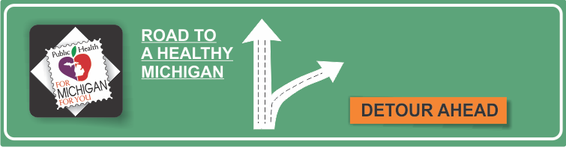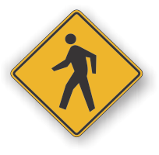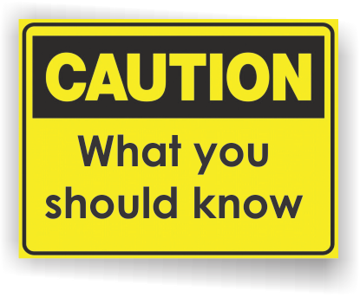[](http://www.countyhealthrankings.org)

**Healthy Habits Month**

**Handwashing**

* Handwashing is a vital tool in preventing the spread of bacteria and viruses that can cause infections and foodborne illness.
* Infectious diseases that are commonly spread through hand-to-hand contact include the common cold, flu and several gastrointestinal disorders, such as norovirus.
* Inadequate hand hygiene also contributes to food-related illnesses, such as salmonella and E. coli infection.
* Antibacterial soaps are no more effective at killing germs than is regular soap. Using antibacterial soaps may lead to the development of bacteria that are resistant to the products' antimicrobial agents — making it even harder to kill these germs in the future.

**INSERT LOCAL HEALTH DEPARTMENT CONTACT INFORMATION**

**Centers for Disease Control and Prevention**

**Clean Hands Save Lives!**

<http://www.cdc.gov/cleanhands/>

**Centers for Disease Control and Prevention**

**Hand Hygiene in Healthcare Settings**

<http://www.cdc.gov/handhygiene/>

**Clean Hands Coalition**

<http://www.cleanhandscoalition.org/>

**Mayo Clinic**

**Handwashing**

<http://www.mayoclinic.com/health/hand-washing/HQ00407>

**Information Resources:**

# Facts:

**Clean Hands Save Lives!**

**Proper hand washing with soap and water**

* **Wet** your hands with warm, running water and apply liquid soap or use clean bar soap.
* **Lather** your hands by rubbing them together. Be sure to get the backs of your hands, wrists, between your fingers and under your fingernails.
* **Scrub** your hands for at least 20 seconds. Need a timer? Hum the “Happy Birthday” song twice.
* **Rinse** well.
* **Dry** your hands with a clean or disposable towel. Use a towel to turn off the faucet.

Although it's impossible to keep your bare hands germ-free, there are times when it's critical to wash your hands to limit the transfer of bacteria, viruses and other microbes.

**Always wash your hands:**

* Before, during and after preparing food
* Before eating food
* Before and after treating wounds or cuts
* Before and after touching a sick or injured person
* Before inserting or removing contact lenses
* After using the toilet
* After changing a diaper — wash the diaper-wearer's hands, too
* After touching animals or animal waste
* After handling pet food or treats
* After blowing your nose
* After coughing or sneezing into your hands
* After handling garbage

Teach and show children how and when to wash their hands.

**Children should wash their hands after:**

* Arriving home from day care, a friend’s house or school
* Using the toilet or having their diapers changed
* Touching a child who may be sick
* Eating or drinking
* Touching an animal or pet.

**Available Services:**

**Fun resources to teach children about germs and handwashing:**

Glo-Germ Kit

*Those Mean, Nasty, Dirty, Downright Disgusting but Invisible Germs*   
by Judith Rice

*Five Nasty Germs*

by Ann Melrose