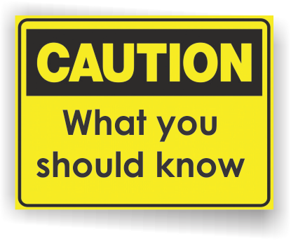[](http://www.countyhealthrankings.org)

* Approximately 600 – 1,000 people get meningococcal diseasein the United States each year.
* Rates of meningococcal disease have been declining in the United States since the late 1990s. Health officials believe this is due in part to increased vaccination.
* Meningococcal disease is rare, but it can be deadly. Ten to fifteen out of 100 people may die even with antibiotic treatment. About 11 to 19 out of every 100 survivors will have disabilities such as loss of limbs, deafness, nervous system problems, or brain damage.
* Infants, adolescents, and young adults have the highest rates of disease.
* Infectious diseases tend to spread wherever large groups of people gather together. Outbreaks of meningococcal disease have been reported from college campuses during the last several years.

**Meningitis**

**Back to School Month**

**INSERT LOCAL HEALTH DEPARTMENT CONTACT INFORMATION**

**CDC’s meningococcal disease website**[www.cdc.gov/meningococcal/](http://www.cdc.gov/meningococcal/)

**CDC’s Travelers Health**

[www.cdc.gov/travel](http://www.cdc.gov/travel)

**Meningitis Foundation of America**

[www.musa.org/](http://www.musa.org/)

**National Meningitis Foundation**

[www.nmaus.org/](http://www.nmaus.org/)

**Information Resources:**

# Facts:

What services are available either locally or statewide?

You can add hyperlinks here too!

**What is meningococcal disease?**

Meningococcal disease is a serious illness, caused by the bacterium [*Neisseria meningitidis*](http://en.wikipedia.org/wiki/Neisseria_meningitidis). It is a leading cause of bacterial meningitis in children 2 to 18 years old in the United States. Meningitis is an infection of fluid surrounding the brain and the spinal cord. Meningococcal disease also causes blood infections.

Anyone can get meningococcal disease, but it is most common in infants less than one year of age and people with certain medical conditions, such as lack of a spleen. College freshmen who live in dormitories have an increased risk of getting meningococcal disease.

Bacterial meningitis is of greater concern than viral meningitis because it is associated with a significant risk of brain damage and death, and the disease may progress rapidly if untreated. Bacterial meningococcal infections can be treated with antibiotics but it is important that treatment be started as soon as possible. There are vaccines to prevent some kinds of viral and bacterial meningitis.

**Meningococcal vaccine**

Three meningococcal vaccines are available in the U.S.:

* Meningococcal conjugate vaccines (Menactra®, MenHibrix® and Menveo®)
* Meningococcal polysaccharide vaccine (Menomune®)
* Serogroup B meningococcal vaccines (Bexsero® and Trumenba®)

These vaccines help protect against types of meningococcal disease that are most commonly seen in the United States, but they will not prevent all cases.

**Who should get meningococcal vaccine?**

Meningococcal vaccination is recommended for all preteens and teens. All 11 to 12 year olds should be vaccinated with a single dose of meningococcal conjugate vaccine. Since protection decreases over time, a booster dose is recommended at age 16 so teens continue to have protection during the years when they are at highest risk of meningococcal disease.

Teens and young adults (16 through 23 year olds) mayalso be vaccinated with a serogroup B meningococcal vaccine, preferably at 16 through 18 years old.

Meningococcal vaccination is also recommended for some babies, children and adults.

**Available Services:**