[](http://www.countyhealthrankings.org)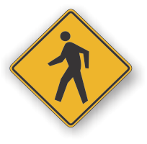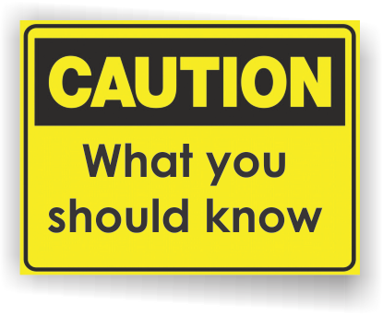

* Head lice (pediculosis) are parasitic insects found on people’s heads. They do not pose a significant health hazard and are not known to spread disease. Lice do not jump or fly, but crawl from hair to hair and feed on blood from scalp bites.
* An estimated 6 million to 12 million infestations occur each year in the United States among children 3 to 11 years of age.
* Anyone can get head lice regardless of their personal hygiene practices. Head lice are most common in preschool and elementary school age children and household members of infected individuals.
* Head lice can be passed from one person to another in a number of ways:
* Head to head contact is the most common way
* Sharing items like combs, brushes, towels, bedding, hats, coats, scarves, ribbons, and barrettes.
* Placing heads on furniture, rugs, pillows, or car seats recently used by someone with lice.
* Dogs, cats, and other pets do not spread human lice.

# Facts:

**Back to School Month**

**Head Lice**

**INSERT LOCAL HEALTH DEPARTMENT CONTACT INFORMATION**

**State of Michigan Head Lice Manual**

[www.michigan.gov/documents/Final_Michigan_Head_Lice_Manual_103750_7.pdf](http://www.michigan.gov/documents/Final_Michigan_Head_Lice_Manual_103750_7.pdf)

**CDC – Head Lice Information**

[www.cdc.gov/parasites/lice/head/index.html](http://www.cdc.gov/parasites/lice/head/index.html)

**The National Pediculosis Association**

[www.headlice.org](http://www.headlice.org)

**MedlinePlus – Head Lice**

[www.nlm.nih.gov/medlineplus/headlice.html](http://www.nlm.nih.gov/medlineplus/headlice.html)

**Information Resources:**

**Signs and symptoms:**

* Tickling feeling in the hairor an itchy head, especially around the ears and back of the neck
* Irritability and sleeplessness
* Sores on the head caused by scratching. These sores can sometimes become infected.
* Lice eggs are smaller than sesame seeds and are called "nits." Unlike dandruff and other matter, nits are tightly attached to the hair shaft, often close to the scalp.  Nits can vary in color including white, gray, yellow, tan, or brown.
* Nits can be found on any hair and hatch in 8-9 days.
* Adult lice are about the size of a sesame seed and may or may not be seen on examination.

Head Lice is most commonly found on the scalp, behind the ears, near the neckline at the back of the neck.

**Diagnosing Head Lice:**

The diagnosis is best made by finding a live nymph or adult lice on the scalp or hair of a person. Because lice are very small, move quickly, and avoid light, they can be difficult to find. Use of a magnifying lens and a fine-toothed comb may be helpful. If crawling lice are not seen, finding nits firmly attached within a ¼ inch of base of the hair shafts suggests that a person is infested and should be treated. All household members and other close contacts should be checked. If you are not sure if a person has head lice, contact a health care provider or your local health department.

**Head Lice Treatment:**

There are several prescription and over-the-counter head lice products available through your healthcare provider or drugstore. In addition, various cleaning steps are recommended of household and personal items.

What services are available either locally or statewide?

You can add hyperlinks too!

**Available Services:**