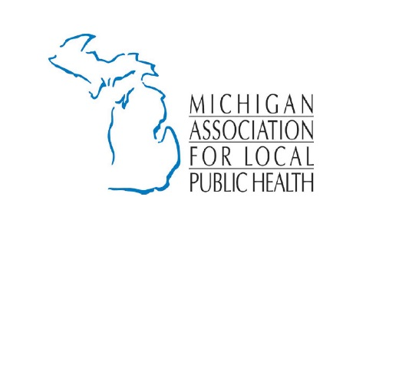
Talking Points FY 2020

Essential Local Public Health Services (ELPHS). The public health system provides tangible results to Michigan citizens on a daily basis. Drastic cuts to drinking water safety, immunization capacity, food safety, infectious disease investigation/reporting, sexually transmitted disease control, groundwater safety, and on-site sewage monitoring/control services have occurred in the last two years. However, State funding levels are still below the 50/50 cost share as provided for in the Public Health Code.

The Governor maintains FY 2019 funding levels for Essential Local Public Health Services through FY 2020.

FOR YOUR CONSIDERATION:

Sustainable Funding at the Consumer Price Index Rate (Headlee): If the State will not fund ELPHS at the 50/50 cost share rate, we are requesting that local public health have sustainable increases that are commensurate with the Headlee Amendment or the Consumer’s Price Index rate. This eliminates year after year of uncertainty with regard to funding levels and leads to planned budgeting for local health departments and the State of Michigan. The cost of service delivery goes up each year including, but not limited to, transportation, operations, equipment, staffing, supplies, etc. How can we facilitate the conversation to ensure local public health is funded according to the Consumer Price Index?

SUPPORT the Governor on Drinking Water Compliance Assistance Unit ($1.9M). This provides for technical expertise to better safeguard Michigan residents from lead in their drinking water.

SUPPORT the Governor on School Hydration Stations ($60M). We know that equipment in schools have failed lead tests. Replacing lead plumbing and fixtures will go a long way to ensure children are getting safe drinking water while at school.

SUPPORT the Governor on Drinking Water Grant/Innovation ($120M). This initiative supports funding for the Lead and Copper Rule implementation, and PFAS and emerging contaminate identification, treatment, and clean up.

SUPPORT the Governor on Enhancing Monitoring of and Response to Environmental and Public Health Hazards ($13.9M).

SUPPORT Local Government Revenue Sharing ($41.8). We support full funding and constitutional protection for county revenue sharing. We support a more secure and reliable funding mechanism and an equitable distribution system for county revenue sharing.

SUPPORT the recommendations of the Public Health Advisory Council including continuing and expanding collaboration locally and between state departments, investing in Michigan’s public health system, specifically that of local public health departments as “boots on the ground” stakeholders, to study issues, problems, and programs to make recommendations from a perspective of health (Health in All Policies).

