
  - COVID-19

Slowing the Spread of COVID-19 with Masks and Face Coverings

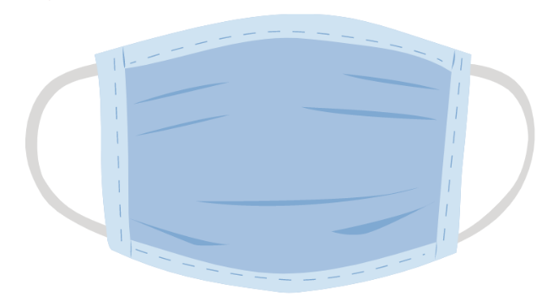
The Centers for Disease Control and Prevention (CDC) recommends wearing facemasks or cloth
face coverings in public settings where other social distancing measures are difficult to maintain (e.g., grocery stores and pharmacies). The proper use of face coverings may help slow the spread of the virus. If you do not have a facemask, cloth face coverings made at home from common materials can be used.

Face coverings are only effective if they are used and removed properly. This handout will provide tips on how to properly use face coverings to slow the spread of COVID-19.

When should I wear a mask or cloth face covering?

A face covering should be worn whenever you are in a community setting, especially in situations where you may be near people. These settings include grocery stores and pharmacies.

Face coverings should also be worn if you are caring for others who are sick. If the person who is sick is not able to wear a face covering (for example, because it causes trouble breathing), then as their caregiver, you should wear a face covering when in the same room with them.

Face coverings are not a substitute for social distancing. Stay home as much as possible. When you must go out in the community, maintain a distance of at least six feet between yourself and others.

Who should not wear face coverings?

Masks or cloth face coverings should not be placed on young children under age 2, anyone who has trouble breathing, or is unconscious, incapacitated or otherwise unable to remove the mask without assistance.

How do I properly use face coverings?

When wearing a face covering, it is important to know how to use it and clean/dispose of it properly. Keep in mind; face coverings are only effective when used in combination with frequent hand washing.


Step One: Before putting on a face covering, wash your hands with
soap and water for at least
20 seconds. Use an
alcohol-based hand
sanitizer with at least
60% alcohol if soap and
water are not available.

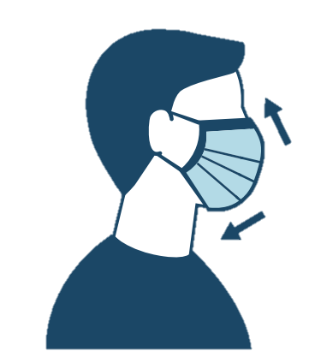
Step Two: Cover your mouth and nose with the face covering. Make sure
there are no gaps between
your face and the face
covering. If your face
covering has a metal
piece along the bridge of
your nose, will need to
gently bend and mold the
metal against your face.


Step Three: Avoid touching the face covering while using it. If you do
touch it, wash your hands with
soap and water for at least
20 seconds. Use an alcohol-
based hand sanitizer that
contains at least 60% alcohol
if soap and water are not available.

Step Four: To remove the face covering, grab the tie strings or elastic straps. Do not touch your face or the part of the mask that covers your face.

Step Five: If your face covering is a single-use disposable mask, throw the used mask directly in the trash. If your face covering is a reusable cloth face covering, wash it in a washing machine before wearing again.

Step Six: Immediately after removing your face covering, wash your hands with soap and water for at least 20 seconds. Use an alcohol-based hand sanitizer that contains at least 60% alcohol if soap and water are not available.

Where can I find more info?

Learn how to make your own mask:
www.cdc.gov/coronavirus/2019-ncov/prevent-getting-sick/diy-cloth-face-coverings.html

Find local COVID-19 updates:
www.livgov.com/health/ph/Pages/COVID19.aspx

Email your COVID-19 questions to:
LCHD: COVID19@livgov.com
MDHHS: COVID19@michigan.gov

COVID-19 hotlines to call:
LCHD: 517-546-9850
MDHHS: 888-535-6136

