[Note: this drill may be best run with outside partners or other key subject matter experts for your area (ex., EMS, Dispatch, Hospital, CMH, etc.). Unlike other topics included in this training package, this scenario includes guided questions at the end in case you need prompts for discussion. Based on the size or population of your county, you may need to increase or decrease overdose numbers portrayed in this scenario to appropriately strain your resources and surge involved agencies.]

Scenario
[Day, Date, Month, Year]
7:32 pm
A friend called 911 at a party at [Name of university, event venue, popular bar, etc.] after three people were found not breathing. These students were using drugs of an unknown type to the caller. EMS arrives and administers Narcan, and the three students are transferred to the emergency department at [local hospital].

9:13 pm
A 911 caller reports that two people near [well-known community park/amphitheater/outdoor venue area] are not responsive after using cocaine. EMS is dispatched and arrive in 10 minutes. The two people become responsive with stable vitals after Narcan is administered. Both refuse transfer to the ED.

10:03 pm
A 911 caller reports that three people are not responsive near [well-known trailer park]. The caller states they were a designated person to monitor their friends as they were using heroin they recently purchased. The caller stated they administered naloxone to all three people, but they remained unresponsive. When [ambulance agency] personnel arrived, naloxone was administered again, but there continued to be no respirations and no pulses. All three individuals are pronounced dead on scene.

12:13 am
Someone calls 911 to report two high schoolers were at a party near [high school name] and were found unresponsive on a basement couch. EMS arrives and administers Narcan. Both students become responsive and are transferred to the emergency department at [Hospital Name]. One of the two students continues to have severe respiratory depression and with a Non-ST-elevation myocardial infarction (NSTEMI) and is transferred to the ICU.

1:19 am
EMS is called to an area near [popular park area] after a passerby reported an unconscious person found on a park bench. When EMS arrives, the person has no pulse and is not breathing. This person is pronounced dead on scene.

4:32 am
EMS is also called to [local motel] when the Overdose Prevention Hotline (1-800-484-3731) number reports that a group of four people have not been responding on the call for thirty seconds. [Ambulance agency name] personnel arrive quickly, administer naloxone, and all four people become responsive and are transferred to [hospital name]. Three of these four people have severe respiratory depression and are transferred to the ICU.

[Next Day, Date, Month, Year]
9:51 am
911 receives a call from a mobile home in [A different trailer park than listed above] from someone who returned home from work and found their spouse unresponsive next to drug paraphernalia. When paramedics arrive, there was no pulse or respirations on exam. The person was not responsive to naloxone and was pronounced DOA when they arrived at the [hospital name] emergency department.

[Provide a recap of events as listed below. Consider adding a map for your identified sites to show the locations and proximity of incidents]

In summary, there were 11 nonfatal overdose incidents and 5 fatal overdose incidents. Of the 11 nonfatal incidents, 2 adults refuse transfer to the ED. Of the 9 that were transferred to the ED, 4 were transferred further to the ICU for severe respiratory depression, and one had a cardiac event. The locations are plotted on the map with numbers indicating the order in which dispatch was called. The two high school students who overdosed are less than 18 years of age. All other individuals are over 18 years of age.

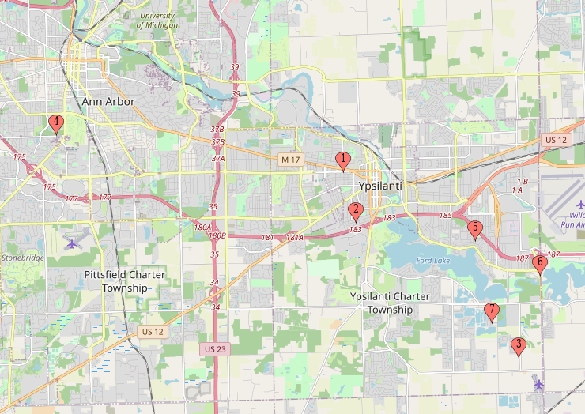

- [University, event venue, popular bar, etc.] ([hospital name] ED, 3)
- [Park/amphitheater/outdoor venue name] (Refused ED transfer, 1)
- [First Trailer Park Name] (Dead on arrival, 3)
- [High School Name] ([hospital name] ED, 2)
- [Community Park Name] (Dead on arrival, 1)
- [Local Motel Name] ([hospital name] ED, 4)
- [Second Trailer Park Name] (Dead on arrival, 1)
- What systems allow people who experience or witness an opioid overdose to receive help? What are barriers that prevent people from calling for help?

- What are data sources to monitor overdose rates? What are the strengths and weaknesses of these sources?

- According to the Community Perspectives on the Michigan SOS, 60% of the people surveyed answered that they would never or rarely call 911 when someone is having an opioid poisoning event. How can we collect data to understand how many other nonfatal overdoses occurred in the community that did not involve 911 or EMS?

- How will the [Health Department Name] define an opioid poisoning event spike?

- How does the [Health Department Name] expect to be notified of an overdose spike? Is it more likely to have internal epidemiologists be the first to identify a spike or that MDHHS will notify [Health Department Name]? Are there other agencies likely to notify the [Health Department Name] first?

- What information is important for the [Health Department Name] to know as soon as it is possible?

- Which partners will the [Health Department Name] notify? How will they maintain effective communication?

- How will the [Health Department Name] facilitate each of the following roles in the community?
  - Harm reduction sub-team: naloxone distribution
  - Support services sub-team: coordinate post overdose and survivor support services
  - Treatment sub-team: coordinates treatment facility information

- How and what will the [Health Department Name] communicate to the general public?
  - NACCHO states several topics that are important to communicate include: “bad batch” alerts, overdose spike alerts, harm reduction and overdose education, and 911 good Samaritan reminders.

- How will the community of people who use drugs be notified of these events?

- How does protocol differ, if at all, for pediatric cases?

[For the questions 4,6, and 7, use follow-up questions if these topics did not come up during discussion. These discussion points are based on the framework that NACCHO recommends.]

- The ODMAP system uses first responder reporting of overdoses or naloxone administration. This system defines an overdose spike by the following: when cases increased by two standard deviations above the mean in the past 24 hours. Other counties identify a response by a % increase from a previous month or quarter. It is also important to consider how statistically significant differences may not correlate with clinically significant differences. How will the [Health Department Name] define an overdose poisoning event spike?

- NACCHO’s suggestions include:
  - Where are most overdoses occurring?
  - What factors may be contributing to the local overdose spike?
  - Which individuals are most vulnerable?
  - Which prevention strategies are most effective?

- Specifically, it is important to address:
  - What channels of communication will be used?
  - When, if at all, should partners and the [Health Department Name] meet as a group?

Intended Audience
[Change titles as appropriate] Health Officer, Medical Director, PPHS Director, Nursing Supervisor, Epidemiology, EPC, Health Promotions Coordinator

Objectives and Tasks
- Ensure participating staff understand the role they might fill during this type of response as well as the role/responsibilities of [agency name] as we fit into the “bigger picture” of the response.
- Identify if there is a need for [enter name of your public health EOC/command center: ex., PHECC, EOC, etc.] activation. Determine thresholds that would warrant [enter name of your public health EOC/command center: ex., PHECC, EOC, etc.] activation (partial or full) and identify possible triggers for changes in activation (ex., scaling up or down).
- Understand the process for activating the [enter name of your public health EOC/command center: ex., PHECC, EOC, etc.] and the steps taken for notification, alerting key partners, initial meeting, etc.
- Identify pre-event incident action planning items (i.e., things we need to accomplish or develop now prior to this type of incident occurring – materials for the [enter name of your public health EOC/command center: ex., PHECC, EOC, etc.] activation process, templates, etc.).
- Identify potential communication and/or print/digital materials needs.
- Identify who is at highest risk for this type of incident. What additional needs should we consider for our Access and Functional Needs population?

Possible Reference Materials
- Emergency Response Checklist
- SAMHSA Overdose Information
- MDHHS Drug Poisoning Page
- Michigan Overdose Data to Action Dashboard
- CDC Drug Overdose Deaths page

