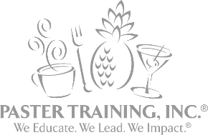
SAVE THE DATE
What: Train the Trainer with Active Managerial Control
When: March 17th, 2020
Where: Park Place Hotel, Traverse City
AFDO Professional Development Series
Evaluating Active Managerial Control (AMC) Training Methods
How to teach your staff to evaluate AMC!
Best Known Science with the Best-Known Professionals Excelling at Retail Food Safety!
Active Managerial Control (AMC) is the purposeful incorporation of specific actions or procedures by industry management into the operation of their business to attain control over foodborne illness risk factors. It embodies a preventive rather than reactive approach to food safety through a continuous system of monitoring and verification. What can you control? What can you influence?
This is a high energy and interactive experience where Participants will:
- Explain how the Food Code addresses and establishes controls for risk factors and further establishes the 5 key public health interventions.
- Recognize the AMC Multiplier Effect and how to make a positive impact on foodborne illness by increasing results exponentially based on empowering others and taking new approaches.
- Understand the difference between Training Methodologies, Techniques, Systems, and Best Practices.
- Identify Trainer qualities and how these weaknesses and strengths influence retail food safety.
- Demonstrate proper training techniques on how to teach your staff to evaluate AMC.
- Understand proper use of knowledge calibration, robust preparation, collaboration, and shared responsibility and how this contributes to practical application.
- Learn to combine prerequisite programs, basic sanitation, employee training, and other management practices, including the principles of HACCP to provide an effective system for achieving Active Managerial Control of Foodborne Illness Risk Factors.

Participant Advisory: Please get plenty of rest prior to attending the AFDO Professional Development Series "How to teach your staff to evaluate AMC"!

