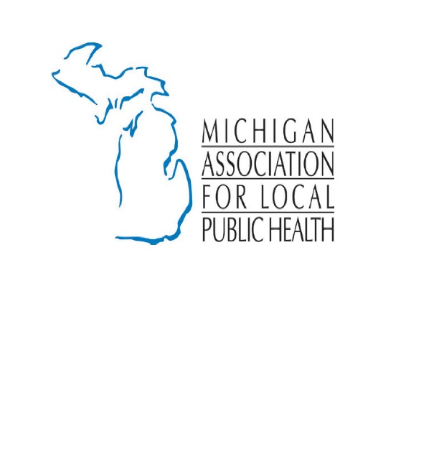
Opioids

What you need to know about opioids:
Local health departments are on the front lines of the prescription drug and heroin abuse epidemic. They advocate for increased community access to prescription drug abuse treatment and prevention and for medication that reverse the effects of an overdose and save lives.

A comprehensive local and federal response is needed. Overdoses caused by opioids, both prescription drugs and heroin, take more than 90 lives a day. Death rates from opioid overdose have never been higher. The problems for most users begin with prescription drug use and later abuse. In the US, one in 10 people misusing prescription drugs will switch to heroin; over 435,000 Americans reported using heroin in 2014.

What your local health department may be doing:

- Surveillance: Monitoring both local and state data to analyze opioid and heroin use, overdose, drug use-related infections, and mortality trends.
- Education: Educating healthcare providers on proper opioid prescribing practices and encouraging use of prescription drug monitoring programs.
- Training: Teaching first responders and community members to use lifesaving overdose reversal medication, such as naloxone.
- Treatment and Recovery: Promoting substance abuse treatment programs including those that use medication-assisted treatment.
- Cross-Cutting Partnerships: Creating local task forces to develop and implement “take back” programs that allow for safe disposal of unused prescription drugs.

Resources:
Centers for Disease Control Emergency Department Data:
https://www.cdc.gov/media/releases/2018/p0306-vs-opioids-overdoses.html

Centers for Disease Control Guidelines for Prescribing Opioids for Chronic Pain:
https://www.cdc.gov/drugoverdose/prescribing/guideline.html

Centers for Disease Control Opioid Basics:
https://www.cdc.gov/drugoverdose/opioids/index.html

Centers for Disease Control Opioid Data Analysis and Resources:
https://www.cdc.gov/drugoverdose/data/analysis.html

Centers for Disease Control Understanding the Epidemic:
https://www.cdc.gov/drugoverdose/epidemic/index.html

State of Michigan Department of Health and Human Services Opioid Information:
http://www.michigan.gov/mdhhs/0,5885,7-339-71550_2941_4871_79584---,00.html

State of Michigan Launch of New Prescription Drug Monitoring Program:
http://www.michigan.gov/som/0,4669,7-192-29943_34759-409144--,00.html

State of Michigan Prescription Drug and Opioid Abuse Commission through LARA:
https://www.michigan.gov/lara/0,4601,7-154-89334_72600_72783_73913_80371---,00.html

