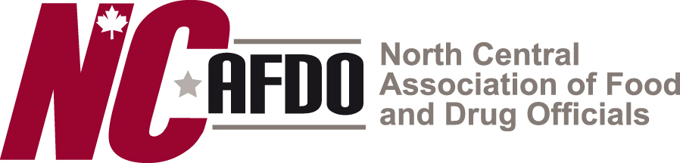
AFDO Pre-conference MEHA Annual Educational Conference Scholarship Application

For more information contact Brandon Morrill (734-369-1062) or by email MorrillB@Washtenaw.org

APPLICANT INFORMATION:
Name: | Title:
Agency/Company:

Address:

Phone: | E-Mail:
SCHOLARSHIP OPPORTUNITIES:
This scholarship is funded by the Association of Food and Drug Officials (AFDO) and covers class expenses to attend:
MEHA Annual Educational Conference Pre-conference workshop with Paster Training.
Co-hosted by the North Central Association of Food and Drug Officials
March 17th, 2020
Traverse City, MI
Park Place Hotel

BENEFIT OF ATTENDANCE: Please describe below
To you as a professional individual –

To your employer as an organization –

Other (please specify) –

SUPERVISOR APPROVAL:
By accepting an offered scholarship, I have been approved by my supervisor to attend the pre-conference workshop.

I understand the participation expectation noted above.

Name: Signature: Date:

Supervisor Name: Signature: Date:

Please return completed form electronically to:
Brandon Morrill, NCAFDO President at MorrillB@Washtenaw.org

