NAF Dropbox Instructions
- Open the Dropbox website www.dropbox.com
- Click on the “Sign In” link
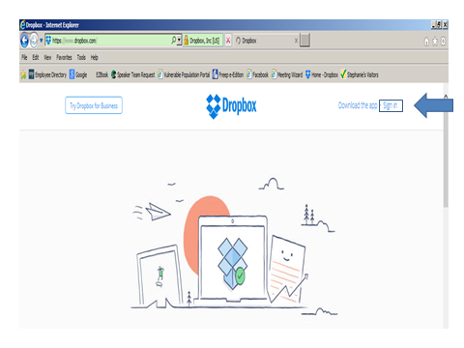

- Type in the Email address: naf@malph.org
- Type in the Password: leadership
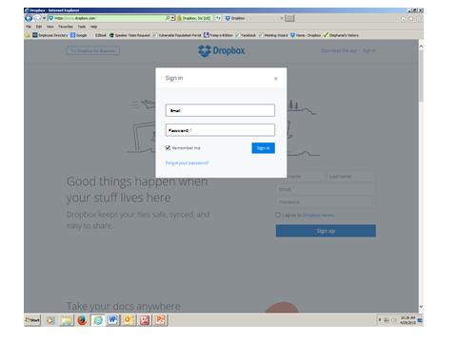
- Once you have access to shared folders, simply click once on blue folder in list to open
- To open a document, click once on the document and view or download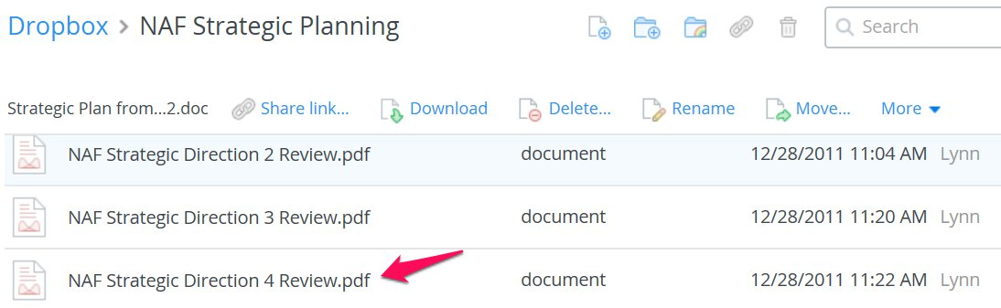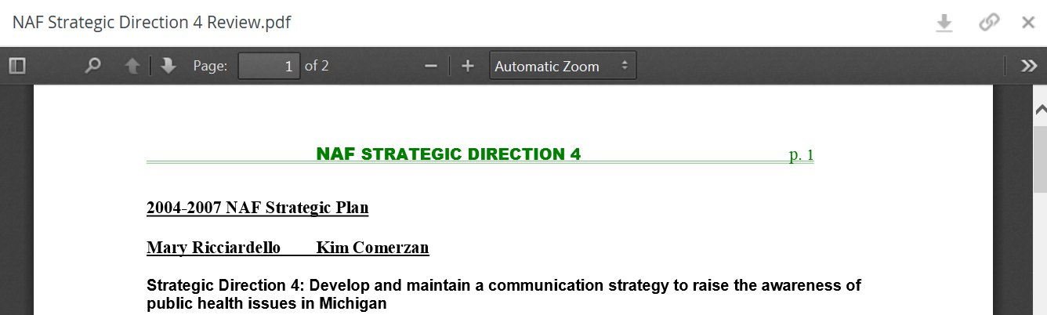

NOTE: If you drag from Dropbox onto your computer, you will remove the file from Dropbox. Make sure to copy and paste or save as

- To upload documents, click on icon Paper with plus sign
You will then be able to upload files from into the selected folder from your computer files by clicking on the Choose files button.

- To go back to main menu of folders, click on the blue Dropbox in header line

Revised 4-29-15 (McDaniels)

