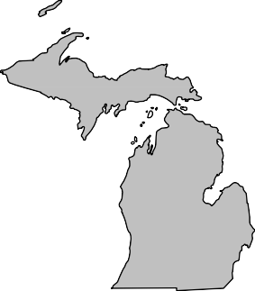
BOARD MEMBERS 2020-2021

President Andrew Cox Macomb County (586) 469 5510

President Elect Sara Simmonds Kent County (616) 632 7316

Past-President Matt Bolang Livingston County (517) 552 6870

Secretary Liz Braddock Mid-Michigan
(616) 302 6301

Treasurer Chris Westover Monroe County (734) 240 7921

Directors
Ken Bowen (2021)
Ionia County (616) 527 5341

Tony Drautz (2021) Oakland County (248) 858 1320

Steve Stoddard (2022)
Lapeer County (810) 245 5791

Kevin Green (2022) Calhoun County (269) 969 6398

Dan Thorell (2022) Northwest Health
(231) 547 7651

Michigan Association of

Local Environmental Health Administrators MALEHA

Representing Local Environmental Public Health Departments in Michigan

Forum Report – May 2021

- May 5th, MDHHS provided End of Year Guidance for schools to help guide schools and local health departments with guidance on prom, graduation, and end-of-year parties. No additional guidance or updates have been released specifically about fair and festivals.

- Vaccine clinic have slowed in some jurisdictions but many EH programs continue to support COVID activities in some way. Expansion of ages of 12-15 has increased some activity at clinics.
- May 15th, MDHHS updated the Gatherings and Face Mask Order which aligned with CDC guidance on face masks released a few days prior. One of the major changes of the order allowed fully vaccinated individuals to be unmasked indoors.
- MALEHA submitted comments to The Nature Conservancy regarding the septic project survey. MALEHA will be meeting soon to discuss the comments provided.
- EGLE is sending a written correspondence response to MALEHA who provided public comment for the Parjana permit. As soon as I receive I will provide it to the forum.
- MPHI will continue to be on pause for State Accreditation. This pause includes:
  - On-Site Reviews are paused and will be rescheduled at a later date in cooperation with local health departments and programs within Accreditation at the state;
  - An extension to the Corrective Plan of Action (CPA) process for those health departments who are still in the process of implementing CPAs in response to their On-Site Review;
  - Suspension of Minimum Program Requirements (MPRs) during the COVID-19 response; and
  - Suspension of the Standards Review Committee process.

Respectfully Submitted, Andrew Cox
May, 2021

“Protecting, Promoting and Enhancing Public and Environmental Health in Michigan”

