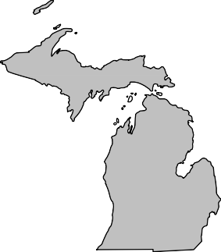
BOARD MEMBERS 2020-2021

President Andrew Cox Macomb County (586) 469 5510

President Elect Sara Simmonds Kent County (616) 632 7316

Past-President Matt Bolang Livingston County (517) 552 6870

Secretary Liz Braddock Mid-Michigan
(616) 302 6301

Treasurer Chris Westover Monroe County (734) 240 7921

Directors
Ken Bowen (2021)
Ionia County (616) 527 5341

Tony Drautz (2021) Oakland County (248) 858 1320

Steve Stoddard (2022)
Lapeer County (810) 245 5791

Kevin Green (2022) Calhoun County (269) 969 6398

Dan Thorell (2022) Grand Traverse County (231) 995 6021

Michigan Association of

Local Environmental Health Administrators MALEHA

Representing Local Environmental Public Health Departments in Michigan

Forum Report – March 2021

- LHDs continue to deal with enforcement and interpretation of MDHHS orders. I have reached out to MALPH and MDHHS specifically about fair and festival guidance as well as prom guidance for schools. So far the answer has been to follow what is in the epidemic orders.

- MDHHS announced expanded vaccination priority groups to all 16 years of age and older beginning April 5th. We can all expect to be busy at our vaccination clinics.

- Nature Conservancy will present at our April forum meeting about a project they are interested in to support funding of onsite wastewater systems. They have had limited exposure to local Environmental Health programs so this is a great opportunity for all of us to share our concerns and the issues we face on regular basis.

- MDARD is interested in starting a small group to discuss EEE related activities in the past. I have reached out to a few jurisdictions that had cases as I think it is important they be a part of this group. If you are interested please let me know by the end of the day on March 16th.

- MPHI will continue to be on pause for State Accreditation. This pause includes:
  - On-Site Reviews are paused and will be rescheduled at a later date in cooperation with local health departments and programs within Accreditation at the state;
  - An extension to the Corrective Plan of Action (CPA) process for those health departments who are still in the process of implementing CPAs in response to their On-Site Review;
  - Suspension of Minimum Program Requirements (MPRs) during the COVID-19 response; and
  - Suspension of the Standards Review Committee process.

Respectfully Submitted, Andrew Cox
March, 2021

“Protecting, Promoting and Enhancing Public and Environmental Health in Michigan”

