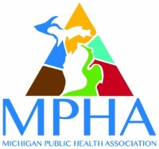

MICHIGAN PUBLIC HEALTH ASSOCIATION
Public Health Nursing Section

ANNUAL CONFERENCE:
Addressing Addictions:
Opioids, Cannabis, & Vaping

SAVE THE DATE!
Tuesday, April 16, 2019
8:30 a.m. - 4:30 p.m.

Kent County Health Department
700 Fuller Ave. NE., Grand Rapids, MI 49503

As it becomes available, more information and registration will be posted on the MPHA website at http://www.mipha.org/event-calendar.php and distributed by e-mail. Contact hours will be available.

