April 2, 2020
ORDER OF THE HEALTH OFFICER
OF THE MID-MICHIGAN DISTRICT HEALTH DEPARTMENT
FOR THE PROVISION OF NON-CONGREGATE SHELTERS
WHEREAS, on January 31, 2020 the United States Secretary of Health and Human Services announced a nationwide public health emergency to respond to COVID-19; and
WHEREAS, on March 10, 2020 Michigan Governor Gretchen Whitmer issued Executive Order 2020-04, declaring a state of emergency for the State of Michigan to address the threat that COVID-19 poses to the health and welfare of Michigan residents; and
WHEREAS, on April 1, 2020, Governor Whitmer issued Executive Order 2020-33, expanding the emergency declaration into a state of emergency and disaster, and declaring that the state must “coordinate and maximize all state efforts that may be activated to state service to assist local governments and officials and may call upon all state departments to utilize available resources to assist”; and
WHEREAS, MCL 333.2253 of the Public Health Code Act 368 of 1978 states, “If the director [of a local health department] determines that control of an epidemic is necessary to protect the public health, the director by emergency order… may establish procedures to be followed during the epidemic to insure continuation of essential public health services and enforcement of health laws. Emergency procedures shall not be limited to this code.”
WHEREAS, I do so find that the continuing widespread transmission of COVID-19 is a threat to public health and that emergency measures must be taken to control this epidemic; and
WHEREAS, non-congregate sheltering is necessary to save lives, to protect property and public health, and to ensure public safety, as well as to lessen or avert the threat of a catastrophe; and
WHEREAS, there is an urgent health need for non-congregate shelters for individuals who may need to be isolated or quarantined in order to prevent the spread of COVID-19; and
WHEREAS, as the disease spreads, vulnerable people such as the homeless, people fleeing domestic abuse, etc. will be at risk for contracting or spreading COVID-19, and it will be increasingly difficult to distinguish persons with and without the disease; and
WHEREAS, sheltering such individuals in congregate settings will further the spread of this disease;
NOW, THEREFORE,
- I, Mark W. (Marcus) Cheatham, Health Officer of the Mid-Michigan District Health Department, hereby declare the existence of a public health emergency within our jurisdiction, for which certain orders and actions are necessary to protect the health and safety of the residents of Clinton, Gratiot and Montcalm counties, and for which exercising the power of the Board of Health to prevent, mitigate, control and abate the current emergency presented by COVID-19 is necessary.
- I hereby order all agencies that may be responsible for providing shelter to any person in the area to locate, secure, operate, and make available non-congregate sheltering to any person needing to be isolated or quarantined in order to prevent the spread of COVID-19 or to vulnerable persons who have lost access to shelter for reasons related to the spread of COVID-19. The provision of non-congregate shelters required by this Order shall be limited to that which is reasonable and necessary to adequately protect the public from the threat presented by the COVID-19 pandemic.

These shelters shall be Tier 1 Alternate Care Sites under Michigan’s taxonomy for Relief Healthcare Facilities and Alternate Care Sites. Following the taxonomy they shall be for persons who need limited monitoring, can care for themselves and do not need assistance with medications or activities of daily living. These patients could be housed in a dedicated hotel or dormitory meant for this purpose, in their own rooms with their own bathroom.
- This Order shall be effective immediately and remain in effect until the end of the public health emergency or such earlier time as I may indicate, subject to the authority of the Board of Health to continue or rescind, alter, or modify this Order.
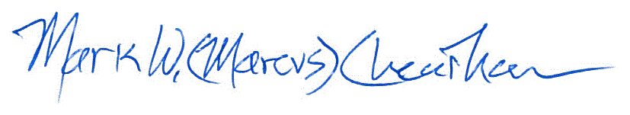
__________________________________ _April 2, 2020 ___
Mark W. (Marcus) Cheatham Date
Health Officer
Mid-Michigan District Health Department

