MDHHS
Wear a Mask Social

We’ve included the copy and the reference visual. When placing these on social, please use the actual reference file vs. what’s included below. If you have any questions, please reach out to Ellyn Davidson at edavidson@brogan.com

STATUS UPDATE: To contain COVID-19, mask up, Michigan. 😷 Wearing a mask can greatly reduce the chance of spreading the virus. Learn more at Michigan.gov/Coronavirus.
Video File
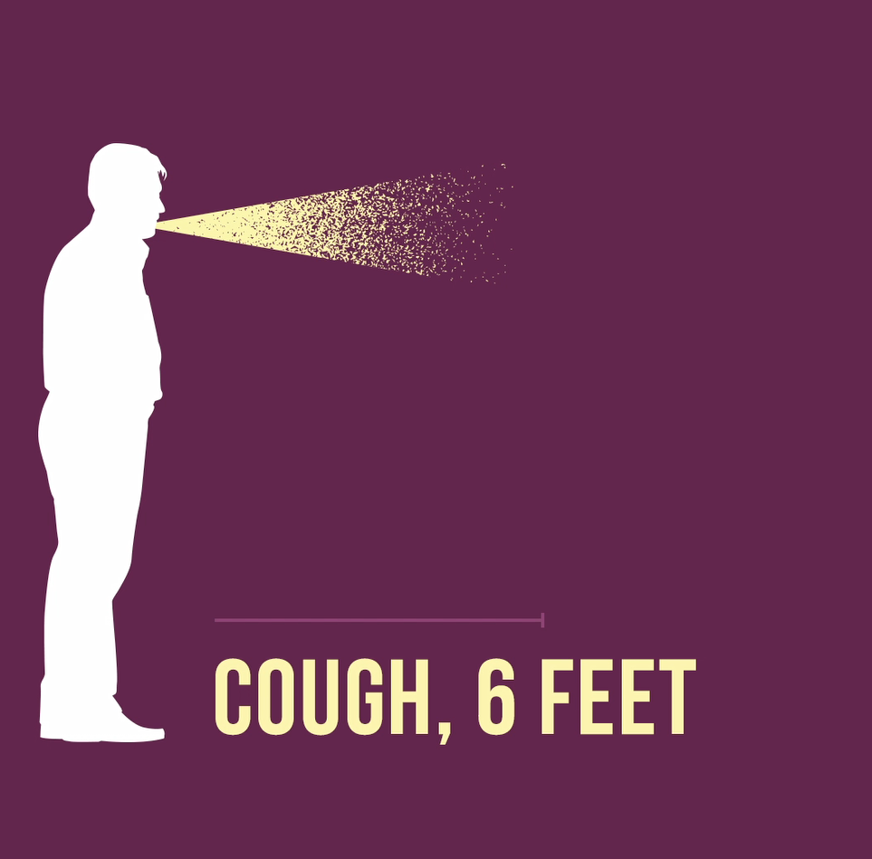

STATUS UPDATE: Without a face covering, the risk of getting COVID-19 gets higher. And higher. And higher. Wearing a mask can greatly reduce the chance of spreading the virus. Learn more at Michigan.gov/Coronavirus.
Video File
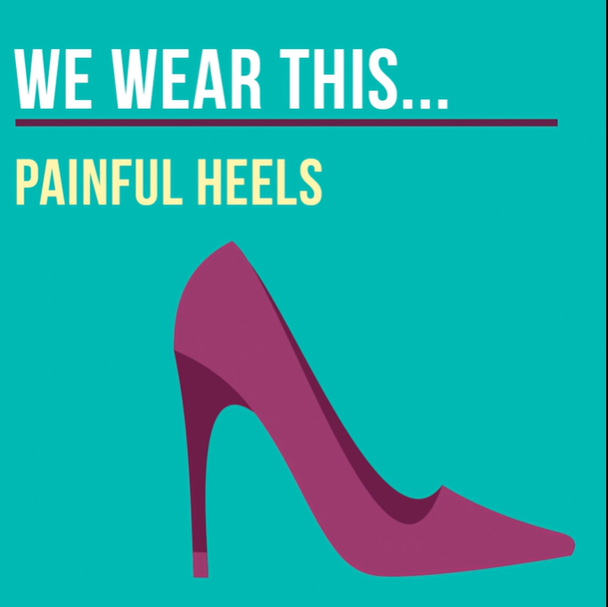

STATUS UPDATE: A fact to wrap your head around: A face covering is proven to stop the spread of COVID-19. So, mask up, Michigan. 😷 To learn more, visit Michigan.gov/Coronavirus.
Video File



STATUS UPDATE: From top to bottom, our state is committed to containing COVID-19. So, mask up, Michigan. 😷 Every time you leave home. Even if you feel fine. To learn more about stopping the spread, visit Michigan.gov/Coronavirus.

Video File

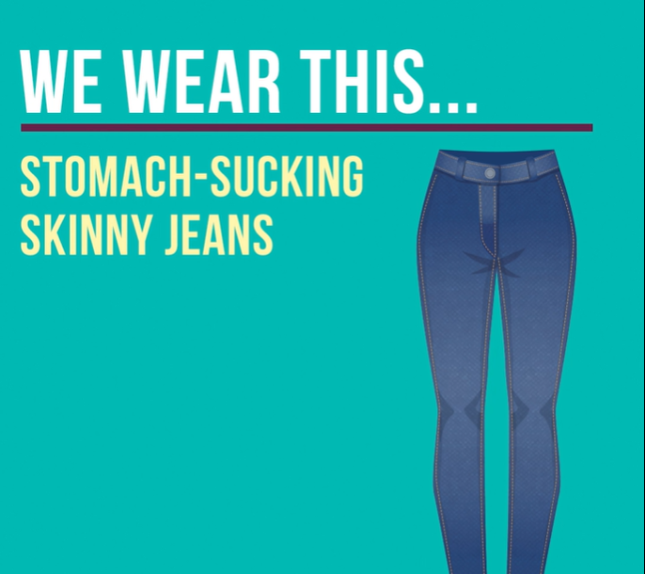

STATUS UPDATE: When it comes to COVID-19, the only comfort is knowing you’re protected. So, mask up, Michigan, and greatly reduce the chance of spreading the virus.
Video File



STATUS UPDATE: Inconvenience… or infection? Mask up, Michigan. Every time you leave home. Even if you feel fine. Learn more at Michigan.gov/Coronavirus.

Video File



STATUS UPDATE: Together, we can reduce the spread of COVID-19. Mask up, Michigan. Every time you leave home. Even if you feel fine. Learn more at Michigan.gov/Coronavirus.

Video File



Option 2

Video File

