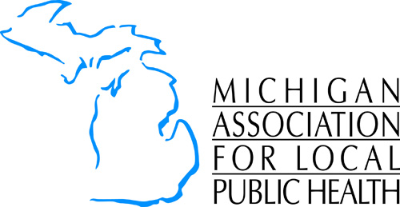
Friend of Local Public Health Award

NOMINATION/SELECTION PROCEDURES

- Nominations are submitted by a MALPH Board of Director. All nominations must be submitted on the nomination forms provided by MALPH.

- The originators of nominations must supply current basic biographical data of the nominee. It should include information on (a) national activities, (b) state activities, and (c) other policy activities.

- The originators of nominations must provide a narrative statement detailing the accomplishments of the nominee. The statements should describe the nominee’s compliance with the established criteria for the award as explicitly and concisely as possible.

- The originators of nominations may supply letters of support describing how the nominee meets award criteria. Multiple jurisdictions can co-sign a joint letter of support.

GENERAL CRITERIA FOR Friend of Local Public Health RECOGNITION

Candidates for recognition shall have contributed outstanding efforts for the promotion of health status to the people of the State of Michigan and as applicable to residents in local health jurisdictions. In addition, candidates who have provided direct support for MALPH-endorsed initiatives. The following generalized areas should be considered as criteria:

- Created necessary and effective legislation or provided other governmental support to enhance or otherwise promote local public health programs and efforts.
- Provided significant leadership within the government sector, providing incentives and capacity for public health to deliver increased or needed services for enhancement of the health status of residents.
- Has contributed significantly to the control and prevention of public health problems, either personal or environmental, and achieved positive outcomes, thereby increasing the health status of residents.
- Increased public awareness of public health programs and the need for the implementation of local public health services.
- Identified health problems, and thereby gain greater community participation in the reduction, elimination, or prevention of situations or diseases causing disability and death.

The deadline for submission of nominations is Friday, March 15, 2019

Nominations postmarked after that date will not be considered.

Email or fax completed nomination forms and supporting material to:
Michigan Association for Local Public Health * email: jshaver@malph.org * fax: 517-485-6412

