PUBLIC HEALTH ADMINISTRATORS’ FORUM
January 16, 2025
10 AM – 12 PM
Virtual

- Call to Order – Please e-mail DeAnn Coan Dcoan@cmdhd.org to confirm attendance.

- Consent Agenda w/ add Item B Single Audit Updates: 1st Jennifer Brassow 2nd Derek Burton

- Approve Meeting Minutes - December 12, 2024, 1st Derek Burton 2nd Jennifer Brassow

- Treasurer’s Report ~ No Questions

- Correspondence/Officer Report, Health Officer’s Meeting –January 13, 2025

  - The Legislation is back in full session. A couple items did not make it through the lame duck session and will have to be reintroduced in the new session.
  - The new House Speaker has established six subcommittees. The subcommittees have the power to subpoena individuals to testify and that is new.

- Committee Reports
  - Education Committee – Derek Burton
    - Conference topic suggestions or ideas please email those to Derek. The first meeting was yesterday, and it went well.
    - For any CPA’s we may have, is there anyone who would like chair and do the research regarding getting CEU’s for CPA’s if this is valuable and to include that in our conference
  - Mentor/Mentee Group – Holly Karpovich
    - The meeting will start immediately on Zoom link so jump on.

- State Department Reports
  - MDHHS – Laura de la Rambelje / Janine Whitmire / Molly Cotant
    - Laura: It was brought up at the conference how important it is to submit accurate obligation reports. Laura is now dealing with a situation in which one was submitted late, and this caused a problem that they would rather not have to address.
    - Covid Imms grant question from Jaime/Jessica through 2027.
      - Laura has a meeting to discuss with Molly to ask for better communication on what is allowable. Stay tuned. Laura is asking for everything in writing.
    - HRA funding is extended through July 2026.
  - Medicaid Policy, HMP, and Medicaid Outreach – Elizabeth Pitts / Kyle Norman
    - E. Pitts: HMP beneficiaries are at 722,023 who are currently enrolled in the program.
    - Policy updates: One update is coming out for a proposed policy for EPSDT. The policy language will be updated for HIV screenings for adolescence 15-18. It was previously recommended that one screening be done for that age group but that will now be increased to the age of 21. This will align us with the APP schedule. Public comments are due up until 02/14/2025.
    - Kyle Norman: Medicaid Outreach qtr. 1 is in the books/came to a close and just as a reminder don’t forget to attach the quarterly narrative in EGRAMS. If you prefer to send it by email that is also okay. Let Kyle know if he should expect an email.
    - For additional training, reach out. Kyle has a handful of trainings already scheduled.
  - Medicaid Hospital and Clinic Reimbursement Division, MDHHS –Tammy Stevens / Teressa Long
    - No updates ~ email Tammy with any questions.
  - LMCH, MDHHS – Trudy Esch / Jessica Hamel
    - Jessica ~ Updates 4th amendment requests are due by May 6th adjusted to align with Comprehensive Agreement.
    - The LMCH news has been updated with the current FY. Due May 2nd for the FY26 plan. The plan notification will go out next month. Refer to LMCH news for updates.
    - Trudy Esch will be retiring on Jan 30, 2025, and she is so thankful to all the people she has had the pleasure to work with so many wonderful people during her time with LMCH. She is looking forward to spending time with family and grandchildren.
  - Bureau of Audit, MDHHS – Bryce Wooton/ Eric McGaugh
    - Eric: WIC/FP section. Not much to update still zipping through the FY 23 audits and getting ready to reach out for FY 24 audit activities WIC audits are done every 2 years. FP only audits are done every 3 years. Email any questions.
    - Beth Kinney: We are working with HIV and IMMS to get audits completed and moving on to the next round.
  - Grants Division – Carissa Reece, Anita Miko
    - Anita: Wanted to remind anyone who has outstanding amendments to get those completed as quickly as possible so Amendment 3 can be released. There are many agencies with projects yet to submit.
  - EGLE – Lisa Hoeh
    - Lisa: Getting payable payments out this week for the 4th qtr. LHD’s should see those soon. 1st qtr. FSR is due at the end of Jan. reach out if you don’t have the updated FSR worksheet.

- MALPH Report – Norm Hess
  - Norm: MALPH meeting on Monday. He would like to point out that communications training should be coming out today. Beginning on Feb. 11th. Information will be coming from Jody Shaver with vital information so be on the lookout for that.
  - Still formulating the process for training series in the spring. Premier Public Health conference is gearing up already. Let Norm know if there is anything you would like to see at the conference.
  - The legislation session had a very bumpy ending due to the internal turmoil they were experiencing and so every bill that was not addressed is now dead and will have to be resubmitted in the new legislative session.

- Current Business

  - Financial/Billing Coalition Opportunity
    - Holly stated: we are very close to having the guidebook finished and sent to the printers. Waiting for an update from the consultant. There wasn’t much feedback to start a coalition of trainers throughout the State. To help those people who are new to the LHD and to help those that are struggling. There is a grant and through that grant they can help cover costs through the same grant and the cost for the time helping others as well as mileage.
    - With people getting ready to retire we are trying to help, and they may want to help consulting in this capacity. So far there are only a handful of people that have indicated they would be willing to help with this endeavor.
    - Thank you from Norm Hess for all the work that Holly has put into this endeavor. Cheers!
  - Single Audit Update Notification.
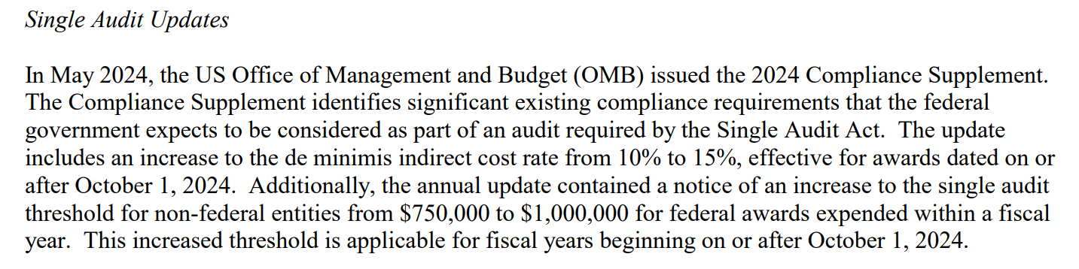

- Recurring Conversation

  - Uploading FSR’s into EGRAMs
    - If you have a procedure to help with this and would like to share it, please let the forum know.

- Adjournment 1st Jennifer Brassow 2nd Derek Burton

The next meeting will be on February 13, 2025, and will be virtual.

