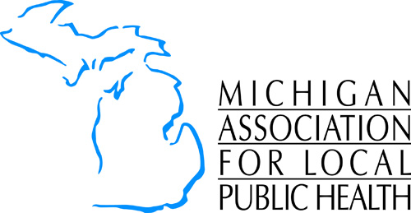
MALPH Award Nomination Form

AWARD
Friend of Local Public Health

NOMINEE

Name

Address

Home #

Employer

NOMINATOR

Name

Address

Home #

Employer

Credentials

City/State/Zip

Work

Email

E-mail

City/State/Zip

Work

ATTACH/INCLUDE

- Brief resume/work overview
- Narrative statement
- Letter(s) of support (can be signed by multiple health jurisdictions) (optional)
- Other documentation like news articles highlighting this individual’s work (optional)

Send nomination to:
Michigan Association for Local Public Health
Attn: Jodie Shaver at jshaver@malph.org or fax to 517-485-6412
PO BOX 13276
Lansing, MI 48901

Questions? Contact Jodie Shaver at jshaver@malph.org.

For OFFICE use ONLY
Nominee member Yes No Date Received ___________________________________
Form complete Yes No Date Nominator acknowledged______________________
Resume/work overview Yes No
Narrative Yes No

