October 16, 2021

BOARD MEMBERS
2021-2022

President
Sara Simmonds
Kent County
(616) 632 7316
President Elect
Tony Drautz
Oakland County
(248) 858 1320
Past-President
Andrew Cox
Macomb County
(586) 466 4135
Secretary
Elizabeth Suggitt
LMAS
(906) 643 1100
Treasurer
Chris Westover
Monroe County
(734) 240 7921
Directors
Steve Stoddard (2022)
Lapeer County
(810) 245 5791

Kevin Green (2022)
Calhoun County
(269) 969 6398

Dan Thorell (2022)
Grand Traverse County
(231) 995 6021

Tanya Rule (2024)
Western U.P.
(906) 482 7382

Steve King (2024)
Central Michigan
(989) 773 5921

President’s Report

- There was a MALEHA Board Meeting was held in September. After the first of the year, the Board will begin to review the By Laws for revision. This is needed so that the By Laws evolve with the Association to keep us nimble. The Technology Committee has also been charged with investigating cloud base solutions for MALEHA Documents and Information.

- MALPH addressed the funding issues surrounding the T2 program with EGLE (Dana DeBruyn) at their September meeting. She elevated the concern to EGLE leadership. As a result, Aaron Keating – EGLE Chief Deputy Director will be at the next MALPH meeting on November 8th to hear the concerns. The Groundwater Committee has been charged with putting together a simple survey to collect data that will be presented at the MALPH meeting with Aaron Keating.

Respectfully submitted,

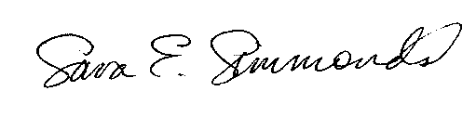

Sara Simmonds – MPA, REHS
MALEHA President

