Definitions
- Cloth Face Coverings Help Prevent the Spread of COVID-19
- Contact Tracing in the School Setting
- Recommended Scripts for Communication
- School Scenarios with Actions Steps
- Isolation/Quarantine Timeline
- Frequently Asked Questions

Coronavirus: Coronavirus Disease (COVID-19) is an illness caused by a virus that can spread from person to person. The virus that causes COVID-19 is a new coronavirus that has spread throughout the world.
Contact Tracing: A strategy for slowing the spread of disease in which public health workers communicate with infectious people to identify their contacts. They then follow up with those contacts to provide guidance on how to quarantine themselves and what to do if they develop symptoms of disease.
Quarantine: The practice of keeping someone who might have been exposed to COVID-19 away from others. Quarantine helps prevent spread of disease that can occur before a person knows they are sick or if they are infected with the virus without feeling symptoms. People in quarantine must stay home (usually 14 days), separate themselves from others, monitor their health, and follow directions from their state or local health department.
Isolation: The practice of separating people infected with the virus (those who are sick with COVID-19 and those with no symptoms) from people who are not infected.
People who are in isolation (usually for 10 days) must stay home until it’s safe for them to be around others. In the home, anyone sick or infected must separate themselves from others by staying in a specific “sick room” or area and using a separate bathroom (if available).
Close Contact: A person who was within 6 feet of a person infected with COVID-19 for more than 15 minutes with or without a mask.
Examples of close contacts include individuals who were close to a person who is infected with COVID-19 by providing care to them at home, sharing a living space, having direct physical contact with them (touched, hugged or kissed them), and sharing eating or drinking utensils. People may also be close contacts if they were somehow exposed to droplets from an infected person (sneezed or coughed on).
Types of Masks:
- Cloth Face Coverings: Cloth face coverings are masks made from material that are meant to cover your nose and mouth and to be secured under the chin and are not considered personal protective equipment (PPE). These are effective in reducing the spread of the virus.

https://www.cdc.gov/coronavirus/2019ncov/prevent-getting-sick/cloth-face- cover-guidance.html
- Surgical Masks: Surgical masks were originally intended to be worn by health professionals and are considered personal protective equipment. These are effective in reducing the spread of the virus.
- N95 or N95 respirator: A N95 mask, also known as a respirator, filters particles that meet a certain standard for air filtration, meaning that it filters at least 95% of airborne particles. These are recommended only for use by healthcare personnel who need protection from both airborne and fluid hazards (e.g., splashes, sprays).

Cloth Face Coverings Help Prevent the Spread of COVID-19

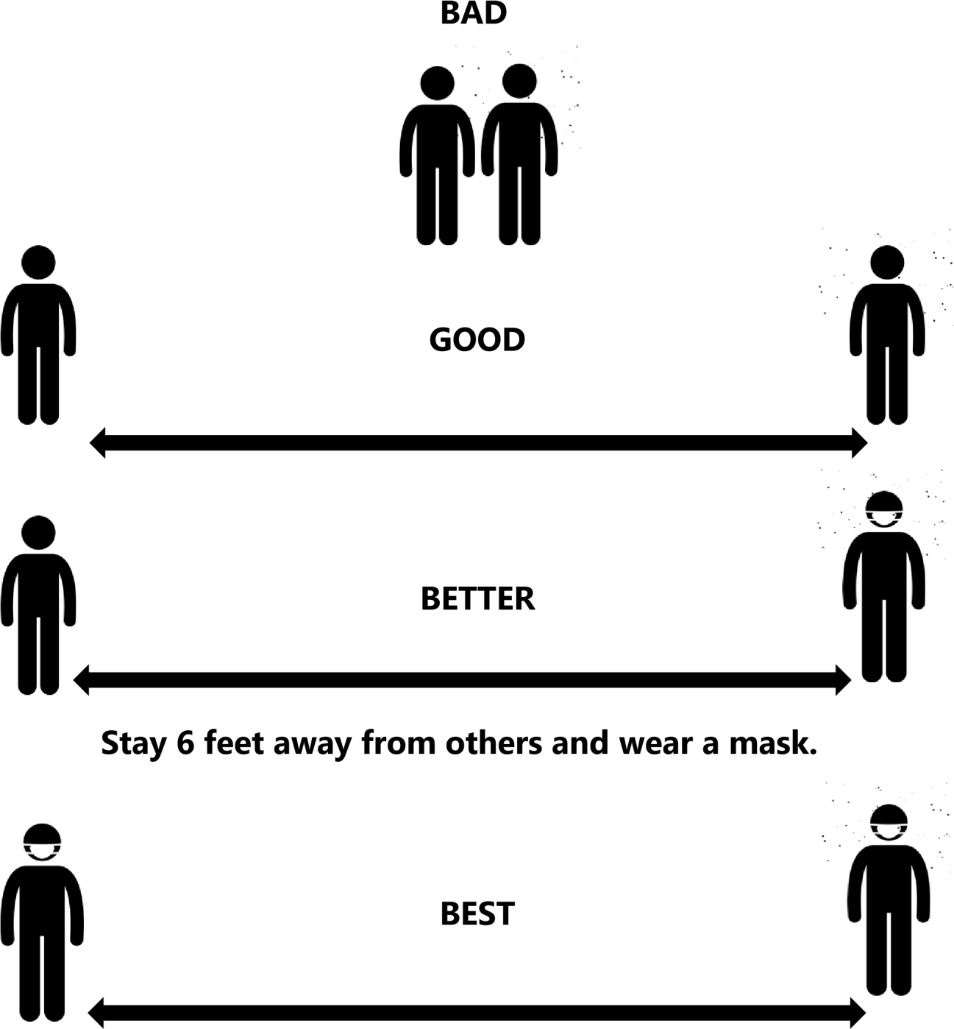
Stay 6 feet away from others and both wear a mask.

Contact Tracing in the School Setting
Contact tracing is a public health tool that is used to help stop the spread of certain communicable diseases. It involves identifying others that may have had recent close contact with a person confirmed to have the virus and giving those close contacts guidance on how to stay safe and protect others. This includes close contacts quarantining to prevent further spread of the virus. Quarantine is important with COVID-19 as a person can spread the virus before they know they are sick or if they are infected with the virus without feeling symptoms.
Symptomatic Case  Staff/Student tests positive after having symptoms.  Symptoms include:  - Cough  - Shortness of breath  - Fever (Temp >100.4°F)  - Chills  - Repeated shaking with chills  - Muscle pain  - Headache  - Sore throat  - New loss of taste or smell |  | Asymptomatic Case  Staff/Student tests positive and has NOT had symptoms.  Symptoms include:  - Cough  - Shortness of breath  - Fever (Temp >100.4°F)  - Chills  - Repeated shaking with chills  - Muscle pain  - Headache  - Sore throat  - New loss of taste or smell
Date symptoms started: / / 48 hours prior to this: / / |  | Test Date: / /  48 hours prior to test date: / /
Dates Staff/Student attended school starting from 48 hours prior to onset of symptoms:  / / / /  / / / /  / / / /  *If the staff/student did not attend school during/after the 2-day window, the need to contact trace is up to  school discretion. |  | Dates Staff/Student attended school starting from 48 hours prior to onset of symptoms:  / / / /  / / / /  / / / /  *If the staff/student did not attend school during/after the 2-day window, the need to contact trace is up to  school discretion.
Close contacts on those dates:  *Close contacts are those who were in proximity to the  infected person for >15 minutes and within 6 ft with or without a mask. |  | Close contacts on those dates:  *Close contacts are those who were in proximity to the  infected person for >15 minutes and within 6 ft with or without a mask.
Those who are identified as close contacts must quarantine (not leave the house unless necessary) for 14 days from last time of known exposure.

CDC Contact Tracing in the School Setting Helpful questions to consider when identifying close contacts in the school setting:

Who is the staff/student near (less than 6ft) throughout the day?
- Has there been adequate physical distancing in breakrooms & lunchrooms?
- Are there any others at the school that live with the staff/student, or carpool with them?
Other considerations for schools when there is more than one positive case identified (to look for patterns/areas of concern):
- Did the school already know staff/student had been identified as a close/household contact of someone who was positive for COVID-19?
- Is there one location/classroom in the school that seems to be more affected?
- Is there something else in common with positive cases?
- Mask adherence in the school? (not just while in the hallway, but during classroom time?)
Contact Tracing Resources:
- Contact Tracing: https://www.cdc.gov/coronavirus/2019- ncov/php/openamerica/contact-tracing-resources.html

Contact Tracer’s Guide to COVID-19:
https://www.cdc.gov/coronavirus/2019ncov/php/notification-of-exposure.html

Key Information to Collect During a Case Interview:
https://www.cdc.gov/coronavirus/2019-ncov/php/contact-tracing/keyinfo.html
- Quarantine Log: https://www.cdc.gov/coronavirus/2019-ncov/downloads/php/14- DayTemperature-and-Symptom-Log-for-Contact-Tracing.pdf

The KCHD begins contact tracing for related cases outside of the school community.
The KCHD alerts close contacts of COVID-19 exposure who are not associated with the school.
School interviews the COVID-19 positive person to identify close contacts per CDC definition.
School alerts families by providing general communication about COVID-19 positive case while protecting the identity of the person who is infected.

Contact Tracing in the School Setting
A student or staff person tests positive for COVID-19.
School alerts Kent County Health Department (KCHD) about COVID-19 positive case. Call 616-632-7228 to report.

School alerts close contacts of COVID-19 exposure who are a part of the school community.
All identified close contacts of the COVID-19 positive case must quarantine at home for 14 days from last positive day of exposure and monitor for symptoms.

Recommended Scripts for School Community

General COVID-19 Exposure in a School Setting
“We recently became aware of a [staff member/student/child] in our [school/childcare] setting that tested positive for COVID-19. We found out on [Insert Date Here] that the test came back positive. We are responsible for informing all [staff member/students/child(ren)] who are considered “close contacts” by the CDC guidelines. If you are required to quarantine because of an exposure, we will contact you. If your [student/child] does not qualify as a close contact, you will not hear from us.
We want to protect the confidentiality of this person unless there is a reason to inform
you of this person’s identity. At this time, it is our role to tell all the families of
[Insert School/Program Name Here] that we are moving forward under the guidance of the Kent County Health Department and that all measures have been taken to protect the wellbeing of your child(ren). Please monitor for onset of symptoms related to COVID-19, including fever, cough, difficulty breathing, headache, or new fatigue. If you note any change in the health of your child, please call your regular medical provider.”
COVID-19 Exposure in a Specific Group in School Setting:
“A [staff member/student] involved with [Insert Group Name] was exposed to COVID-19. When the [staff member/student] became aware of this exposure, they were tested. The [staff member/student] was with the [Insert Group Name] on [Insert Date Here] for approximately [Insert Amount of Time]. If you are required to quarantine because of an exposure, we will contact you. If your [student/child] does not qualify as a close contact, you will not hear from us. We want to protect the
confidentiality of this person unless there is a reason to inform you of this person’s identity. At this time, it is our role to tell all the families of [Insert School/Program Name Here] that we are moving forward under the guidance of the Kent County Health Department and that all measures have been taken to protect the wellbeing of your child(ren). Please monitor for onset of symptoms related to COVID-19, including fever, cough, difficulty breathing, headache, or new fatigue. If you note any change in the
health of your child, please call your regular medical provider.”

Student/Staff person is confirmed or symptomatic pending results or a close contact.
Scenario 1: | Scenario 2: | Scenario 3:
A student/staff person within the school is confirmed to have COVID- 19. | A student/staff person within the school is symptomatic and pending lab result for COVID-19. | A student/staff person within the school is a close contact to a confirmed COVID-19 case.
The student/staff person AND all household members of the student/staff person are immediately excluded from school.  The confirmed positive student/staff person must isolate at home. The student/staff person must be excluded from school until  - 3 days with no fever (without the use of fever-reducing medication) and  - Respiratory symptoms have improved (e.g. cough, shortness of breath) and  - 10 days since symptoms first appeared. | The student/staff person is excluded from school until results of the test are negative.  If positive, see scenario 1. If negative, the student/staff person must be symptom free for 24 hours without the use of medications prior to returning to school.  Household members, classmates, and teachers of the pending case should be monitored for symptoms while waiting for test results. If symptoms develop, they should call their medical provider to be tested for COVID-19. | The student/staff person must quarantine for 14 days since last date of close contact.  Household members, classmates, and teachers of the quarantined student/staff person may continue to attend school and should monitor for symptoms. If symptoms develop, they should call their medical provider to be tested for COVID-19.
Household members,
classmates, and teachers of
the quarantined student/staff
person who are close contacts
are excluded for 14 days after
their last date of close
contact.
*Close contact with a confirmed COVID-19 case is defined as being within 6 feet of a person who has tested positive for at least 15 minutes with or without a mask.

Household member of a student within the school is confirmed or symptomatic pending results or a close contact.
Scenario 1: | Scenario 2: | Scenario 3:
1. Household member of a student within the school has been confirmed to have COVID-19. | 2. Household member of a student within the school is symptomatic, pending results, and has had close  contact with a known case. | 3. Household member of a student within the school has had close contact to a known case of COVID-19.
Students who live in the same house as the COVID-19 positive person are excluded from school while the household member is in isolation (10 days). The student must quarantine for 14 days after the last date of close contact. | Students who live in the same household of the family member are excluded from school until test results are in.  If the household member is positive, see scenario 1. If the household member is negative, student can return to school. | Student can remain in school but should be monitored.  If COVID -19 symptoms develop in the household member, students should be excluded from school, and should be treated as in Scenario 1 pending results.
*Close contact with a confirmed COVID-19 case is defined as being within 6 feet of a person who has tested positive for at least 15 minutes with or without a mask.




Household member that
tested positive can return
to work, school or daycare.


Isolation and Quarantine Timeline
STAY HOME |  | RETURN TO WORK, SCHOOL, DAYCARE
ISOLATION PERIOD
The sick household member must remain in isolation for 10 days since symptoms first appeared and 3 days with no fever (without the use of fever-reducing medications) and other symptoms have improved.
The sick
household
member who
tested positive
must isolate at
home.

A household member becomes sick with COVID-19

People who live in the same household as the person who was tested positive must quarantine at home. | QUARANTINE PERIOD  Stay home 24/7 and monitor for symptoms for 14 days since last possible exposure. (The last possible exposure is when the sick family member’s isolation period ended.) |  | If the household members of the person who tested positive for COVID-19 do not develop symptoms, they can return to work, school, or daycare upon completing quarantine.
Household members cannot attend work, daycare, or school during the other household member’s isolation (10 days) or for the 14 days after the isolation period (quarantine). If the quarantined household member DOES develop symptoms, they cannot return until 10 days since first symptoms appeared AND 72 hours being fever-free AND other symptoms have improved. Isolation and quarantine periods start over any time a new household member become sick with COVID-19.
Everyone should assume exposure to COVID-19 and monitor for symptoms. Check your temperature and watch for symptoms. Call your doctor if symptoms develop. QUARANTINE keeps someone who was in close contact with someone who has COVID-19 away from others in case they become infected. People should stay home and monitor for symptoms. ISOLATION keeps someone who is sick or tested positive for COVID-19 from people who are not infected, even in their own home. In the home, anyone sick or infected should separate themselves from others by staying in a specific area and using a separate bathroom (if available). For more information on quarantine and isolation, visit https://www.cdc.gov/coronavirus/2019-ncov/if-you-are-sick/quarantine-isolation.html.

Frequently Asked Questions for School Administrators and Teachers
1. What is the difference between isolation and quarantine?

Isolation is for people who are COVID positive. It separates people who are infected with the virus from people who are not infected. It usually lasts 10 days.
Quarantine is for people who are well but are exposed to someone who is COVID positive. It keeps someone who might have be infected with the virus away from others. It lasts 14 days since the last possible exposure.
2. How long must a teacher or staff person be out of school if they test positive for COVID-19?

A teacher or staff person that tests positive for COVID-19 should isolate at home. The teacher or staff person may return to school after 3 days with no fever and respiratory symptoms have improved (e.g. cough, shortness of breath) and 10 days have passed since symptoms first appeared. https://www.cdc.gov/coronavirus/2019-ncov/if-you-are-sick/end-home- isolation.html
3. How long must a student, teacher or staff person be out of school if they have a family member in the same house as them that tests positive for COVID-19?

A student, teacher or staff person that lives in the same house as someone who tests positive for COVID-19 must remain out of school the entire time the family member is in isolation (typically 10 days) plus 14 additional days of quarantine. The total time out of school would be at least 24 days.
https://www.cdc.gov/coronavirus/2019-ncov/if-you-are-sick/quarantine.html

4. If a person tests positive but does not have symptoms, can they work from home?

Yes, if the school has a system in place for working from home this is encouraged. An employee with mild symptoms should be able to work from home as well.
5. If a teacher or staff member has a household member that tests positive but does not have symptoms, can the teacher or staff member come to work anyway and monitor for symptoms?

No, asymptomatic people who test positive can still spread the virus. A teacher or staff member that has a household member that tests positive and is considered a close contact must quarantine during the household member's isolation period and 14 days after the isolation period ends.

6. Must we close a classroom if a person with COVID-19 attended class in that classroom? If so, for how long?

Yes, the classroom should be closed, cleaned and disinfected. It is recommended to close off the area for at least 24 hours. If that is not feasible, wait as long as possible and then clean and disinfect the classroom following CDC guidance. https://www.cdc.gov/coronavirus/2019- ncov/community/disinfecting-building-facility.html.
7. If a teacher or staff person was in a classroom full of children, and that teacher later finds out that they have COVID-19 while they were in the classroom, must all the class be quarantined, or only those children who were within 6 feet of the teacher for 15 minutes or more?

The entire class must be quarantined and monitor for COVID-19-related symptoms.
8. If the teacher was wearing a cloth mask in the classroom, and that teacher later finds out that they have COVID-19 while they were in the classroom, do the children still have to be quarantined?

Yes, the children who were in the classroom are still considered close contacts and must quarantine for 14 days and monitor for symptoms.

9. Does a sibling of a child in quarantine have to be quarantined?

No, if the sibling was not a direct contact of a person who tested positive for COVID-19, then they should monitor for symptoms and can continue attending school.
10. If a student has an illness that is not COVID-19, like a cold, does that child still have to be out of school until they are 72 hours fever free?

If the student is experiencing any COVID-19-related symptoms, they might have COVID-19 and they should not attend school. They should contact their regular medical provider and get tested for COVID-19.

If they test negative for COVID-19, then they can return after 24 hours. https://www.cdc.gov/coronavirus/2019-ncov/if-you-are-sick/steps-when-sick.html
11. Does the school have to inform the families of students when a child is excluded from school because of COVID-19, or does the Health Department do that?

The school is responsible for communication to families of students. However, the Health Department can provide guidance as needed.
12. How many children have to be sick with COVID-19 before a school closes?

The Health Department will work closely with School Administration recognizing there are many factors to be considered when closing a school.
13. Does a teacher, staff person, or student have to retest for COVID-19 after testing positive before they are allowed back to school?

No, the teacher, staff person or student who tested positive can return to school after 3 days with no fever and respiratory symptoms have improved (e.g. cough, shortness of breath) and 10 days have passed since symptoms first appeared.

The health department does not recommend a retest. Sometimes a person will continue to test positive even though they are no longer infectious.
14. How can we know when a person is no longer infectious?

The general timeline is 10 days since symptoms first appeared.
15. If a student changes classes and is with many different students during the day rather than just one classroom of students, and that student tests positive, do all those students have to quarantine?

Yes, this is one reason it is wise to keep students in small cohorts.
16. Should all students get tested for COVID-19 prior to starting school?

No, the COVID-19 test only indicates the presence of the virus the moment the test is taken.
17. If a student teacher or staff are told they are a close contact of a positive case and they get a COVID-19 test that is negative are they released from quarantine?

No, a person can become COVID-19 positive any time during quarantine (the 14 days after the exposure).
18. Should students get an anti-body test to prove that they have already had COVID-19 and thus do not need to quarantine if they are exposed again?

No, students who have already tested positive for COVID-19 will need to quarantine again. We are still learning about the virus and there is a possibility of reinfection. https://www.cdc.gov/coronavirus/2019-ncov/if-you-are-sick/quarantine.html
19. If a student or teacher already had a proven case of COVID-19 and then has an exposure in school, do they have to quarantine anyway?

Yes, students or teachers with proven cases of COVID-19 will still need to quarantine. We are still learning about the virus and there is a possibility of reinfection.
20. Does the school have to tell families which child tested positive for COVID-19? Isn’t
that a violation of HIPAA?

The identity of the child or teacher should be protected as much as possible. Close contacts will be contacted and only given information related to their exposure. The name of the COVID-19 student or teacher will be shared on a need to know basis only.
21. Will children who are at the highest risk for complications, such as children with severe respiratory problems, be required to stay out of the school classroom until this pandemic is over?

The decision to send a child to school or not will be made jointly by the parent and school with
guidance from the child’s medical provider.

22. What if a staff member/student goes out of state?
There are no current restrictions for staff members or students who travel out of state. However, everyone should assume COVID-19 exposure and monitor for symptoms.

