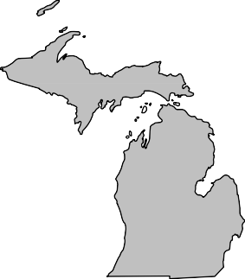
BOARD MEMBERS 2020-2021

President Andrew Cox Macomb County (586) 469 5510

President Elect Sara Simmonds Kent County (616) 632 7316

Past-President Matt Bolang Livingston County (517) 552 6870

Secretary Liz Braddock Mid-Michigan
(616) 302 6301

Treasurer Chris Westover Monroe County (734) 240 7921

Directors
Ken Bowen (2021)
Ionia County (616) 527 5341

Tony Drautz (2021) Oakland County (248) 858 1320

Steve Stoddard (2022)
Lapeer County (810) 245 5791

Kevin Green (2022) Calhoun County (269) 969 6398

Dan Thorell (2022) Northwest Health
(231) 547 7651

Michigan Association of

Local Environmental Health Administrators MALEHA

Representing Local Environmental Public Health Departments in Michigan

Forum Report – July 2021

- The Nature Conservancy and Public Service Consultants are reaching out to few remaining jurisdictions that have not responded to the survey to participate in the septic survey. Response rate was close to 80%.

- The board has discussed internally returning back to in person meetings. State agencies have stated they are able to attend in person. We are looking at our first in person meeting potentially in August. Location TBD due Nature Association not currently being available for meetings.
- The board will be meeting with state partners to have discussions around current capacities of local health jurisdictions and future initiatives we can work together on.
- We are moving forward with planning our MALEHA Directors conference in September in person at the RAM center. Details will be coming out shortly from Chris Westover on registration.
- MPHI will continue to be on pause for State Accreditation. This pause includes:
  - On-Site Reviews are paused and will be rescheduled at a later date in cooperation with local health departments and programs within Accreditation at the state;
  - An extension to the Corrective Plan of Action (CPA) process for those health departments who are still in the process of implementing CPAs in response to their On-Site Review;
  - Suspension of Minimum Program Requirements (MPRs) during the COVID-19 response; and
  - Suspension of the Standards Review Committee process.

Respectfully Submitted, Andrew Cox
July, 2021

“Protecting, Promoting and Enhancing Public and Environmental Health in Michigan”

