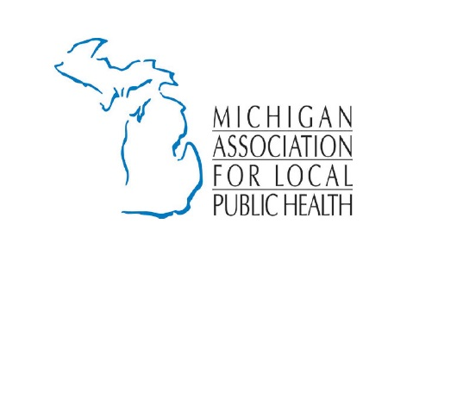
Michigan’s
Emergency Preparedness

Michigan’s system of local health departments works closely with The Michigan Department of Health and Human Services’ Bureau of EMS, Trauma, and Preparedness. Together, the bureau and local health departments serve to better protect the health and well-being of Michigan citizens through the administration and continuous improvement of emergency medical services, trauma system, as well as all-hazards preparedness planning and response. The bureau is composed of two divisions: the Division of EMS and Trauma, and the Division of Emergency Preparedness and Response.

Public Health Preparedness and Response Grants: The proposed Presidential budget for 2020 is predicted to have a 12% cut to the federal Department of Health and Human Services. This has the potential to impact emergency preparedness funding allocated to the Centers for Disease Control and Prevention, Public Health Emergency Preparedness (PHEP) and the Assistant Secretary for Preparedness and Response, Hospital Preparedness Program (HPP) Cooperative Agreements.

In FY 19, Michigan took slightly less than 1% cut to PHEP and 3.8% cut to HPP which directly impacts state, local and healthcare emergency preparedness planning and response strategies. Federal emergency preparedness funding is the only funding available to MDHHS for state and local health programs and has experienced a steady decline since 2006.

Recent outbreaks of hepatitis A and measles across the country demonstrate the criticality of state and local public health standing on the front line of emergencies. Ensuring adequate funding must remain a priority to maintain and augment resources established.

These programs are critical to responding to communicable disease outbreaks, environmental health emergencies (including contaminated drinking water), natural disasters (flooding, snow and extreme cold), mass casualty incidents (active shooters or bombings), and medical surge incidents (natural disasters etc.) which could impact the general population or special populations such as pediatrics, elderly and vulnerable populations.

Resources to learn more:
Sources:
Bureau of EMS, Trauma, and Preparedness
https://www.michigan.gov/mdhhs/0,5885,7-339-71548_54783_72703---,00.html

The Division of Emergency Preparedness and Response
https://www.michigan.gov/mdhhs/0,5885,7-339-71548_54783_54826---,00.html

The Division of EMS and Trauma
EMS: https://www.michigan.gov/mdhhs/0,5885,7-339-73970_5093_28508---,00.html
Trauma: https://www.michigan.gov/mdhhs/0,5885,7-339-71551_69345---,00.html

