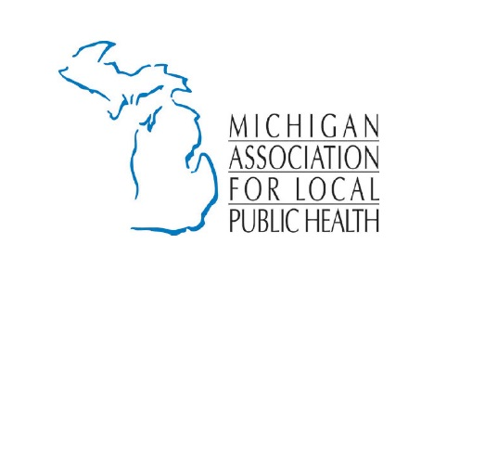
For Discussion

- Essential Local Public Health Services: Governor Whitmer has recommended flat funding for FY 2020. The House and Senate have not presented budgets yet. We are requesting that the State honor its 50/50 cost share as provided in PA 368 of 1978 – the Public Health Code, Section 333.2475. If the state were to fund ELPHS at 50/50, how does that impact your department’s service delivery?

- Funding in Line with Consumer Price Index: We are requesting that local public health have sustainable funding, seeking increases that are commensurate with the Headlee Amendment or a Consumer’s Price Index rate. This eliminates year after year of uncertainty regarding funding levels. The cost of service delivery goes up each year including, but not limited to, transportation, operations, equipment, staffing, supplies, etc.

- Community Health Assessment Dollars: We recommend financial resources to conduct community health assessment plans. The purpose is to develop short-term and long-term systematic plans to address ongoing and emerging public health issues. It shall describe how the local health department and strategic community partners will work together to improve the health of the population.

- Public Health Advisory Commission Report: Discuss recommendations of support or areas of concern. We must tell the story that local health departments collaborate amongst each other, including board meetings, forums, emergency preparedness, and public information officers.

- Where are your priority areas? Environmental Health? Sexually Transmitted Diseases? PFAS? Hepatitis A? Bring awareness to the issues your jurisdiction is facing: Pertussis? Measles? Influenza? Water? Contamination? Housing? Jobs? Vapor Intrusion? Maternal and Infant Health Program? Revised Total Coliform Rule? Statewide Sanitary Code?

- Immunization Waiver Rules: Outreach? Issues? Success? Lessons learned? Next Steps?

Additional discussion:
- A Department of Public Health: Restore core public health functions (water/sewerage, food, and infectious disease) into a single autonomous section within the MDHHS or a separate department.
- Support the Public Health Advisory Council: To study issues, problems, and programs to make recommendations from a perspective of health (Health in All Policies).
- Regionalization: Where are you collaborating or cross jurisdictional sharing? Community partnerships with providers, health systems, schools, faith-based community, employers, etc.
- Healthy Michigan Plan Update: How many clients do you see? Has the impact been beneficial? What do you do for outreach/enrollment? Has it impacted other programs like family planning or BCCCP? If so, where is there additional need in service delivery to reduce uncompensated costs?
- Gaps in service delivery within your jurisdiction: Veteran services, maternal/infant programming, access to healthcare, oral health, etc.
- Have you been able to solve a problem for a constituent: How were you able to link or help?

