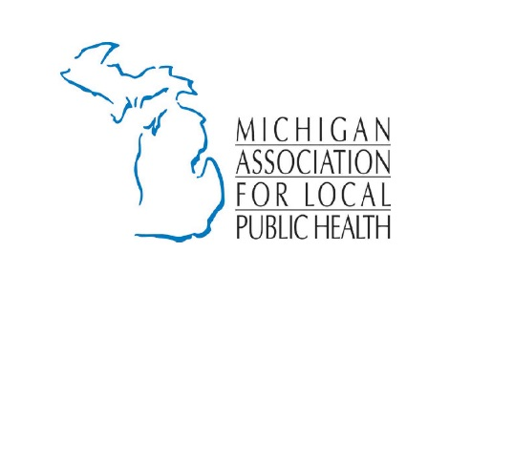
Local Public Health’s Unique Role

Local Health Departments (LHD) protect and improve community well-being by preventing disease, illness and injury and impacting social, economic and environmental factors fundamental to excellent health. The LHD is the foundation of the local public health system that comprises public- and private-sector health care providers, academia, business, the media, and other local and state governmental entities.

- Track and investigate health problems and hazards in the community. LHDs gather and analyze data on the community's health to determine risks and problems. This information drives specific programs and activities designed to control multiple threats: both communicable and chronic diseases; food, water, insect and other "vector-borne" outbreaks; biological, chemical and radiological hazards; and public health disasters.

- Prepare for and respond to public health emergencies. As a result of extensive and ongoing preparation, LHDs respond quickly and effectively to disease outbreaks and other public health events—they are trained extensively to respond to the increase of the incidence of diseases, natural disasters, and acts of terrorism. They coordinate delivery of drugs, supplies, and provisions to victims and populations at risk. They keep the public informed and serve as the network hub for community hospitals, physicians, and other health care providers.

- Develop, apply and enforce policies, laws and regulations that improve health and ensure safety. Acting on their knowledge about their community, LHDs create data-driven policies to meet health needs and address emerging issues. They help craft sound health policies by providing expertise to local, state and federal decision makers. LHDs also inform individuals and organizations about public health laws while monitoring and enforcing compliance.

- Lead efforts to mobilize communities around important health issues. With local and state government agencies, businesses, schools, and the media, LHDs spearhead locally organized health promotion and disease prevention campaigns and projects. They galvanize the community to tackle disease prevention and personal health care needs. LHDs also educate and encourage people to lead healthy lives through community forums; public workshops and presentations; and public service announcements.

- Link people to health services. LHDs connect people with personal health services, including preventive and health promotion services, either in the community or as close to the community as possible. They also advocate for development of needed programs and services in underserved populations and continuously monitor the quality and accessibility of public health services.

- Achieve excellence in public health practice through a trained workforce, evaluation, and evidence-based programs. LHDs recruit and develop skilled workers with expertise in core public health competencies. They ensure that public health workers update their knowledge and skills through continuing education, training and leadership development activities. They regularly evaluate the effectiveness of all programs and activities using evidence-based standards and strive to adapt successful interventions.

