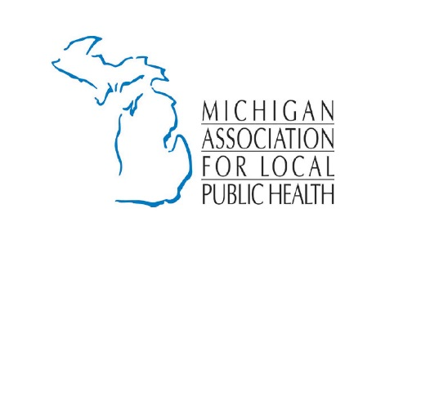
2019 Measles Outbreak

The Michigan Department of Health and Human Services has updated the confirmed count of measles cases in the state to 39, with infected individuals residing in Oakland and Wayne counties. Oakland County has 38 cases and Wayne County has one. Infected individuals range in age from 8 months to 63 years of age.

The measles vaccine is highly effective and very safe. A single dose of measles vaccine protects about 95 percent of children, but after two doses, almost 100 percent are immune. You cannot get measles from the vaccine. It is effective within 72 hours of exposure to prevent illness. In addition, immune globulin (Ig) treatment is effective within six days of exposure for high-risk individuals. Talk to your healthcare provider to determine if immune globulin is right for you and if it is available.

High-risk individuals include those who are unvaccinated or unsure about vaccination status, pregnant women and those who are immune-compromised (have a weakened immune system due to illness and diseases like HIV, malnutrition and/or medications).

Measles is highly contagious; it is a vaccine-preventable disease that is spread by direct person-to-person contact and through the air.

The virus can live for up to two hours in the air where the infected person was present. Symptoms of measles usually begin 7-14 days after exposure, but can appear up to 21 days after exposure and may include:

- High fever (may spike to over 104˚F).
- Cough.
- Runny nose.
- Red, watery eyes (conjunctivitis).
- Tiny white spots on the inner cheeks, gums, and roof of the mouth 2-3 days after symptoms begin.
- A rash that is red, raised, blotchy; usually starts on face, spreads to trunk, arms, and legs 3-5 days after symptoms begin.

If symptoms develop, residents are urged not to visit their doctor or emergency room unless they have called ahead so they can take precautions to prevent exposure to other individuals.

From 2001 – 2012, the average number of measles cases reported nationally per year was about 60. But in recent years there have been far more, which is of great concern to public health authorities. So far this year, there have been 314 cases of measles confirmed in 15 states. In 2018, Michigan had 19 cases of measles, the most reported in the state since 1994; the majority of people who got measles were not vaccinated. The first of two routine childhood measles vaccine doses is given at 12 months of age. A second vaccine dose is given before the start of kindergarten. For international travel, infants as young as 6 months should be vaccinated against measles. Measles vaccine, or other acceptable documentation of immunity to measles, is recommended for all persons travelling internationally.

Sources:
2019 Michigan Measles Outbreak Information
https://www.michigan.gov/mdhhs/0,5885,7-339-73971_4911_4914_68359-492981--,00.html

Centers for Disease Control and Prevention
https://www.cdc.gov/measles/

