Michigan State and Local Public Health COVID-19 Standard Operating Procedures
Interim 3/6/2020

Background
On December 31, 2019, an outbreak of pneumonia in Wuhan City, Hubei Province, China was reported to the World Health Organization (WHO). This outbreak is now known to be caused by the 2019 novel coronavirus. On February 11, 2020 the WHO announced the official name for the disease as COVID-19. As of March 6, 2020, 101,765 confirmed cases have been reported in multiple countries, including 260 U.S. cases. See current case counts at the 2019-nCoV Global Cases by Johns Hopkins CSSE: https://gisanddata.maps.arcgis.com/apps/opsdashboard/index.html#/bda7594740fd40299423467b48e9ecf6 Initially, many patients reported exposure to a large seafood and animal market, suggesting animal-to-person spread. However, person-to-person spread has been confirmed. Active investigations on the period of communicability and how the virus is spread are ongoing. Patients with COVID-19 may experience fever, cough, dyspnea, chest tightness, and pneumonia. Healthcare providers should obtain a detailed travel history on patients being evaluated with fever and acute respiratory illness and report any suspect cases of COVID-19 to the Local Health Department (LHD). A Patient Under Investigation (PUI)/Case Report Form should be completed and provided when reporting suspect PUIs. The most current Michigan PUI form may be found at www.michigan.gov/coronavirus under “For Health Care Professionals”. The Michigan Department of Health and Human Services (MDHHS) is working closely with LHDs and the Centers for Disease Control and Prevention (CDC).
On March 5, 2020, the CDC posted the Interim US Guidance for Risk Assessment and Public Health Management of Persons with Potential Coronavirus Disease 2019 (COVID-19) Exposures: Geographic Risk and Contacts of Laboratory-confirmed Cases (https://www.cdc.gov/coronavirus/2019-ncov/php/risk-assessment.html). This CDC monitoring and movement risk-assessment guidance provides isolation, quarantine, and monitoring guidance for potentially exposed individuals. As of March 6, 2020, China, Iran, South Korea, and Italy are listed as a CDC Travel Warning Level 3; Japan is listed as a CDC Travel Alert Level 2. Travel Alerts are posted at https://wwwnc.cdc.gov/travel/notices. For the most current information, visit: www.michigan.gov/coronavirus and www.cdc.gov/coronavirus/2019-ncov/index.html
On March 4, 2020, the CDC expanded the criteria for testing, indicating that clinicians should use their judgment to determine if a patient has signs and symptoms compatible with COVID-19 and whether the patient should be tested. Decisions on which patients receive testing should be based on the local epidemiology of COVID-19, as well as the clinical course of illness. Most patients with confirmed COVID-19 have developed fever and/or symptoms of acute respiratory illness (e.g., cough, difficulty breathing). Clinicians are strongly encouraged to test for other causes of respiratory illness, including infections such as influenza. Epidemiologic factors that may help guide decisions on whether to test include: any persons, including healthcare workers, who have had close contact with a laboratory-confirmed COVID-19 patient within 14 days of symptom onset, or a history of travel from affected geographic areas within 14 days of symptom onset.

Receiving a Referral for a Traveler
Traveler Evaluation and Monitoring (TEAM-COVID-19) Protocol Overview
☐ | - Traveler referrals are expected to be sent from Epi-X to MDHHS; these will also be listed on the CDC platform, DCIPHER (Data Collation & Integration for Public Health Event Response)
☐ | - MDHHS enters all traveler information into the Outbreak Management System (OMS) under 2019-NCOV-2020-STATEWIDE; jurisdictions with travelers are notified via daily MIHANs.
☐ | - The LHD establishes contact with the traveler and monitors health status for 14 days since last exposure; LHD enters information in OMS.
☐ | - If a monitored traveler becomes ill with respiratory symptoms/fever, this person should be referred for care and should contact the healthcare facility prior to arrival about their travel/ COVID-19 exposure history. Follow suspect PUI procedures (see section below).
☐ | - If a traveler remains asymptomatic, home-quarantine can be lifted upon completion of the monitoring period.
☐ | - See pages 16-20 for full TEAM Protocol. See current CDC Risk assessment and Monitoring at: https://www.cdc.gov/coronavirus/2019-ncov/php/risk-assessment.html

Initial LHD Contact with Travelers
For the initial contact with referred travelers, MDHHS recommends twice daily (AM/PM) attempts for two days. These contact attempts should include calling and texting all valid phone numbers, leaving voice messages, and sending emails. If, after two days of attempts, the LHD cannot reach the traveler, the recommendation is to send a letter (if a residential address was provided), note the contact attempts and outcome in OMS, and mark the monitoring status as loss to follow up. If the traveler contacts the LHD, the OMS referral can be re-activated to complete the monitoring period or to document that the monitoring period is over. The final health status of the traveler should be recorded. All initial information entered in the OMS is as it is received by MDHHS in the Epi-X referral from the CDC Quarantine Stations and Customs and Border Patrol. For Michigan residents, contact information may be obtained through other reporting sources (e.g., MCIR), if the individual has a report in the system.
MDHHS Guidance on Traveler Monitoring and Movement
Individuals who have had travel from mainland China outside Hubei Province, Iran, or another country with widespread, sustained transmission or with sustained, community transmission, but have not had any exposures that meet a “high risk” definition are considered to be “medium risk”. For asymptomatic individuals at “medium risk”, CDC recommends various levels of management as listed below.
Asymptomatic, “medium risk”:
- Travelers from mainland China (outside Hubei Province) or Iran:
  - Recommendation to remain at home or in a comparable setting, practice social distancing, self-monitor with public health supervision, and postpone additional long-distance travel on commercial conveyances after reaching final destination
- Travelers from a country with widespread transmission (other than China or Iran):
  - Remain at home or in a comparable setting, practice social distancing, self-monitor, and postpone additional long-distance travel on commercial conveyances after reaching final destination
- Travelers from a country with sustained community transmission:
  - Practice social distancing and conduct self-observation
Michigan, along with other states, have opted to conduct active monitoring as the method of public health supervision, and to strongly recommend self-quarantine. To encourage compliance of that self-quarantine in a home setting, LHDs should try to establish a rapport with travelers. Inform travelers of resources that can support this quarantine, (e.g., grocery delivery services, exclusion letters for school/work, etc.). There may be circumstances where a traveler who is otherwise compliant with self-quarantine must leave the house for essential services (e.g., unrelated doctor appointment or to obtain groceries). If the traveler does leave the house, they should be instructed to inform the LHD of their plan so that those locations can be noted in OMS and tracked in the event that the traveler becomes ill with a possible novel coronavirus infection. The traveler does not need to wear a mask when making these essential trips unless otherwise directed. Travelers should also be made aware that if they experience any symptoms (e.g., cough, sore throat, fatigue, chills) or any change in baseline health that might be indicative of a viral prodrome, they should stay at home unless they decide to pursue medical care. In these instances, communication with the LHD and medical facility should occur prior to the individual presenting for care. There may be instances where LHDs need to consider pursuing legal recourse for asymptomatic or symptomatic individuals who refuse to refrain from attending work/school/unnecessary trips in public (e.g., going to the movies), or otherwise engage in activities that could constitute a health risk to others. If legal recourse is being pursued, please notify the MDHHS. This guidance is subject to change as more is learned about the virus, the outbreak progression, and as CDC recommendations are updated.

Receiving a Referral for a Suspect Patient Under Investigation (PUI)
☐ | - Referrals may be received from healthcare providers, LHDs, or Q-Stations. Obtain:
 | ☐ | Name, title, and phone number of caller
 | ☐ | Patient identifiers (full name, DOB, sex)
 | ☐ | Patient address and/or county of residence (or location of where they are staying)
 | ☐ | Patient location & status (facility name, inpatient, ED, released to home, etc.)
 | ☐ | Illness onset and description of symptoms
 | ☐ | Patient travel: dates and specific location (e.g., Wuhan, China, etc.)
 | ☐ | Any testing results (e.g., influenza PCR); if appropriate, recommend respiratory panel
 | ☐ | Which specimens have been collected? Are they being stored and retained properly?
☐ | - Consider monitored contacts who become ill with compatible symptoms as suspect PUIs. These individuals should be referred for care; contact the healthcare facility prior to arrival and notify about potential for COVID-19 disease. Follow suspect PUI procedures.
☐ | - For suspect PUIs, request a completed PUI form from the physician or assist in the completion of the form. See current MDHHS PUI form at www.michigan.gov/coronavirus
☐ | - If, after consultation with public health, the specimen will be sent to BOL for COVID-19 testing, the LHD creates a MDSS Novel Coronavirus case with outbreak name: “WUHAN19-20”. If the person is under PH monitoring, a MDSS case can be created from OMS.
 | ☐ | Public Health consultation should include discussions on ruling out other etiologies (e.g., respiratory panel), the current epidemiology, and the patient’s individualize risk.
☐ | - For any PUI approved for testing, consider collecting information on close contacts. These close contacts can be entered into OMS for monitoring prior to receiving test results. LHDs can consider imposing self-quarantine for these contacts based on the PUI risk assessment.
☐ | - Upload the completed PUI form as an attachment in the MDSS notes tab for that individual.
☐ | - Enter “Specimens to BOL” in the “Local 1” field of the Novel Coronavirus case report form.
☐ | - The nCoV ID is the patient’s MDSS Investigation ID, proceeded by MI [Example:MI-1234567]
☐ | - MDHHS CD Division staff translate the PUI information into the MDHHS 2019-nCoV linelist, which serves as notification to BOL that specimens can be tested.
☐ | - If individual was previously entered into MDSS but does not meet current PUI criteria and will not be tested for COVID-19, classify referral as “not a case”.
☐ | - MDHHS CD Division staff work with LHD to provide recommendations on:
 | ☐ | Specimen collection and testing
 | ☐ | Patient isolation and infection control (within the facility or at home)
 | ☐ | Identification and monitoring of close contacts
☐ | - Specimens sent to BOL require the submitter to complete the test requisition form (https://www.michigan.gov/documents/DCH-0583TEST_REQUEST_7587_7.pdf); specimens tested positive at BOL are considered “presumptive” but are actionable.
☐ | - Presumptive positive specimens are forwarded to CDC; BOL completes CDC test req form.
☐ | - The patient should remain in isolation at the facility or at home, depending on health status.
☐ | - If a PUI tests negative for COVID-19, home-isolation can be lifted and any close contact monitoring ends. If the individual continues to be ill with respiratory symptoms, follow standard respiratory illness guidelines (stay home while ill, practice good hand hygiene).
☐ | - If a PUI tests positive and is confirmed as a case of COVID-19, contact tracing and monitoring will immediately be initiated in coordination with the LHD, MDHHS, and CDC.

PUI/Case Data Collection and Transmission
☐ | - For PUIs testing positive for COVID-19:
 | ☐ | MDHHS CD Division Staff update the PUI’s status and report the confirmed case to CDC.
 | ☐ | Basic case information is entered into the OMS COVID-19 investigation outbreak.
 | ☐ | LHD interviews the case using the assigned questionnaire in OMS (investigation).
 | ☐ | MDHHS CD Division Staff submits questionnaire data by transcribing into DCIPHER.
 | ☐ | Contact tracing activities are expanded. Potential for CDC on-site assistance.

Additional Information
☐ | - WHO Situation Reports
 | ☐ | https://www.who.int/emergencies/diseases/novel-coronavirus-2019/situation-reports
☐ | - Johns Hopkins Tracker
 | ☐ | https://gisanddata.maps.arcgis.com/apps/opsdashboard/index.html#/bda7594740fd40299423467b48e9ecf6
☐ | - CDC Guidance Links
 | ☐ | General Page: https://www.cdc.gov/coronavirus/2019-ncov/index.html
 | ☐ | Case Definition: https://www.cdc.gov/coronavirus/2019-nCoV/clinical-criteria.html
 | ☐ | Specimens: https://www.cdc.gov/coronavirus/2019-nCoV/guidelines-clinical-specimens.html
 | ☐ | Infection Control: https://www.cdc.gov/coronavirus/2019-nCoV/infection-control.html
 | ☐ | Travel: https://www.cdc.gov/coronavirus/2019-ncov/travelers/index.html
 | ☐ | Risk assessment & Monitoring: https://www.cdc.gov/coronavirus/2019-ncov/php/risk-assessment.html

Page intentionally left blank.

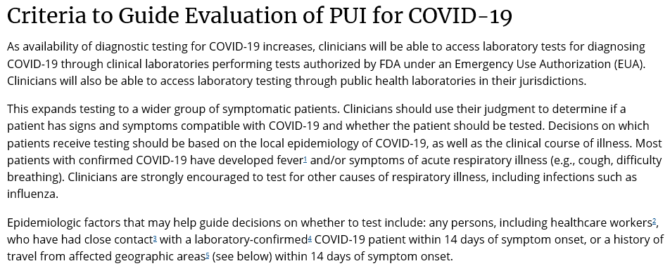

Footnotes
¹Fever may be subjective or confirmed
²For healthcare personnel, testing may be considered if there has been exposure to a person with suspected COVID-19 without laboratory confirmation. Because of their often extensive and close contact with vulnerable patients in healthcare settings, even mild signs and symptoms (e.g., sore throat) of COVID-19 should be evaluated among potentially exposed healthcare personnel. Additional information is available in CDC’s Interim U.S. Guidance for Risk Assessment and Public Health Management of Healthcare Personnel with Potential Exposure in a Healthcare Setting to Patients with Coronavirus Disease 2019 (COVID-19).
³Close contact is defined as—
- being within approximately 6 feet (2 meters) of a COVID-19 case for a prolonged period of time; close contact can occur while caring for, living with, visiting, or sharing a healthcare waiting area or room with a COVID-19 case
– or –
b) having direct contact with infectious secretions of a COVID-19 case (e.g., being coughed on)
If such contact occurs while not wearing recommended personal protective equipment or PPE (e.g., gowns, gloves, NIOSH-certified disposable N95 respirator, eye protection), criteria for PUI consideration are met. Additional information is available in CDC’s updated Interim Infection Prevention and Control Recommendations for Patients with Confirmed COVID-19 or Persons Under Investigation for COVID-19 in Healthcare Settings.
Data to inform the definition of close contact are limited. Considerations when assessing close contact include the duration of exposure (e.g., longer exposure time likely increases exposure risk) and the clinical symptoms of the person with COVID-19 (e.g., coughing likely increases exposure risk as does exposure to a severely ill patient). Special consideration should be given to healthcare personnel exposed in healthcare settings as described in CDC’s Interim U.S. Guidance for Risk Assessment and Public Health Management of Healthcare Personnel with Potential Exposure in a Healthcare Setting to Patients with COVID-19.
⁴Documentation of laboratory-confirmation of COVID-19 may not be possible for travelers or persons caring for COVID-19 patients in other countries.
⁵Affected areas are defined as geographic regions where sustained community transmission has been identified. Relevant affected areas will be defined as a country with at least a CDC Level 2 Travel Health Notice. See all COVID-19 Travel Health Notices.
Accessed on 3/6/2020 https://www.cdc.gov/coronavirus/2019-nCoV/hcp/clinical-criteria.html; Criteria is subject to change, please use link to confirm criteria.


Novel Coronavirus (COVID-19) Monitoring Using the MDHHS

Outbreak Monitoring System (OMS)

MDHHS is using the Outbreak Management System (OMS) to maintain monitoring data for the novel coronavirus (COVID-19) outbreak. Monitoring will occur in two instances:

Travel Monitoring
When MDHHS receives a referral for an individual that warrants health monitoring, MDHHS will enter the traveler’s information into OMS under the outbreak name 2019-NCOV-2020-STATEWIDE and will notify the appropriate Local Health Jurisdiction by email. Local Health Jurisdictions should enter monitoring data into OMS within one business day of each monitoring contact/outreach (same day is preferable). For additional monitoring guidance or OMS assistance, please contact your Regional Epidemiologist.

Contact Monitoring
When a confirmed case is identified, all close contacts to that case will need to be monitored for 14 days from last exposure. The Local Health Jurisdiction will be responsible for identifying the case’s close contacts, entering those contacts and monitoring data in OMS. Household contacts of a confirmed case may need additional assessment regarding monitoring and movement. Consult with MDHHS. All monitoring data should be entered into OMS within one business day of each monitoring contact/outreach (same day is preferable). Monitoring is required to be at least once daily by the Local Health Jurisdiction. For OMS assistance, please contact your Regional Epidemiologist.

How to Access OMS
- Log into MiLogin and select Michigan Disease Surveillance System.
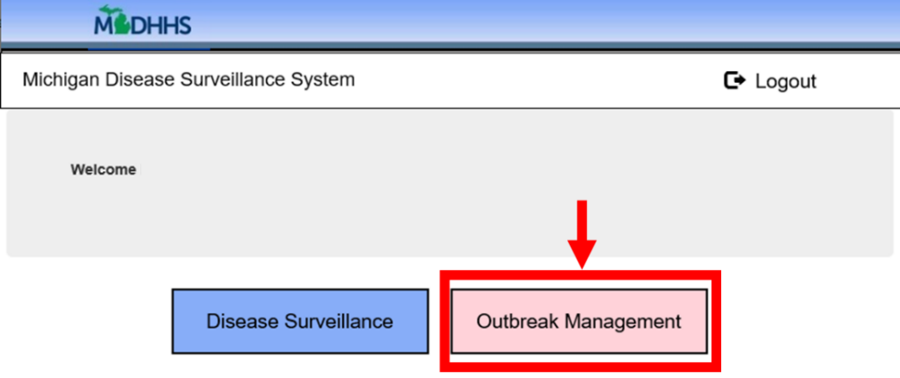
- Select ‘Outbreak Management’. If you do not see that button, contact your Regional Epidemiologist for access.

How to Search for Contacts by Outbreak and Jurisdiction or by Name/Contact ID
- To find all outbreak-associated contacts within a jurisdiction:
  - Click on Contacts Tab (top menu). Some users will be on the Contacts Tab upon accessing OMS.
  - Click on Contact List (left menu).
  - Under Filter By, choose the Investigation Jurisdiction and the Outbreak “2019-NCOV-2020-STATEWIDE” and click Filter.
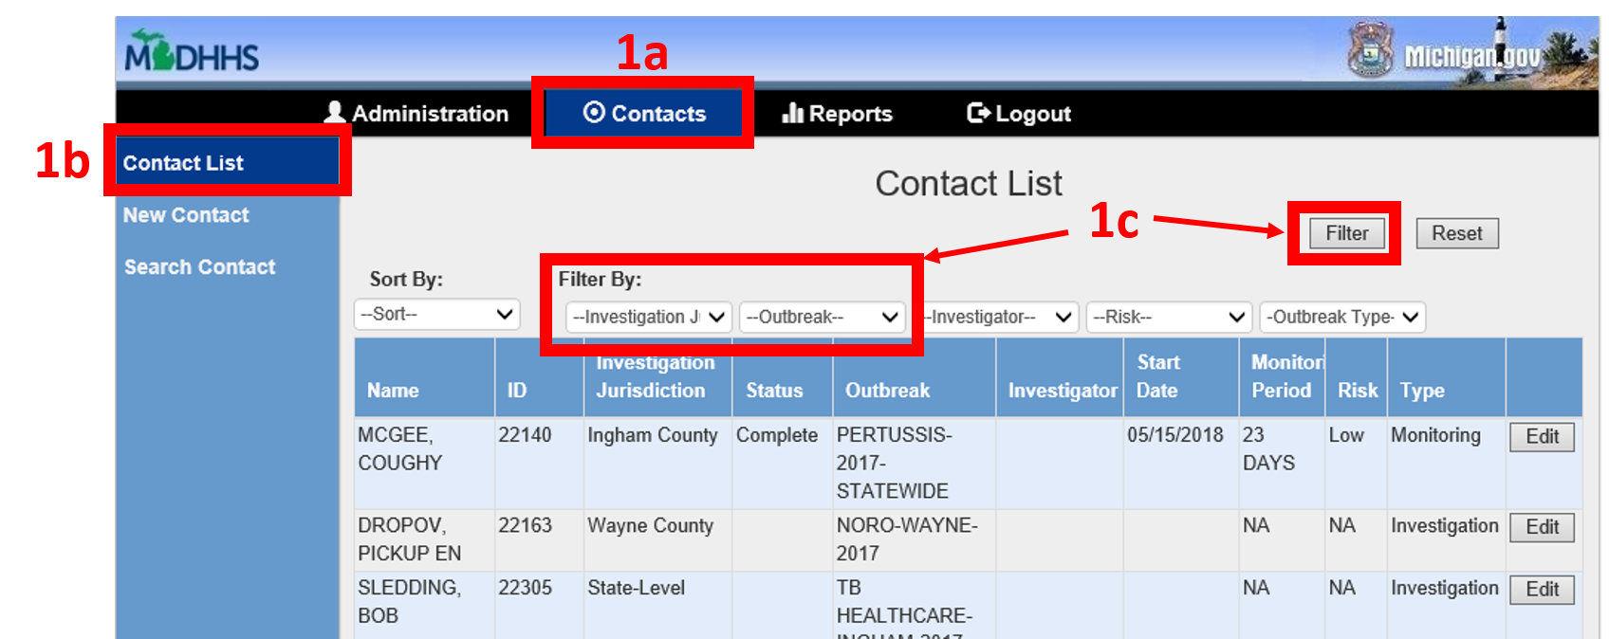

- To find a single outbreak-associated contact
  - Click on the Contacts Tab (top menu). Some users will be on the Contacts Tab upon accessing OMS.
  - Click on Search Contact (left menu).
  - Search by name and/or contact ID.
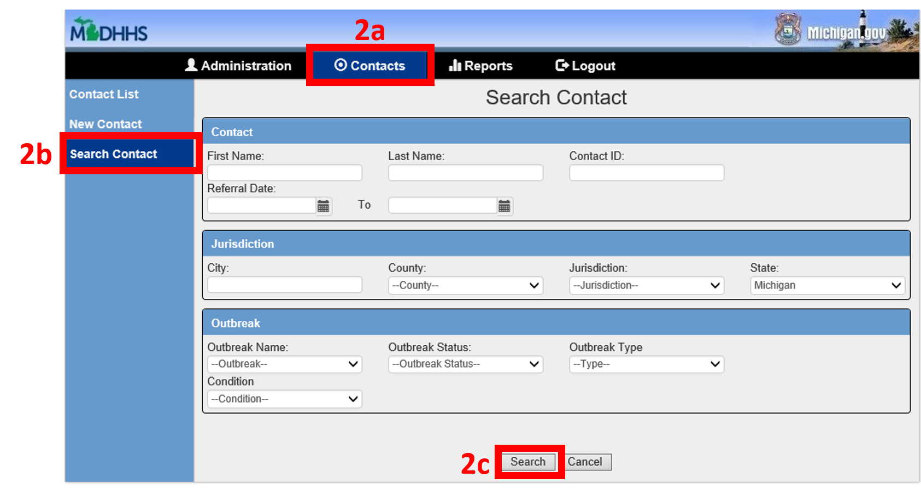

How to Enter a New Contact (if the person is not already in the system)
- Click on the Contacts Tab (top menu). Some users will be on the Contacts Tab upon accessing OMS.
- Click on New Contact (left menu).
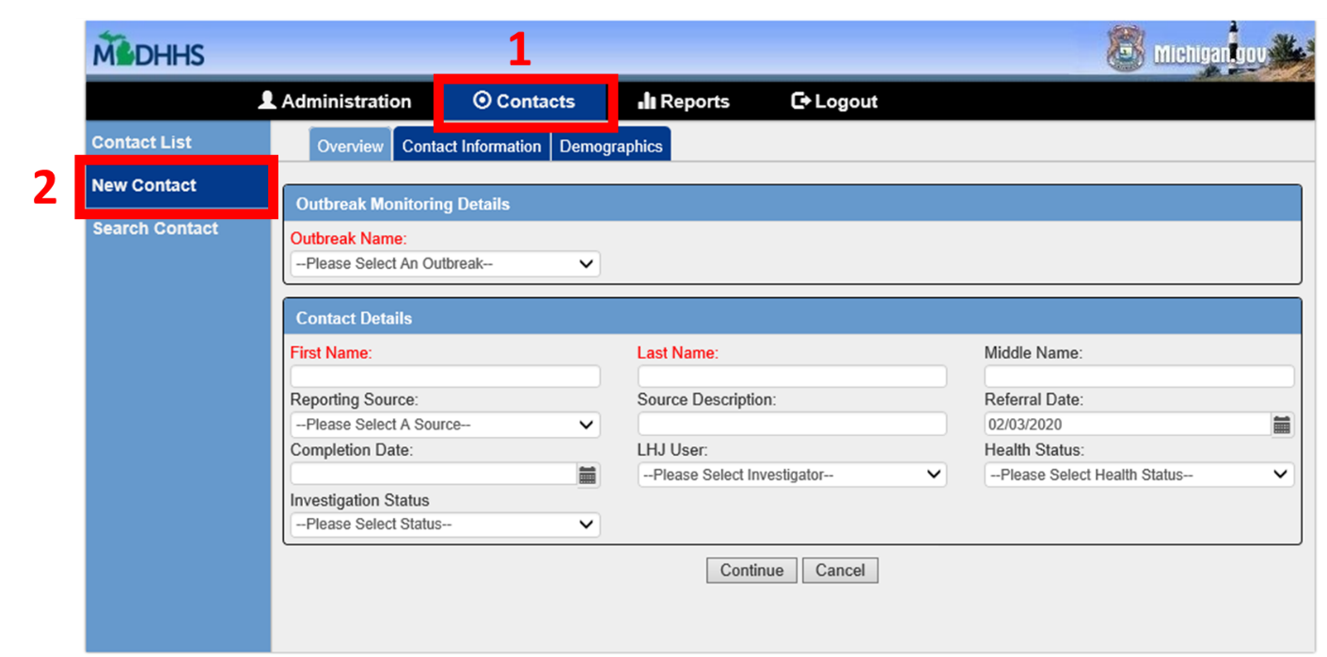
- Enter the contact data. Select the outbreak named “2019-NCOV-2020-STATEWIDE”. Required fields are highlighted red. Note: this is just the initial contact entry page; you will not be able to enter monitoring data at this point.
- Click ‘submit’ to create the contact.
- After submitting the contact, return to the list of contacts. See above, “How To Search for a Contact” to find the newly entered contact in order to enter monitoring data.

Note: for entry of multiple contacts, there is an option to bulk upload a contact list from an excel file into OMS. Contact your Regional Epidemiologist for assistance.

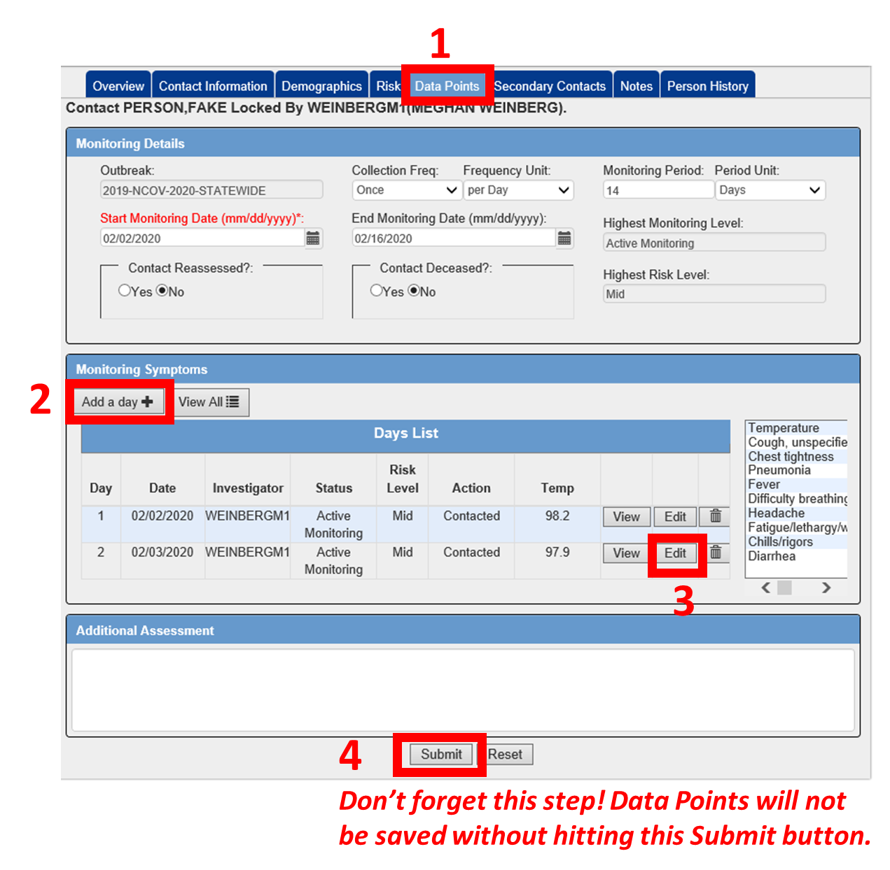
How to Add Monitoring Data to a Contact
Click “Edit” on the contact.
- Within the contact, click on the ‘Data Points’ tab.
- Click “Add a day” to add a monitoring line to the list.
- Click ‘Edit’ next to the timepoint. A pop-up box will appear.
  - Date: enter the date of contact
  - Monitoring Status: Active Monitoring
  - Risk Level: Choose the appropriate option; For those
at “medium risk”, please use “mid” risk level.
  - Action: Choose the appropriate option
  - OMS Investigator: select the person who contacted
the client
  - Document the responses; contact your regional
epidemiologist if a contact has not been reachable
in greater than 24 hours
  - Click Save Changes in the pop-up box
- Click Submit to save.

How to Close Out a Contact
- Click on Overview tab in the contact.
  - For individuals that have completed their monitoring, enter Completion Date and change Monitoring Status to Complete.
  - For individuals that transfer to a different state/country, enter Completion Date and change Monitoring Status to Left Jurisdiction.
  - For individuals that cannot be reached, enter Completion Date and change Monitoring Status to Loss to Follow Up.
  - For individuals that were incorrectly referred to Michigan OR individuals that should actually be assessed as “low” or “no identifiable risk” OR individuals referred to OMS as a potential PUI (or contacts of a potential PUI), and the individual does not meet PUI criteria, enter Completion Date and change Monitoring Status to Canceled.
- Click Submit to save changes.

This document provides interim guidance for travel evaluation and monitoring when responding to 2019 Novel Coronavirus (COVID-19). The following websites should be monitored for current information:

Traveler Evaluation and Monitoring (TEAM) Protocol
COVID-19
Interim Guidance for the Michigan Department of Health and Human Services and
Local Health Departments

- Michigan Department of Health and Human Services (MDHHS): www.michigan.gov/coronavirus
- Center for Disease Control and Prevention (CDC): https://www.cdc.gov/coronavirus/2019-ncov/index.html
- Background MDHHS
- This document reviews the procedure to conduct active monitoring for travelers meeting certain criteria.
- All travelers assessed as “high risk” will be under federal quarantine. Active Monitoring will be initiated for a subset of travelers assessed as “medium risk”. For current criteria, please see https://www.cdc.gov/coronavirus/2019-ncov/php/risk-assessment.html.
- MDHHS will be notified by Epi-X of these travelers.
- MDHHS may be notified via a healthcare provider or a local health department (LHD) of a traveler that was not identified via CDC.
- Once MDHHS is notified of a traveler to be monitored, MDHHS will enter all information as a contact into the Outbreak Management System (OMS) using the outbreak 2019-NCOV-2020-STATEWIDE; the LHD will be notified of the OMS referral via the MIHAN.
- MDHHS will facilitate follow-up coordination for interstate and intrastate movement.
- MDHHS recommends that travelers identified as “medium risk” remain in home-quarantine during the monitored period (14 days since potential exposure).
- Background LHD
- The LHD, in coordination with MDHHS, immediately initiates follow-up for the balance of the 14-day monitoring period using the OMS.
  - Initial contact will establish rapport, assess compliance, and set the follow-up schedule.
  - Active Monitoring includes contacting the traveler(s) once daily. All updates are recorded in OMS the same day if possible, otherwise within 1 business day.
- Travelers undergoing active monitoring are under self-quarantine at home.
- MDHHS notification is necessary for any permanent re-location requests
- The LHD informs the traveler to remain at home for the monitoring period. This means not attending work, school, public places, places of worship, or other people’s homes. Routine medical appointments should be re-scheduled. The LHD should ask the traveler if they have necessities (e.g., food, medications) and/or support to acquire them.
- TEAM Protocol Initiation MDHHS:
- Monitor Epi-X daily for updated traveler identification.
- Monitor communications from MDHHS CD Division, LHDs, and CHECC for notifications of travelers not identified by CDC Quarantine Station screening.
- Enter newly identified traveler information into OMS.
- Notify LHD of OMS referral via MIHAN.
- TEAM Protocol Initiation: LHD
Traveler Evaluation and Monitoring (TEAM) Protocol
COVID-19
Interim Guidance for the Michigan Department of Health and Human Services and
Local Health Departments

- Define the 14-day monitoring period and record dates for that contact in OMS. Day 1 of the monitoring period begins the last day of potential exposure (e.g., day of departure from the monitored country or region).
- Make initial contact with traveler using contact information entered in OMS.
- If you are unable to reach the traveler with the information provided, indicate that as loss to follow up in OMS.
- Inform the traveler of their enrollment into the monitoring and evaluation program.
- Establish preferred communication mechanism for daily contact.
- Obtain and record first health assessment as a data point in OMS for that contact. The 1st day of contact is the 1st data point in OMS (no previous data points are required). The “day” can be edited to reflect the correct day of the individual’s monitoring period.
- Assess initial traveler compliance and confirm that traveler understands the monitoring process and quarantine requirements.
- Active Monitoring Daily TEAM Protocol LHD:
- Conduct a daily health check via phone, email, or other means with traveler. Ensure traveler understands that they need to remain at home.
- Record interview notes into OMS on the same day if possible, otherwise within 1 business day.
- If the traveler reports symptoms, please see the “Instructions for a Monitored Traveler who becomes Symptomatic” section below.
- Frequently remind traveler of the importance of notifying EMS or healthcare providers of their monitoring status should the traveler seek medical care or transport.
- During the last check-in of the 14-day monitoring period, inform traveler that no additional calls will be made. They should feel free to contact the LHD if they have any questions in the future.
- A letter confirming completion of the monitoring period may be provided (Appendix 1).

Additional Information, Continuation Activities, and Resources
- Travel:
- Travelers at “low risk” have no restrictions to movement and are not being monitored by public health and can travel freely.
- Travelers at “medium risk” should be under self-quarantine at home and undergoing active monitoring by the LHD. Close contacts (e.g., household contacts) should be identified.
- MDHHS approval is necessary for any permanent re-location requests because of the potential change in the monitoring health department.
- Instructions for Initial Contact by LHD with a “Medium Risk” Traveler:
- I will need to speak to you once a day for the next XX days, to ask about your health and so that we can help you if you become ill while you are here. My direct phone number is: __-___-____.
- You should consider yourself as being in home-quarantine for the next XX days. This means, do not go to work, school, public places, places of worship, or other people’s homes. Re-schedule routine medical appointments.
Traveler Evaluation and Monitoring (TEAM) Protocol
COVID-19
Interim Guidance for the Michigan Department of Health and Human Services and
Local Health Departments

- Let’s discuss your plan to get necessities (e.g., food, medications) during this time.
- If you develop a fever or have any symptoms such as cough, shortness of breath, chest pain, please call me so that we can assist you in seeking care.
- If you are unable to reach me (or the local health department), please call the Michigan Department of Health and Human Services at 517-335-8165 (or afterhours at 517-335-9030).
- If you have a medical emergency during your monitoring period and call 911 before making other notifications, please tell them that you currently being monitored by the local health department because of your recent travel.
- Instructions for a Monitored Traveler who becomes Symptomatic:
- If a traveler reports subjective fever, a measured temperature > 100.4⁰ F, or signs/symptoms of lower respiratory illness (e.g., cough, shortness of breath) during the 14-day monitoring period:
  - Determine which healthcare provider the traveler intends to use for care. Instruct traveler to isolate as much as possible within the home until departing for care. Remind the traveler to inform healthcare provider of their monitoring status BEFORE arrival.
  - If traveler has transportation:
    - LHD contacts provider to inform them and coordinate the traveler’s arrival.
  - If traveler needs transport assistance:
    - This assistance may be for mild or severe illness, which will direct the type of healthcare indicated. LHDs should have a process to inform the healthcare provider and EMS (or other transport assistance) about the monitoring status. Previous plans may assist in local planning of coordinating transport.
    - Direct traveler to wait for scheduled ambulance or other transport assistance.
  - Contact healthcare provider and request the provider collect specimens and complete and submit the PUI form. See current MDHHS PUI form at: www.michigan.gov/coronavirus
  - If the traveler will be tested for COVID-19, please refer to COVID-19 SOP (above).
  - Review CDC guidance:
    - https://www.cdc.gov/coronavirus/2019-ncov/hcp/guidance-home-care.html
    - https://www.cdc.gov/coronavirus/2019-ncov/hcp/guidance-prevent-spread.html
  - Collect symptomatic traveler’s close contacts’ information and enter in OMS. Household contacts many need additional assessment. Consult with MDHHS.
  - Enter notes into OMS and inform MDHHS immediately.
  - If traveler does not meet PUI criteria, continue with daily monitoring.
- MDHHS Contact Information: Epidemiology 517-335-8165 After Hours 517-335-9030

Point of Contact | Telephone Number | Email Address

Traveler Evaluation and Monitoring (TEAM) Protocol
COVID-19
Interim Guidance for the Michigan Department of Health and Human Services and
Local Health Departments

Appendix 1

Sample language for letter to confirm traveler has completed 14-day monitoring:
*******************************************************************
Date: [XX/XX/2020]
Re: Traveler’s 14-day monitoring completed.

To whom it may concern,

This letter confirms that [TRAVELER] has completed the 14-day monitoring for 2019 Novel Coronavirus (COVID-19) in coordination with the [LOCAL HEALTH DEPARTMENT] and the Michigan Department of Health and Human Services.
[TRAVELER] is asymptomatic and considered to be at no risk for COVID-19. Because the monitoring period is complete, there are no restrictions on movement or activities including, but not limited to: travel, work, school, public conveyances, or congregate gatherings.
If the individual named above presents for medical care, there is no need for additional precautions or isolation measures beyond those typically used.
If you have any questions regarding the status of this individual, you may contact:
[LOCAL HEALTH DEPARTMENT] – [###/###-####]
or
Michigan Department of Health and Human Services – 517-335-8165
Sincerely,

[LHD MEDICAL DIRECTOR]
*******************************************************************

