What is COVID 19 and who is at risk?
COVID 19 is a coronavirus that was recently discovered in Wuhan City, China. It is spread from person to person. Currently, COVID-19 exposure is rapidly increasing in Michigan. Persons at risk for severe disease include people aged 65 years and older; and people with certain health conditions such as chronic lung disease or moderate to severe asthma; serious heart conditions; compromised immune systems; severe obesity; or uncontrolled diabetes. To minimize the risk of spread State health officials are working with healthcare providers to promptly identify, evaluate, and complete diagnostic testing on suspected cases.
The MDOC will comply with all State orders and directives issued intended to address risk and manage illness.
Transmission:
The virus that causes COVID-19 seems to be spreading easily. The virus is thought to spread mainly from person-to-person via respiratory droplets, resembling the spread of influenza.
It could be spread through:
- the air by coughing and sneezing.
- close personal contact, such as touching or shaking hands.
- touching an object or surface with the virus on it, then touching your mouth, nose, or eyes.
- in rare cases, contact with feces.
It is possible that a person can contract COVID-19 by touching a surface or object that has the virus on it and then touching their own mouth, nose, or possibly their eyes. The virus can survive on surfaces for just a few hours up to several days.

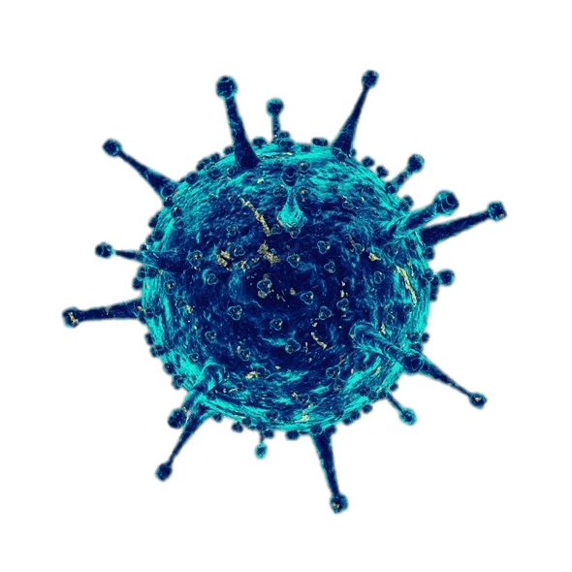

What can you do?
- Clean frequently touched surfaces
- Wash your hands with soap and water frequently
- Wear your mask that is provided to you
- Avoid touching your eyes, nose or mouth with unwashed hands
- Cover your mouth and nose with a tissue or your shirt sleeve when coughing, and promptly dispose of the tissue.
- Maintain social distancing
- Contact health care if you are experiencing any symptoms of COVID 19 – you will not be charged a copayment.

Isolation Upon Release
When you parole or discharge from prison you are leaving a congregant setting with many people and will have exposure with a different group of people, including friends, family and the public. To keep everyone safe, it is important that you adhere to the following self-isolation protocols:

If you are not sick or a close contact, but have not received the results of the test that was taken in the days prior to parole, you should isolate in your own room and limit all contact until you receive your negative test results.

If you are informed that you are a close contact prior to release, you must isolate for a period of 14-days after release, during which you isolate in your own room and limit all contact. You should also monitor for symptoms and seek testing if you believe you have any symptoms.

What are the symptoms?
- Fever
- New/Worsening Cough
- New/Worsening Shortness of Breath
- Sweats/Chills/Shaking
- Muscle Aches/Pain
- New Onset Sore throat
- Nausea
- Diarrhea
- Loss of taste and/or smell
- New Onset Headache

The symptoms of COVID 19 should be taken seriously and acted upon immediately. Please do not hesitate to report any symptoms to your corrections officer so that he/she may contact health care immediately.
Testing:
PCR Swab: This is a nasal swab that detects the presence of the COVID 19 virus. All prisoners entering the MDOC, any prisoner with symptoms of COVID 19 and prisoners with an upcoming parole/discharge will be swabbed for COVID 19. The test results will either be positive or negative. A positive result simply means that the virus was detected on the nasal swab. A negative result simply means that no virus was detected.

Prisoners with a positive COVID 19 PCR swab are required to be quarantined. The length of the quarantine is typically 10 days from the onset of symptoms or date of positive PCR test. The location of quarantine is made on a case by case basis. Factors taken into consideration include length of time from onset of symptoms, resolution of symptoms, and absence of fever. Additional COVID PCR Swabs may be required prior to release to determine absence of the virus. COVID-19 positive patients are released from quarantine as soon as it is safely possible to do so. We do not want anyone quarantined longer than they need to be. While in quarantine, you will be closely monitored by health care staff.

IgG Blood Draw: This blood test looks to see if you have developed an immune response to COVID-19. This test will be done for all prisoners entering the MDOC. It will be offered to prisoners with an upcoming parole/discharge. It is voluntary and is not required to be completed to satisfy parole/discharge requirements. There may be other scenarios where the test is specifically recommended by the Chief Medical Officer.
If your test results came back POSITIVE. This means that antibodies were detected to COVID-19. You may have been infected with the virus
that causes COVID-19 at some point in the past and did not show any symptoms, or your symptoms were very mild. If you were nasal swabbed for COVID-19 in the past and found to be COVID-19 positive, in most cases you would develop antibodies.
The presence of IgG suggests that the infection happened weeks to months in the past. The science is unclear regarding the development of “immunity” and we, along with the rest of the medical community, are still learning about what the presence of antibodies means.

