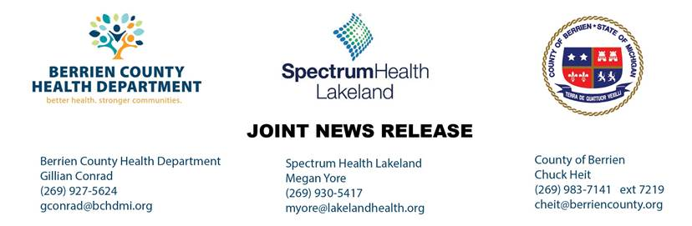

FOR IMMEDIATE RELEASE
News Release #: 21
Date: May 28, 2020
Time: 2:30 PM
Michigan National Guard Assists with Voluntary COVID-19 Testing for Berrien County Jail and Long-Term Care Facilities
(Berrien County, MI) – In support of the statewide efforts to increase testing for COVID-19 across Michigan, especially amongst vulnerable populations, Berrien County officials are pleased to report a recent partnership with the Michigan National Guard and Michigan State Police in testing Berrien County Jail inmates and staff as well as residents and staff at long-term care facilities. The COVID-19 testing taking place in partnership with the Michigan National Guard augments many weeks of prior testing efforts that has already been conducted in a variety of settings in Berrien County, including those at highest risk for the virus.
The Michigan National Guard team conducted voluntary testing for inmates and staff at the Berrien County jail on Friday, May 22nd, which resulted in 95 (or 64%) of the jail population and 22 Sheriff’s Office staff members choosing to be tested. All 117 tests gathered at the time of mass voluntary testing were shown to be negative for COVID-19. Berrien County Sheriff Paul Bailey stated, “I am proud of the diligence of our staff and the way our medical provider has worked with us and the Health Department to provide the safest environment we can for the inmates and staff.”
For many weeks, Berrien County Health Department (BCHD) has been focused on protecting residents of long-term care facilities from potential outbreaks of COVID-19 by partnering with facilities to test residents and staff to understand risk of COVID-19 in the facility, educate staff on best practices for infection prevention, and provide resources including personal protective equipment where needed. While there has been an ongoing focus placed on testing for COVID-19 within long-term care facilities in Berrien County, the Michigan National Guard will provide the largest one-day mass testing event to date on Thursday, May 28th to augment the testing that has already been conducted previously. It is anticipated that in this mass testing event, more than 1,300 individuals, including long-term care facility residents and staff members, will be tested for COVID-19. “We understand the unique challenges congregate living situations, such as long-term care facilities, face in regard to the spread of COVID-19,” said Melinda Gruber, vice president continued care services, Spectrum Health Lakeland. “The safety of our residents and team members remains our highest priority. Proactive testing is a crucial tool in protecting these vulnerable populations and we are pleased to partner with the National Guard, the Berrien County Health Department, and our facility partners on this important work.”
The Berrien County Sheriff’s Office continues to work closely with the Health Department to monitor inmates at the jail for potential symptoms of COVID-19 and has received support from Spectrum Health Lakeland to conduct testing for inmates as needed. To date, the jail has tested 19 inmates, with only two of these tests resulting as positive for COVID-19. Both of the inmates that tested positive have been released from the jail, either being released from their out of state hold or on bail, and are still subject to the standard follow-up and isolation procedures. Knowing the potential for outbreaks of COVID-19 in correctional facilities, the Berrien County jail has taken several proactive steps to ensure that isolation protocols are in place, enhanced cleaning schedules are in effect, and there are a limited number of outside visitors allowed inside the jail. Berrien County has also contracted with an outside cleaning company to provide additional cleaning and sanitizing in the jail.
The Berrien County Health Department and its partners understand the ongoing impact COVID-19 will have on the vulnerable populations in Berrien County, until which time a vaccination or antiviral treatment is developed. Older adults, those with underlying medical conditions, and individuals living in congregate settings are at a particular elevated risk for severe illness associated with COVID-19. Nicki Britten, health officer, Berrien County Health Department said, “to limit the spread of the virus to the greatest extent possible, we continue to work collaboratively with our partner agencies, especially those who serve more vulnerable residents, to ensure that infection prevention education and personal protective equipment/resources are made available, a strategy for ongoing testing is implemented, and that contact tracing and follow-up occurs for all individuals found to be positive for the virus.”
As testing for COVID-19 has expanded even further for all Berrien County residents, anyone who is experiencing symptoms of COVID-19, including fever, cough, sore throat, body aches, or shortness of breath, should seek testing. Presently, Berrien County residents can get tested at Spectrum Health Lakeland, InterCare Community Health Network, Walmart in Benton Harbor, and Rite Aid Pharmacy in Bridgman. Pre-screening and appointments are required at all testing sites. Find more information regarding testing availability at www.bchdmi.org/COVID19.
###

