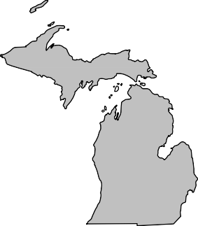
BOARD MEMBERS 2020-2021

President Andrew Cox Macomb County (586) 469 5510

President Elect Sara Simmonds Kent County (616) 632 7316

Past-President Matt Bolang Livingston County (517) 552 6870

Secretary Liz Braddock Mid-Michigan
(616) 302 6301

Treasurer Chris Westover Monroe County (734) 240 7921

Directors
Ken Bowen (2021)
Ionia County (616) 527 5341

Tony Drautz (2021) Oakland County (248) 858 1320

Steve Stoddard (2022)
Lapeer County (810) 245 5791

Kevin Green (2022) Calhoun County (269) 969 6398

Dan Thorell (2022) Northwest Health
(231) 547 7651

Michigan Association of

Local Environmental Health Administrators MALEHA

Representing Local Environmental Public Health Departments in Michigan

Forum Report – August 2021

- Bridge magazine featured a story on August 11th about the need for septic system funding for homeowners and had some quotes from Norm Hess and myself. The story can be found here.

- One of the most critical things to continue having a strong MALEHA to move local Environmental Health forward and advocate for ourselves is participation in our association. We have the following Board positions we need nominations for:
  - President Elect
  - Secretary
  - Treasurer
  - Board of Director (x2)
- Discussions will be held at the forum meeting this month regarding the MALEHA Directors conference in September at the RAM center and what is in the best interest of MALEHA membership.
- MPHI will continue to be on pause for State Accreditation. This pause includes:
  - On-Site Reviews are paused and will be rescheduled at a later date in cooperation with local health departments and programs within Accreditation at the state;
  - An extension to the Corrective Plan of Action (CPA) process for those health departments who are still in the process of implementing CPAs in response to their On-Site Review;
  - Suspension of Minimum Program Requirements (MPRs) during the COVID-19 response; and
  - Suspension of the Standards Review Committee process.

Respectfully Submitted, Andrew Cox
August, 2021

“Protecting, Promoting and Enhancing Public and Environmental Health in Michigan”

