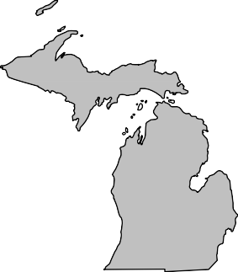
BOARD MEMBERS 2020-2021

President Andrew Cox Macomb County (586) 469 5510

President Elect Sara Simmonds Kent County (616) 632 7316

Past-President Matt Bolang Livingston County (517) 552 6870

Secretary Liz Braddock Mid-Michigan
(616) 302 6301

Treasurer Chris Westover Monroe County (734) 240 7921

Directors
Ken Bowen (2021)
Ionia County (616) 527 5341

Tony Drautz (2021) Oakland County (248) 858 1320

Steve Stoddard (2022)
Lapeer County (810) 245 5791

Kevin Green (2022) Calhoun County (269) 969 6398

Dan Thorell (2022) Grand Traverse County (231) 995 6021

Michigan Association of

Local Environmental Health Administrators MALEHA

Representing Local Environmental Public Health Departments in Michigan

Forum Report – April 2021

- Fair, festival, prom guidance continues to be one of the biggest priorities that I have requested of both MALPH and MDHHS. Nick Derusha, current president of MALPH, has continued to bring it up at the Executive meetings with the Governor’s office as well as the Epidemic Order workgroup meetings. Currently no specific answers have given in response.
- FLOW (For the Love of Water) is hosting the Michigan Groundwater Table. There will be a series of six bimonthly 90-minute Zoom meetings with a presentation by a subject matter expert at the beginning of each meeting. The 30-40 minutes presentations will cover the following areas:
  - Overview of groundwater resources [May 5, 2021]
  - Threats to groundwater in Michigan [July 7, 2021]
  - Existing groundwater databases and monitoring capabilities [Sept. 1, 2021]
  - Risk-based groundwater management policy [November 3, 2021]
  - Minnesota groundwater initiatives [January 5, 2022]
  - Need for statewide sanitary code [March 2, 2022]
- With the expansion of the priority groups to all 16 years of age and older most jurisdictions continue to be pulled into supporting vaccination clinics and efforts. Conducting EH programmatic activities continues to be a challenge with a reduction in staffing resources.
- MPHI will continue to be on pause for State Accreditation. This pause includes:
  - On-Site Reviews are paused and will be rescheduled at a later date in cooperation with local health departments and programs within Accreditation at the state;
  - An extension to the Corrective Plan of Action (CPA) process for those health departments who are still in the process of implementing CPAs in response to their On-Site Review;
  - Suspension of Minimum Program Requirements (MPRs) during the COVID-19 response; and
  - Suspension of the Standards Review Committee process.

Respectfully Submitted, Andrew Cox
April, 2021

“Protecting, Promoting and Enhancing Public and Environmental Health in Michigan”

