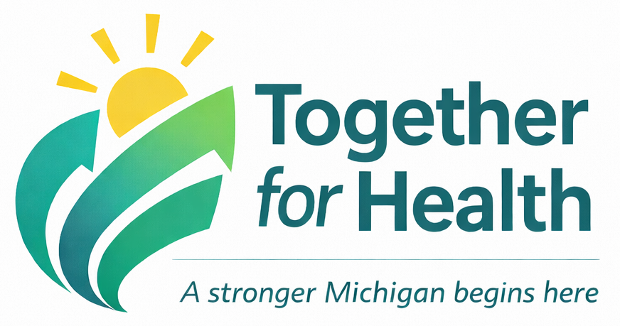
T4H Elevator Speeches for Various Stakeholders

Policymakers and Funders
Call to Action:
- Champion sustained, inflation-adjusted public health funding
- Align policies with Health in All Policies principles
County Commissioners
Public health is shifting from a system that reacts to crises to one that prevents them and that shift directly benefits counties.
Together For Health is about building a stronger, more efficient system – one with stable, flexible funding, better use of data, and stronger partnerships across sectors like housing, schools, and economic development. It’s about getting a better return on every public health dollar by addressing issues earlier before they become more costly emergencies.
For counties, that means fewer crises, reduced strain on emergency services and healthcare systems, and healthier communities that are more resilient and economically stable.
It also makes public health more visible and understandable, so residents see the value in safer communities, stronger services, and clear, trusted communication, especially during uncertain times.
At the local level, we hope to align this vision with your priorities so that we’re not just responding to problems but preventing them together.
We need your partnership to make that possible by championing sustained, inflation-adjusted public health funding and aligning policies with a Health in All Policies approach. Because when we invest upstream and work across sectors, we don’t just improve health - we strengthen the entire community.
Policymakers and Funders
Call to Action:
- Champion sustained, inflation-adjusted public health funding
- Align policies with Health in All Policies principles
State Legislators
Public health in Michigan is at an inflection point. We have an opportunity to move from a system that reacts to crises to one that prevents them, and that shift has real implications for both the state budget and long-term outcomes.
Today, Michigan spends billions annually on healthcare and emergency response, yet many of our health outcomes still lag national benchmarks. For example, chronic diseases account for most healthcare costs, and preventable conditions continue to drive utilization across Medicaid and hospital systems.
Together For Health is about building a more efficient, accountable system that uses data, cross-sector partnerships, and flexible funding to address issues earlier, before they become more expensive crises.
When public health works upstream, it reduces downstream costs in healthcare, emergency services, and other state-funded systems, while improving outcomes like life expectancy, maternal health, and chronic disease prevention.
This goal of this vision is to ensure greater consistency across Michigan, so whether someone lives in a rural county or an urban center, they have access to a foundational level of public health protection.
To realize this vision, we need your leadership in championing sustained, inflation-adjusted public health funding and aligning state policy with a Health in All Policies approach.
Because when we invest strategically in prevention and align policies across sectors, we’re not just improving health, we’re strengthening the efficiency and sustainability of Michigan’s entire system.

Policymakers and Funders
Call to Action:
- Champion sustained, inflation-adjusted public health funding
- Align policies with Health in All Policies principles
Foundations and Other Funders
Public health in Michigan is at a pivotal moment. We have an opportunity to move from a system that reacts to crises to one that prevents them and that shift creates a powerful opportunity for impact.
Together For Health is designed to strengthen the public health system at its core. Through modern data, a skilled and resilient workforce, and strong cross-sector partnerships, we aim to address the root causes of health, from housing to education to economic stability.
For funders, this is an opportunity to invest in systems change - not isolated programs. By aligning funding with this shared vision, we can reduce fragmentation, accelerate innovation, and scale what works across communities.
We know that prevention yields strong returns both in reduced healthcare costs and in improved quality of life. But just as importantly, this approach aims to ensure that every Michigan resident, regardless of geography or circumstance, benefits from a consistent level of public health protection.
This work is designed to be measurable and sustainable by using data to guide decisions, track outcomes, and continuously improve.
We’re inviting partners like you to help accelerate this transformation by aligning investments with this statewide vision, supporting innovation, and helping build the infrastructure needed for long-term impact.
Because when we invest upstream and together, we don’t just improve programs - we transform systems, strengthen communities, and create lasting change.

Cross-Sector Partners
Call to Action:
- Integrate health considerations into planning and decision-making
- Partner with local health departments on shared community goals
Public health is evolving from responding to problems to preventing them and we can’t do that alone.
We know that health is built everywhere - in housing, transportation, education, and economic decisions. The choices made across sectors every day shape the health of our communities. And when health is considered in all policies, outcomes are strengthened not just for health, but for education, workforce stability, public safety, and economic growth.
Together For Health is about working more intentionally together so we’re not addressing issues in isolation, but aligning our efforts to tackle root causes earlier, before they become more complex and costly.
Importantly, this isn’t about adding more to your plate, it’s about strengthening the impact of the work you’re already doing. Healthier communities support stronger schools, a more reliable workforce, and more resilient local economies. Coordination and shared priorities prevent gaps and duplication.
At the local level, we see this as an opportunity for shared system thinking, meaning shared work with shared outcomes. We bring data, public health expertise, and a community-wide lens. Together, we can align strategies for greater impact.
We invite you to partner with your local health department and integrate health considerations into planning and decision-making so we can advance shared community goals together.
Because when health is built into everything we do, we don’t just improve health, we strengthen the entire community.

Public Health Leaders and Staff
Call to Action:
- Use shared tools, data, and messaging consistently
- Highlight local wins and system impact
Public health is at a turning point. We have an opportunity to move from a system that reacts to crises to one that prevents them and that shift starts with us.
Together For Health is about building a more aligned, effective system where we are working toward shared goals, using data more intentionally, and strengthening partnerships across sectors to address the root causes of health.
We know that health is built everywhere - in housing, education, transportation, and economic conditions. Our role is to bring that public health lens into community conversations and help connect the dots across systems.
But this vision only works if we are aligned internally. That means we need to move away from fragmented efforts and toward:
- Shared tools
- Shared data
- And consistent, clear messaging
It also means telling our story more effectively - highlighting local wins, demonstrating impact, and helping our communities and partners understand the value of public health every day, not just during a crisis.
Each of us plays a role in this, regardless of position. So, the call to action is this: use the shared tools, rely on data to guide our work, communicate clearly and consistently, and lift up the impact you’re making locally.
When we align our efforts and show our impact, we don’t just do the work, we elevate it.

Community Members
Call to Action:
- Learn how public health affects daily life
- Engage in local initiatives and prevention efforts
Public health is about the things that shape our daily lives: safe water, clean air, healthy food, strong schools, safe neighborhoods, and access to care when we need it.
We’re working toward a future where public health doesn’t just respond to problems but helps prevent them, so communities can thrive before a crisis ever happens.
Because the truth is, health is built everywhere - in our housing, our jobs, our schools, and the choices made in our communities every day.
Together For Health is about making sure every community has what it needs to be healthy and strong and that no community is left behind. No matter where you live, you deserve access to the same level of protection, opportunity, and support.
Everyone has a role to play.
We invite you to learn more about how public health affects your daily life and to get involved in local initiatives and prevention efforts because when communities are informed and engaged, we all do better.
Together, we can build healthier, safer, and more connected communities for everyone.

