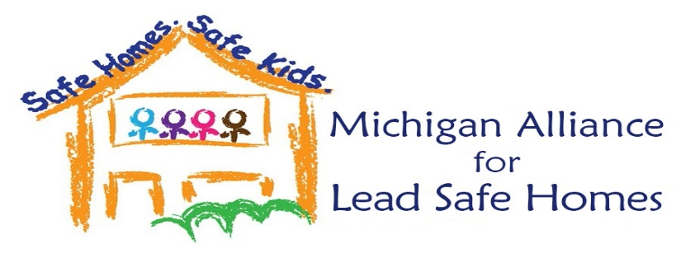

2020 MIALSH Policy Priorities

Top Priorities
- Require universal lead testing for ALL Michigan children aged 1 and 2.
- Require an inspection for lead paint, soil, dust and water before the sale or transfer of property built before 1978 intended for occupancy.
- Have the state of Michigan assume responsibility for the federal RRP enforcement program which requires contractors to have a lead safe certification to do work on pre-1978 homes.
- Identify and secure a dedicated funding source to end lead poisoning in Michigan.
- Make Lead an Essential Local Public Health Service

Other Important Efforts
Encourage local rental certification programs to require identification of hazards upon rental of units prior to occupancy.
Shift the burden of proof to landlords to submit documentation that lead hazards have been abated and indexed to CDC guidelines during enforcement proceedings and as per the Landlord Penalty Law.
Push to validate “relocation” as an abatement strategy (both emergency and long term) through pilot funding and policy change.
Support efforts to train, recruit and identify lead abatement professionals and contractors to help fill our state’s acute shortage.
Support and align with the Michigan Child Lead Exposure Elimination Commission (CLEEC) in their policy development, education and work to maintain and enhance their funding.
Ensure Michigan’s federal Children’s Health Insurance Program (CHIP) match is met each fiscal year to support our state’s lead programs.

