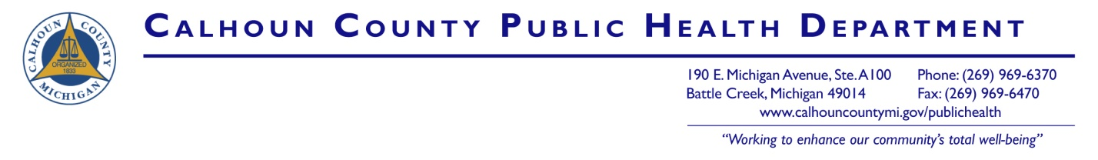

- FOR IMMEDIATE RELEASE –
November 18, 2019

Contact person:
Brigette Reichenbaugh, 269-969-6370

Breathe Easier Starting Today:
November 21st is The Great American Smokeout

November 21st celebrates the Great American Smokeout: An annual date reserved to support smokers nationwide in taking an important step toward a healthier life through quitting smoking. Whether you or someone you love uses cigarettes, cigars, or e-cigarettes (also known as vape pens) Calhoun County Public Health Department (CCPHD) wants to remind you that today is a great day to make a change to reduce the risk of cancer, heart disease, stroke and more.
This year in particular, CCPHD encourages parents to connect with their children about the risk of e-cigarettes. Relatively inexpensive vaping devices and easy to come by e-cartridges with fun flavorings have made vaping popular among our younger population, and it is a real cause for concern. Nationwide, e-cigarette use (vaping) among middle and high school students has increased at an alarming rate; the Centers for Disease Control and Prevention (CDC) and Food and Drug Administration (FDA) data show that 1 in 5 high school students and 1 in 20 middle school students were e-cigarette users.
What is the harm?
As of October 15, the Michigan Department of Health and Human Services has identified 36 (20 confirmed and 16 probable) cases of severe lung disease associated with vaping in the state of Michigan.
Cigarettes and most e-cigarettes contain nicotine, a drug found naturally in tobacco, which is highly addictive. Nicotine can harm adolescent brain development and increase risk for future addiction to drugs. It increases the user’s risk of lung cancer, heart disease, and infertility in women. Women who smoke during pregnancy also increase their risk of having a baby with low birth weight. Quitting smoking can reduce ALL of these health risks and more.
“Tobacco use in any form is one of the most preventable causes of disease and premature death,” stated CCPHD Health Officer, Eric Pessell. “Quitting can be difficult and we [CCPHD] want to connect you and your loved ones with what you need to be successful.”
How to Quit
Research shows that while quitting is difficult for most tobacco users, people who use tobacco can increase their success in quitting with help. Quitters are most successful when using a combination of therapies, including resources such as nicotine replacement, counseling, self-help materials, and a strong support network of family and friends.
Young adults and teens who wish to quit can visit www.mylifemyquit.com, a free and confidential program that can be used online or via your cell phone by texting “Start My Quit” to 855-891-9989.
Adults who wish to quit can find free support, advice, and counseling through calling 1-800-QUIT-NOW (1-800-784-8669), downloading the free app, quitSTART, or by visiting the Michigan Tobacco Quitline at https://michigan.quitlogix.org/.
More information
For more information about the Great American Smokeout, visit the American Cancer Society's web site at www.cancer.org. For more tips on quitting and other resources and services for the health of you and your family, we encourage you to follow CCPHD on facebook at www.facebook.com/CCPublicHealthDepartment.
---end---

