Meeting Agenda

BOARD MEMBERS
2018-2019

President
Kristen Schweighoefer
Washtenaw County
(734) 222-3968
President Elect
Matt Bolang
Livingston County
(517) 552-6870
Past-President
Vern Johnson
Kalamazoo County
(269) 373-5356
Secretary
Addie Hambley
Ottawa County
(616) 393-5625
Treasurer
Chris Westover
Monroe County
(734) 240-7921
Directors
Ken Bowen (2021)
Ionia County
(616) 527-5341
Andrew Cox (2021)
Macomb County
(586) 466-4135
Tony Drautz (2021)
Oakland County
(248) 858-1320
Don Hayduk (2019)
Jackson County
(517) 788-4433
Chris Klawuhn (2019)
Saginaw County
(989) 758-3684

January 17, 2019, 9:30am - noon
MPHI Offices, 2436 Woodlake Circle, Okemos, MI

- Call to Order/Introductions
- Additions to Agenda/Agenda Approval
- Approval of Minutes
- Officer & Affiliate Reports
  - President’s Report
  - Treasurer’s Report
  - MALPH Report
  - MEHA Report
- State Department Reports
  - DEQ Report
  - MDARD Report
  - MDHHS Report
  - LARA Report
- Committee Reports
  - Food (Liz Braddock)
  - Drinking Water (Tip McGuire/Mark Hansell)
  - On-site & Land-use (Matt Bolang/Mark Hansell)
  - Legislative
  - Technology & Training (Don Hayduk)
  - Vapor Intrusion Ad-hoc (Don Hayduk)
  - PFAS Ad-hoc
- MALEHA Member Reports (non-MALEHA Committees)
  - Medical Waste Pilot Program
  - Local Inspection of Fairs
  - DEQ Septic Code Workgroup
- Old Business
  - Statewide sewage code – discussion on survey
- New Business
- Items from Board
- Items from Members
- Future Agenda Items

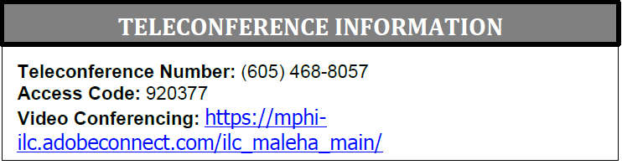

Next MALEHA meeting:
Thursday, February 21, 2019

